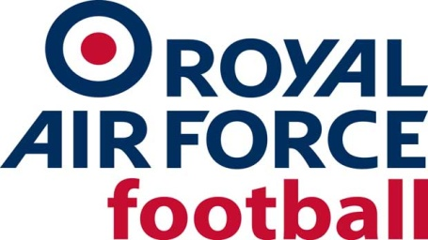

RAF Ladies Rep Team
Fixtures & Results 2018-19
Date: Wed 22 Aug 18
Competition: Friendly
Opponents: Irish Defence Force
Venue: Oxford City FC
Result: D 1-1
Date: Wed 26 Sept 18
Competition: Friendly
Opponents: Boston United Ladies
Venue: Away, Boston
Result: L 3-1
Date: Thurs 8 Nov 18
Competition: Friendly
Opponents: New Zealand Defence Force
Venue: St Georges Park
Result: W 8-0
Date: Wed 12 Dec 18
Competition: Friendly
Opponents: Wolverhampton Wanderers
Venue: Away, City of Wolverhampton College
Result: L 3-0
Date: Wed 16 Jan 19
Competition: Friendly
Opponents: University of South Wales
Venue: Away, USW, Cardiff
Result: W 0-11
Date: Thur 14 Feb 19
Competition: Friendly
Opponents: Sheffield United Ladies
Venue: Away, Sheffield United Football Academy
Result: W 0-2
Date: Thur 14 Mar 19
Competition: Friendly
Opponents: Norwich Ladies Development
Venue: Away, Holt Road, Horsford, Norwich
Result: W 0-4
Date: Wed 20 Mar 19
Competition: Inter-Services
Opponents: Army
Venue: Away, Aldershot Military Stadium
Result: D 1-1
Date: Tue 26 Mar 19
Competition: Inter-Services
Opponents: Royal Navy
Venue: Home, TNS FC, Owestry
Result: W 3-1

