2017/18 RAF Challenge Cup
‘Keith Christie Trophy’ Match Report

RAF Coningsby 3 – 2 RAF Brize Norton

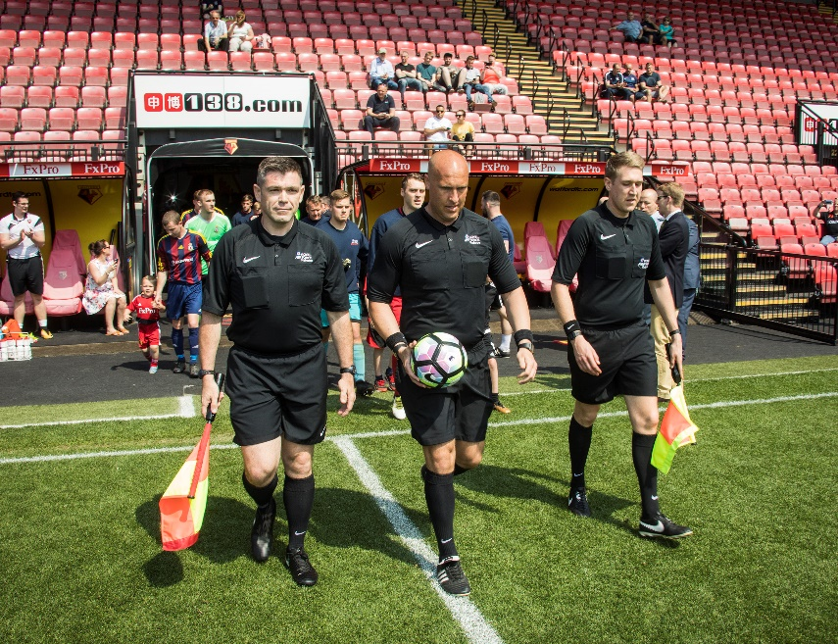
Vicarage Road basked in the light of the late spring sun. The unrelenting rays, unimpeded by a cloudless sky, illuminated what was a hard-fought battle between two almost evenly matched sides. The two teams wasted no time engaging in a determined skirmish that entertained the sun-baked revellers. Both teams were locked in a vice-like-grip of end-to-end action, with each taking turns to threaten and test the defensive capability of the opposing combatants. But both defences held strong and kept out any direct threat to goal, despite the onslaught.

Few chances were had by either side during the opening 10 minutes, and despite the intense pressure the closest either side came to goal were sporadic aerial attempts following long-lofted balls into the respective areas. Both teams enjoyed good spells of possession early in the first half, however, both goalkeepers had a relatively quiet game, as the two sides failed to make the most of any opportunity in the final thirds of the pitch.

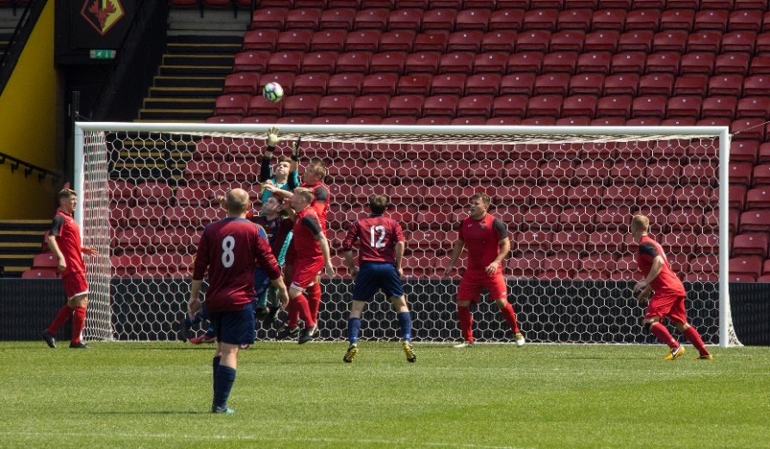
As the first half went on, each side took turns to control the game and both had opportunities to strike first. RAF Brize Norton tested the reactions of goalkeeper, SAC Gorman, who did well to push the ball wide for a corner, as the ball took an unexpected bounce en route to the 6-yard box, following a long-range effort. In an immediate response at the other end of the pitch, it was only thanks to the commitment of bodies on the line that kept out the efforts of Cpl Longbone, with the well-defended effort on goal eventually cleared.

The intensity of the game slowed as the half drew to a close, however, a neat through ball just before half time, cut through the Coningsby defence and allowed SAC McGowan to drive down the right wing. His low drilled ball, fired across the goalmouth was somehow kept at bay by some last ditch defending. The ball ricocheted around the penalty area as Coningsby tried to clear their lines. Somewhat comically, an attempted clearance bounced across the back of an unsuspecting head and landed neatly at the feet of Sgt Wanless, who was lucky to receive two chances to slot the ball home. RAF Brize Norton went into the dressing room at half time with a 1-0 lead.

RAF Brize Norton came quickly out of the blocks for the second half and created a number of chances in the opening spell. However, it did not take long for the rhythm of the first half to return and both sides forged chances to attack the opposition goal throughout the renewed midfield battle.
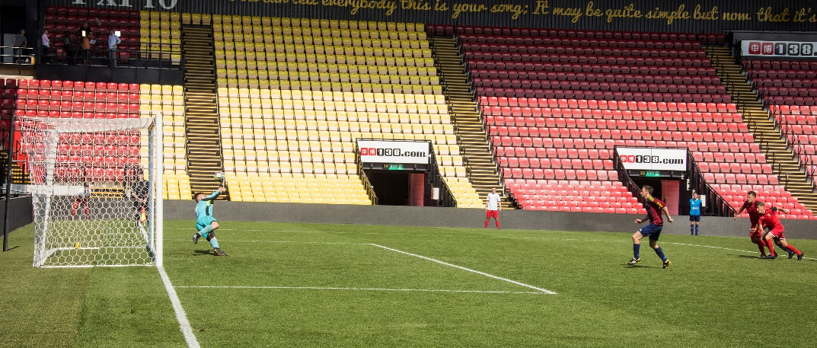
Despite the sides appearing evenly matched, Cpl Norton forced a good save from the RAF Brize Norton keeper, with the resulting corner leading to a goal mouth scramble and eventually a penalty. A chance for RAF Coningsby to equalise. Cpl Norton stepped up to the spot and confidently slammed the ball into the top right-hand corner, well out of SAC Sandall’s reach.

Inspired by the retaliation, RAF Brize Norton launched a determined attempt to reply. One notable long ball was brought down well by the attacker in the RAF Coningsby penalty area, however, SAC Gorman was quick off his line to deal with the threat. RAF Coningsby withstood the increased pressure and launched a few counter-attacks that tested the RAF Brize Norton back lines.
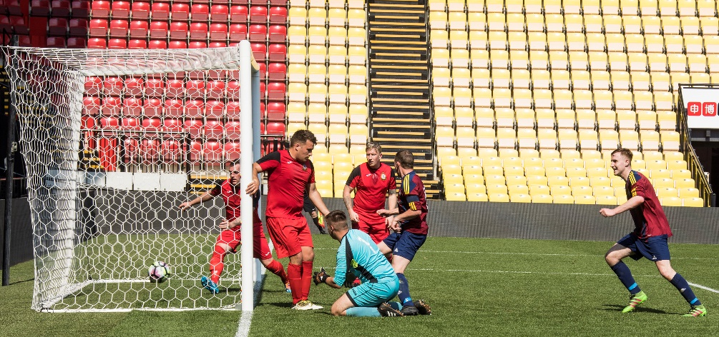
One particular counter-attack resulted in a corner and sloppy defending meant that the chance was capitalised on by Cpl Braniff only 8 minutes after their equaliser. Slotting home neatly from within the 6-yard box. The ball in the back of the net put RAF Coningsby into the driving seat with a 2-1 lead.

As a result, RAF Brize Norton looked ever more determined to pick up the pace, attacking with fury against a Coningsby defence that held up well against the pressure. A good spell of play from the offensive side led to SAC Gorman mishandling the ball in his own area and mistakenly reclaiming it before it could roll out of the penalty box. The resulting indirect freekick was laid short to SAC Morrison, who struck the ball straight at a brave wall. The barrage lasted as long as a few corners before being fired toward the back post, where SAC McGowan climbed above the pack to head the ball home and equalise for RAF Brize Norton. 2-2.
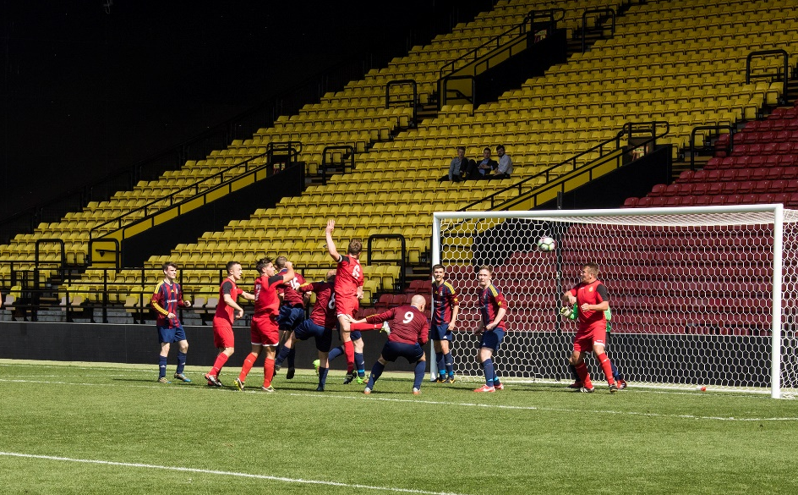
The game intensified as each team looked to prevent extra-time. RAF Coningsby looked to cut through the Brize defence only to be denied shouts for a second penalty as one attacker was brought down in the opposition area. A combination of tame efforts and offside calls prevented either side from taking the lead. Both teams came close but RAF Coningsby looked the more likely to score. Cpl Hig managed to work the ball inside only for Cpl Longbone to trip over his feet and scuff the opportunity.

As the crowd watched under the heat of the sun, Cpl Norton’s shot rolled agonisingly past the far post in what seemed like a last gasp attempt to prevent extra-time. With RAF Coningsby heads in hands, the game appeared set to continue late into the afternoon. This was until, in the dying minutes of the game, substitute Cpl Gemmell cleverly flicked the ball over SAC McGowan, only to be brought down by a late tackle from RAF Brize Norton’s SAC Batty.

Cpl Norton stepped up once more to the spot, with the pressure of the world on his shoulders and calmly slotted home with a powerful shot down the centre. Despite the outstretched hand that the RAF Brize Norton goalkeeper clawed at the ball with, he was unable to prevent the back of the net bulging and sending both the RAF Coningsby players and supporters into rapturous celebration.

Shouts of all-out-attack from the RAF Brize Norton coaching staff and relentless pressure from the players on-field were not enough to surmount the one goal deficit as RAF Coningsby valiantly defended their lead until the final whistle blew.

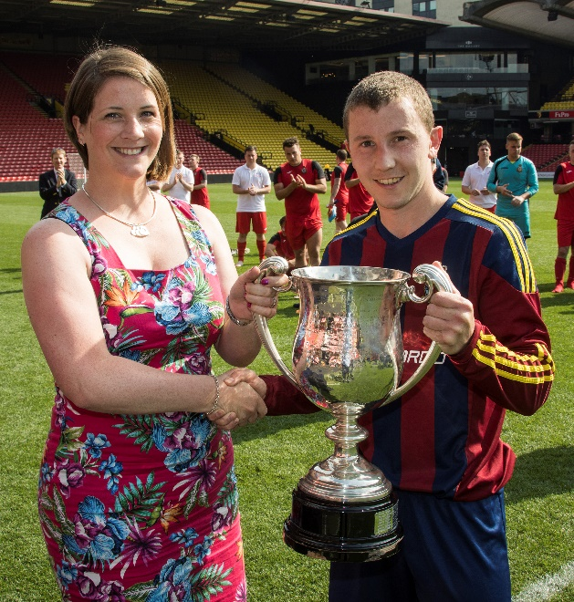
Man of the Match:

Cpl S Norton

Scorers:
Sgt D Wanless – RAF Brize Norton (43 minutes)
Cpl Steve Norton – RAF Coningsby (50 minutes)
Cpl Michael Braniff – RAF Coningsby (55 minutes)
SAC James McGowan – RAF Brize Norton (59 minutes)
Cpl Steve Norton – RAF Coningsby (90 minutes)

Match Report by SAC Steven Howe

Photography by Mr Steve Lympany – RAF Brize Norton Photo Section.
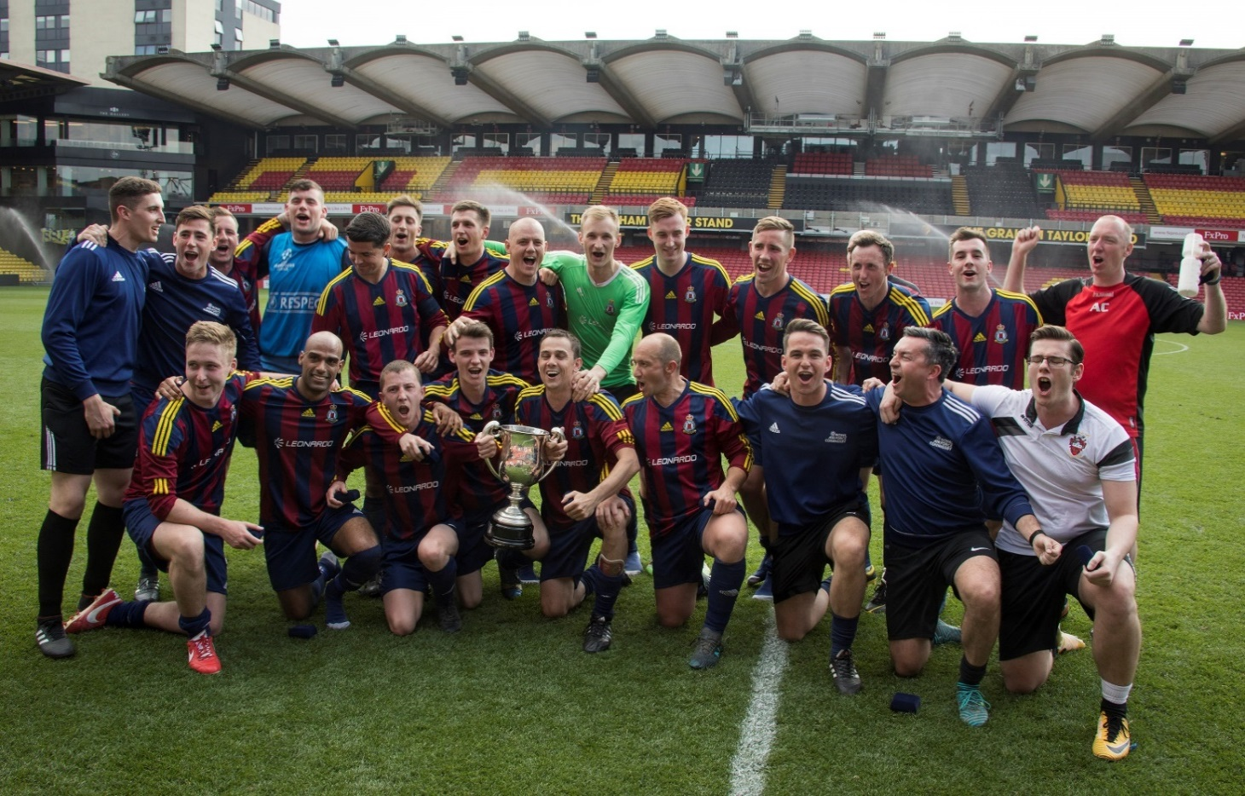

RAF FOOTBALL ASSOCIATION SPONSORS

