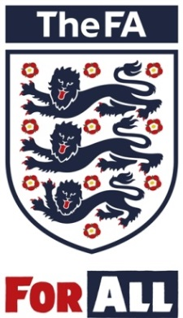
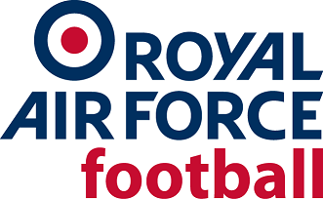
MEDIA RELEASE
Thursday 23 May 2019

THE ROYAL AIR FORCE FOOTBALL ASSOCIATON WINS AT 2019 COUNTY FA RECOGNITION AWARDS

The Royal Air Force Football Association [RAF FA] has landed the Special Recognition award at the inaugural County FA Recognition Awards for its Taking Football to Africa and Beyond Charitable Appeal.

The Awards were introduced this year to recognise and endorse the best projects, products and services launched by County FAs over the past season while sharing best practice and learnings from around the country.

From the 50 County FAs operating across England, 39 of them entered over 150 submissions, highlighting continuous improvements and showcasing how they are innovating to improve football and increase participation across all levels of the game.

The eight categories recognised on the night were:

- Brand Engagement
- Digital Engagement
- Diversity & Inclusion
- Football Development
- Insight & Data
- Partnership
- Women & Girls
- Special Recognition.

The RAF FA was handed the Special Recognition Award for its Taking Football to Africa and Beyond Charitable Appeal. The Appeal is operated from RAF Shawbury, near Shrewsbury in Shropshire by the RAF’s current FA Council member, Wing Commander Neil Hope MBE. The Appeal was started in 2006 with the intent of delivering ‘Aid through Football’ to less privileged adults and children in Africa and across the world, utilising kits no longer needed in England. Kits and footballing items are donated by people, clubs, leagues and County Football Associations (CFAs) across England and are then re-distributed worldwide through the RAF based Appeal. Items have been donated by The FA, clubs from the Premier League through the football pyramid to grassroots, CFAs and many schools and people. To date over 226000 items of kit, including over 66500 shirts to 57 countries worldwide. In 2018, 34 deliveries were made delivering over 31500 items to 19 countries.

Wg Cdr Neil Hope said: "It was an honour to receive this recognition on behalf of RAF Football and I’m proud of the hard work our entire team puts in. This Appeal is globally reaching and provides ‘aid through football’. It utilises the love of football across the world whilst promoting English football and the RAF."

FA Chief Executive Martin Glenn added: "It gives us great pleasure to recognise and reward our County FAs. The work they do in their local communities to inspire a lifelong journey in football are absolutely vital in ensuring we continue to develop, promote and protect the game.

"It’s testament to their work that we now have the highest number of boys playing affiliated football recorded to date, and we are well on track to deliver on our ambition to double participation in the female game."
For more information on the work of County FAs, visit www.thefa.com

[ENDS]

For further information, please contact: Aaron Bains Corporate Communications Manager Aaron.Bains@thefa.com / 07970 739307 or Wg Cdr Neil Hope neil.hope684@mod.gov.uk 07903135508

About The FA

The Football Association [The FA] is the not-for-profit governing body of football in England. It is responsible for promoting and developing every level of the game, from grassroots through to the professional game, and successfully generates enough revenue to support the investment of well over £100m into English football each year.

The FA oversees 28 England international teams, across men’s, women’s, youth and disability football, as well as running FA Competitions, including the Emirates FA Cup and SSE Women's FA Cup, and the world-class facilities of Wembley Stadium and St. George’s Park, all with a purpose to Unite the Game and Inspire the Nation.

