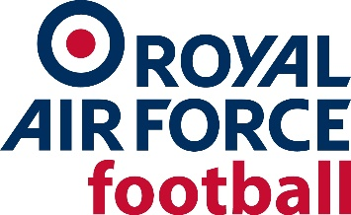

RAF FA AWARD NOMINATION FORM
Name of person submitting Nomination
Contact Details

Full Name of individual being Nominated *
Rank *
Email Address *
Home Address *
* Mandatory
Service Record: (if known e.g. length of service; branch/trade; postings; etc.)

Award individual is being Nominated for:

Please tick
Lifetime Achievement

Outstanding Contribution to RAF Football

Special Recognition

Note: The RAF FA Awards Panel may change the award type for the nominated individual
Key Football Positions held: (Administrator / Coach / Manager / Player etc)

Where:

Dates / Length of time:

Level(s): (International / UKAFF / Rep / Trade / Stn / Sqn)

Honours/Successes:

Wider Engagement: (football activities outside of the RAF)

CITATION: (narrative to include reasons of suitability for the award highlighting breadth, depth and longevity of services to RAF FA, including the above)

ADDITIONAL SUPPORTING TESTIMONIAL STATEMENTS:
Examples:
XXXX XXXXXX – Current/Former RAF Rep Team Manager/Coach
“I met XXXXXX XXXXXXX in XXXX when he/she was (ROLE). [Supporting evidence and personal recommendation].
XXXX XXXXXX – Current/Former RAF Rep Team and UK Armed Forces player
“I met XXXXXX XXXXXXX in XXXX when he/she was (ROLE). [Supporting evidence and personal recommendation].
XXXX XXXXXX – Current/Former Station OIC/Manager
“I met XXXXXX XXXXXXX in XXXX when he/she was (ROLE). [Supporting evidence and personal recommendation].
XXXX XXXXXX – Current/Former RAF FA Board of Trustees/Executive Committee member
“I met XXXXXX XXXXXXX in XXXX when he/she was (ROLE). [Supporting evidence and personal recommendation]
XXXX XXXXXX – Current/Former RAF FA League Official
“I met XXXXXX XXXXXXX in XXXX when he/she was (ROLE). [Supporting evidence and personal recommendation]

All nominations in the first instance should be submitted to the RAF FA Secretary:
Vince.Williams@royalairforcefa.com

