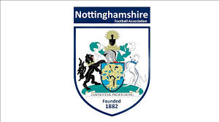
Nottinghamshire FA
Small Grants Fund

Programme overview

The Nottinghamshire FA Small Grants Fund is now available to support the upkeep of facilities for Adult 11v11 Football teams.
Nottinghamshire County FA (NCFA) now has a limited number of grants available to support the upkeep of facilities for Adult 11v11 football teams. A grant of up to £50 will be available to those clubs/teams that are successful. The Grant is intended to help clubs with areas such as, but not limited to:
- Line Markings
- Corner Flags
- Goal Net Maintenance
- Grass Seed/Ground Maintenance
For more information please email: callum.convery@nottinghamshirefa.com

Club Information
Club: Contact Number:
Charter Standard Status?: Contact Email:
Contact Name:
Please answer all the questions. Continue on a separate sheet if required
- Can you provide details on the area of maintenance that your club are looking to do?

2. What other Notts FA help could support your club with this project, if any?

Declaration
Closing date: Friday 24th November 2017
Expectation: To work with the Nottinghamshire FA to offer a safe and inclusive club environments for all.
Full Name: Date:
Signed:
Thank you for completing the application form.
We will be in contact in the near future, in the meantime, if you would like more information please do not hesitate to contact Callum Convery callum.convery@nottinghamshirefa.com

5. How would you ensure the sustainability of the team?

