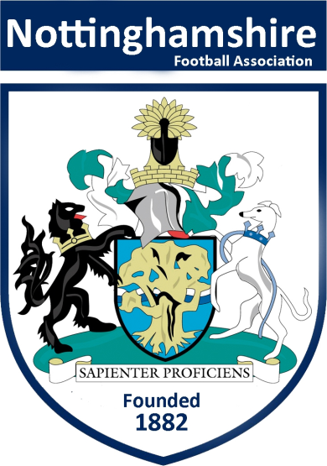

The County Association

Inclusion Advisory Group

Prospective Member Application Pack

Dear Applicant,
Thank you for reading our Inclusion Advisory Group (IAG) Prospective Member Application Pack.

Purpose
The IAG will enable Nottinghamshire County Football Association (NCFA) to meet our legal and moral obligations, allowing us to increase awareness, understanding and knowledge of inclusion, equality and diversity, so that we will better meet the needs of all of our communities who take part in football and ultimately our business.

Our role is specifically to:
1. Advance equality of opportunity amongst all our football communities
2. Foster good relationships with and between all our football communities
3. Eliminate unlawful discrimination, harassment and victimisation
4. Increase diversity in footballs’ talent pool
5. Clarify regulations and sanctions related to discriminatory behaviour
6. Enable transparency and confidence when dealing with matters related to discriminatory behaviour

In doing so we aim to:
- Utilise data to provide intelligence and give substance to our actions
- Set clear targets within our county plan to ensure this meets the needs of the whole of our football community
- Support community engagement, consultations, development programs and disciplinary procedures
- Act as Ambassadors for NCFA in our football communities
- Bring a diverse perspective to the NCFA
- Identify any equality issues, support the identification and delivery of solutions
- Promote and encourage the benefits of addressing equality issues within the football community
- Assess and advise on equality impacts arising out of county plans
- Coordinate consultation sessions with the wider community on annual county plans
- Identify key issues and trends that will promote the growth of the game through inclusion and diversity interventions
- Promote inclusion and diversity in football
- The IAG coordinator will present updates to NCFA Council as relevant and required
- Devise, monitor and evaluate CFA secondary Key Performance Indicators for inclusion and diversity
- Meet a minimum of four times a year

If you are interested and would like to apply for the position on the IAG, please complete the application form and return it by email or post along with your current curriculum vitae
Details of where to send your completed application can be found on the application form.

We look forward to receiving your application.

Kind regards

Elaine Oram
Chief Executive

Guidance on how to apply

If you are interested in applying to be a member of the County Association Inclusion Advisory Group, please complete the application form and return it by email or post, marked Private & Confidential, along with your current CV to:

IAG Co-ordinator
Mrs Elaine Oram
Nottinghamshire County FA
Unit 6b,Chetwynd Business Park
Chilwell
Nottingham
NG9 6RZ

The appointments are on a voluntary basis although relevant travel expenses may be paid in line with the County FA expenses policy.

If you require more information about the role or need assistance with your application, please do not hesitate to contact Elaine on 0115 983 7400. Conversations will be both informal and confidential.

Please note that all applications must be received by 5pm on Wednesday 31st October 2018.

A selection panel will meet following this date to shortlist those who will be required to complete an online assessment prior to being appointed to any panel.

We will be then in touch with shortlisted candidates to provide further information.

Role Profile

Purpose
To be part of an Inclusion Advisory Group whose role is to increase the diversity of football's talent pool.

Essential Skills and Experience for the Role
You will be required to:

- Recognise equality issues and identify possible solutions
- Demonstrate relevant knowledge of inclusion and diversity legislation
- Work across a broad spectrum of ethnicities and cultural backgrounds
- Build effective relationships with members of staff and members of the football community
- To be a positive team and provide direction to the NCFA Council, Directors and professional staff

Desirable Skills and Experience for the Role
It would be desirable for you to:

- Have a good understanding of grassroots football
- Bring a level of experience from the sports/football industry
- Recognise how to utilise and use appropriate and relevant social media
- Possess basic presentation skills
- Be competent in analysing data to assist in making informed decisions

Essential and Desirable Person Skills and Experience
You will be required to:

- Communicate effectively and confidently, both in written form and verbally
- Have a positive attitude towards the requirements of the role
- Handle confidential information sensitively
- Work positively as part of a team
- Act in a professional manner as a representative of the County FA
- Conduct meetings and work outside of normal working hours where required
- It is desirable to possess a good knowledge of local community groups

Application Form

Section 1 – Personal Details
Full Name

Address
Postcode
Date of Birth
Email Address
Contact Tel (Home)
Contact Tel (Mobile)
Occupation
Connection with Football
Driving Licence | Yes / No (delete as appropriate)

Section 2 – Relevant Experience
Please give brief bullet points of all experience relevant to the role, include details of any voluntary and paid experience, and how you meet the requirements of the person and role specification. (Please note the content of this section will be made available for members to view on the NCFA Website)

Section 3 – Reasons for applying
Please give brief bullet points of why you would like to become part of The NCFA IAG. (Please feel free to relate this to your career, hobbies, aspirations and philosophy)

Section 4 – Signed declaration
I confirm that to the best of my knowledge and understanding that the information on this form is correct and accurate.
Signed |  | Date

Please send your completed application form to Elaine Oram by email to elaine.oram@nottinghamshirefa.com
Alternatively you can send your application by post marked Strictly Private & Confidential to Mrs Elaine Oram at:
Nottinghamshire County FA, Unit 6b, Chetwynd Business Park, Chilwell, Nottingham, NG9 6RZ
Closing date for applications is 5pm on Wednesday 31st October 2018.

Thank you for the interest you have shown and for taking the time to complete this application form.

