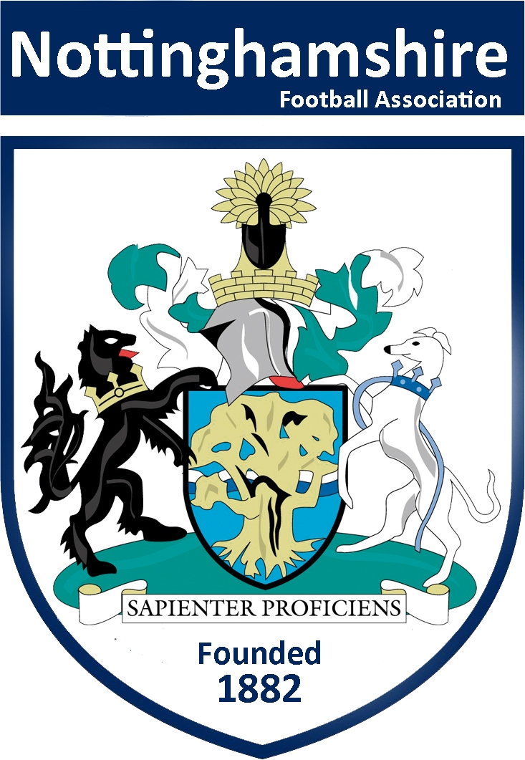

Independent Discipline Panel Member
Application Pack

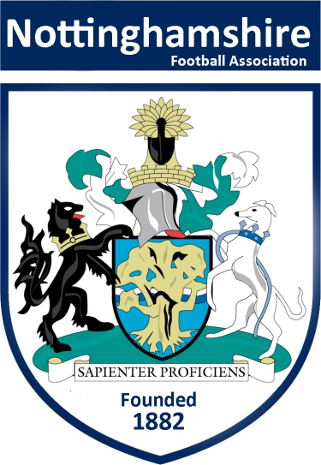

Dear Applicant,

The Nottinghamshire FA is looking for applications from individuals to be considered for the role as an independent discipline panel member.

This is to ensure that the Nottinghamshire FA’s discipline commissions are as independent and diverse as possible to reflect the changes in today’s society.

As part of this process, we are looking to create an Independent Panel of ‘football people’ to complement the existing members which we have. We are therefore seeking to appoint individuals from the Nottinghamshire football community to the Independent Panel; we are looking for a diverse group of committed individuals across the County with a variety of backgrounds and to be reflective of the local community and local football teams’.

If you are interested and would like to apply for a position on the Panel, please complete the application form and return it by email or post along with your current CV.

Details of where you should send your application back to can be found on the application form.

Training will be given prior to being appointed to any discipline commission.

We look forward to receiving your application.

Kind regards,

Adam Wing
Football Services Officer
Nottinghamshire FA

Guidance on how to apply

If you are interested in applying to be a member of the Nottinghamshire FA Independent Discipline Panel, please complete the application form and return it by email or post along with your current CV to:

Independent Discipline Panel Applications, Nottinghamshire FA, Unit 6b, Chetwynd Business Park, Chilwell, Nottingham, NG9 6RZ or by email to adam.wing@nottinghamshirefa.com

These appointments are on a voluntary basis, if successful travel expenses will be paid for any training undertaken and for any commissions completed.

If you feel you require more information about the role or need assistance with your application, please do hesitate to contact adam.wing@nottinghamshirefa.com or phone 0115 9837401. Conversations will be both informal and confidential.

Please note that all applications must be received by Monday 22nd January 2018.

A selection panel will meet following this date to shortlist those who will be required to complete in house training prior to being appointed to any panel.

We will be in touch with shortlisted candidates to provide further information.

Independent Discipline Panel Member – The Role

- To have an understanding of the Regulations of The FA and the Nottinghamshire FA relating to Discipline, although training will be given.

- To serve the Nottinghamshire FA as a member on disciplinary commissions and Boards of Enquiry.

- To represent the Nottinghamshire FA at meetings and seminars of The FA and other organisations relevant to discipline as and when required.

- To remember at all times that the cases that you will be dealing with require you to remain confidential at all times.

Independent Discipline Panel Member – Personal Characteristics

The key qualities required are:

- Ability to work collaboratively with others.

- Strong interpersonal and influencing skills.

- Patience and diplomacy.

- Knowledge of judicial/disciplinary processes (not just within football) would be desirable but not essential.

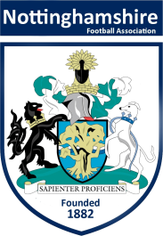

Independent Discipline Panel Members Details 2017-18

Name
Address
Telephone | Home:-
 | Mobile:-
E-Mail | Home:-
 | Work:-

Availability
Generally speaking, please indicate for each day if you are ‘Available’ or Not Available’ in the daytime and evening.
 | Daytime  (Please state ‘Available’ or ‘Not Available’) | Evening  (Please state ‘Available’ or ‘Not Available’)
Monday
Tuesday
Wednesday
Thursday
Friday

Non Personal via WebEx
(Need access to computer with Speaker & Microphone/Headphones or iPad/Tablet)
Friday 10am |  | (State ‘Available’ or ‘Not Available’)

Independent Discipline Panel Members – Conflict of Interest Form

Please list any football clubs you have been (or presently) involved with:
1.__________________________________________________________________
2.__________________________________________________________________
3.__________________________________________________________________
4.__________________________________________________________________
5.__________________________________________________________________
6.__________________________________________________________________
7.__________________________________________________________________
8.__________________________________________________________________

Please list any leagues you have been (or presently) involved with:
1.__________________________________________________________________
2.__________________________________________________________________
3.__________________________________________________________________
4.__________________________________________________________________
5.__________________________________________________________________
6.__________________________________________________________________
7.__________________________________________________________________
8.__________________________________________________________________

Name: ___________________________________ Date:______________________

Please attach any additional clubs/leagues on a separate piece of paper.
If there are any changes to this list during the 2017-18 season please advise the office on:
0115 983716 or adam.wing@nottinghamshirefa.com.
Please tell us how you meet the personal characteristics as set out previously (use a separate sheet if required)

Please tell us your reasons/motivations for wanting to be on this Panel
(use a separate sheet if required)
In addition please attach an up to date CV and return this along with your completed form to:

Independent Discipline Panel Applications
Nottinghamshire FA
Unit 6b
Chetwynd Business Park
Chilwell
Nottingham
NG6 9RZ

Or by email to: adam.wing@nottinghamshirefa.com

All forms (application form and CV) must be returned by Monday 22nd January 2018.

