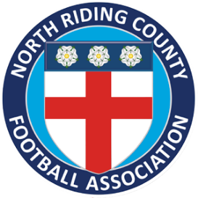
NORTH RIDING FA OFFICIAL CHARITY PARTNER 2018/19
APPLICATION FORM
Please fully complete this form to apply to become North Riding FA’s Charity Partner for the 2018/19 season. All applications should be made by an authorised representative of the charity and should be e-mailed to Jennifer.Bennett@northridingfa.com no later than Tuesday 31st July 2018.

ORGANISATION DETAILS:
ORGANISATION NAME:
ADDRESS:
TELEPHONE NUMBER:
E-MAIL ADDRESS:
WEBSITE ADDRESS:
AUTHORISED REPRESENTATIVE CONTACT NAME:
REGISTERED CHARITY NUMBER:

APPLICATION QUESTIONS
- What is the aim of your charity? (Max 150 words)

- What impact would the support of North Riding FA have on your charity? (Max 150 words)

- What would you do throughout the 2018/19 season with the support of North Riding FA to increase the profile of your charity and raise funds? (Max 150 words)

