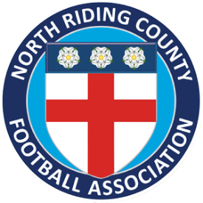
North Riding County Football Association & League’s Early Warning System
North Riding CFA are committed to supporting leagues in order to retain the teams that compete in their respective competitions. With this in mind, if a club fails to fulfil a fixture on two consecutive match days, please complete this form and return it to me. I will then make contact with the club in question to ascertain what support we can offer them in order for the team to continue competing.

League…………………………………………………………………………………………………………………………………………….

Team Name…………………………………………………………………………………………………………………………………….

Contact……………………………………………………………(Telephone)……………………………………………………………
(Email)………………………………………………………………………………………………………………………………………………

Do you know why the team has not fulfilled fixtures?
…………………………………………………………………………………………………………………………………………………………..
…………………………………………………………………………………………………………………………………………………………..
…………………………………………………………………………………………………………………………………………………………..

The earlier we can collectively address any issues teams are facing the more chance we have of keeping them involved.

Regards
Paul Campbell
07872469953
paul.campbell@northridingfa.com

