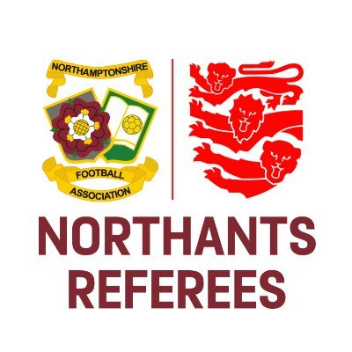
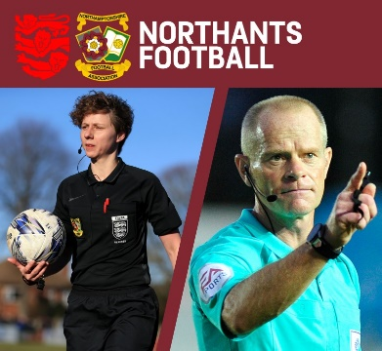
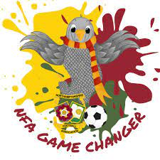

Pre-Match Instructions Guidance
(This advice is suitable for ‘neutral’ Assistant Referees only)

Referees should schedule a short amount of time before the match to speak to their Assistant Referees (ARs). These ‘Pre-Match Instructions’ should be short and sweet and cover as much as you think the ARs must know.

Remember: ARs should now know how to run the line and which signals to use in which scenario so we do not necessarily need to cover this. It is also worth remembering that ARs hear a similar thing before each match, so ensure that your delivery is informative, positive and engaging.

The Gameplan

Consider the teams that you are due to officiate and any tactics / strategies that they employ during a match. How are you and your ARs going to manage these situations? Consider their recent results and position in the league table. Could this have an impact? Is it worth asking your ARs if they know anything about either of the teams involved? The Observer might also be able to help at this stage if there is one appointed.

The Summary

It is always worth summarising your key points. A few examples are below:

- Getting the big decisions right
- The importance of working as a team
- Enjoying the game!

The Important Stuff

It is worth remembering that you may only have the attention of your ARs for a few minutes, so the quicker you mention the important things, the better.

Penalty kicks

More often than not, a penalty kick decision should be taken by the referee, as this is what people expect. Emphasise the importance of not ‘crossing’ on a decision and the likely scenarios that you might need help from an AR i.e. a blind-side handball (within a credible distance to them) or a foul close to the edge of the penalty area. What are your expectations of an AR if this happens? Contrast this with your expectations of them for a foul on the opposite side of the penalty area to them i.e. less is more. As a referee, we should be making this decision without their involvement.

Northamptonshire Football Association Limited
Registered Office: 9 Duncan Close, Red House Square, Moulton Park, Northampton, NN3 6WL
Tel: 01604 670741 Fax: 01604 670 742 Email: info@NorthamptonshireFA.com

www.NorthamptonshireFA.com

Free-kicks

It is worth mentioning the importance of ‘assisting’ and not ‘insisting’. When would you like help from an AR and when would it be credible for them to share their opinion? Emphasise the importance of the ARs intervening if you continue / restart play whilst incorrect in law i.e. a clear red card offence is committed behind your back or you issue a second yellow card to the same player without sending them off.
Northamptonshire Football Association Limited
Registered Office: 9 Duncan Close, Red House Square, Moulton Park, Northampton, NN3 6WL
Tel: 01604 670741 Fax: 01604 670 742 Email: info@NorthamptonshireFA.com

www.NorthamptonshireFA.com

Underpin all of this with the phrase ‘who does everyone expect to make the decision?’ Every decision must be credible!

Throw-ins

In a similar vein, when would you expect ARs to share their opinion about a throw-in. In front of the technical areas, do you want a quick (and potentially rushed) flag? Emphasise the importance of eye contact and ‘discreet’ leading signals to avoid them crossing with you.

The Other Stuff

Now that you have covered the important elements of your pre-match instructions, you can add any other relevant points that you wish to discuss. Some examples are below:

- Mass confrontations
- Offsides
- Substitutions and general management of the technical areas
- Blood injuries
- Anything else you wish to add

Administration

Can you use your ARs to help with your administration? Could you ask AR1 to take a list of all substitutions and misconduct and AR2 to take a list of goals? This shares the responsibility and ensures that both ARs are engaged throughout.

The Summary

Consolidate the summary that you established at the start of the pre-match instructions. Thank your ARs for their attention / help and build on the team ethic that you have already created.

As always, if you require any clarity on anything above, please don’t hesitate to contact us. Good luck in your upcoming games!

Olly Mackey
Referee Development Officer

