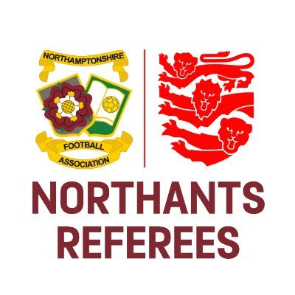
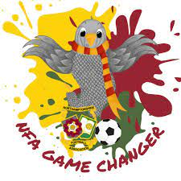

Dealing with Club Officials

We’ve all been there, with an over-excited manager in the technical area who is little bit over keen to voice their opinion on the decisions we are making. If this situation escalates and you as the referee end up taking further action, as you are more than entitled to do, we need to make sure we are doing it the right way.

We would advise using a ‘stepped approach’ in a similar way that you manage players. Ideally this should look something like: Quiet Word, Public Rebuke, Caution, Dismissal. However, it is important to know what the Laws of the Game stipulate for coaches and managers. Law 12 – Fouls & Misconduct – clarifies the various offences for team officials and the relevant outcome (warning, caution, sending-off). Please ensure you aware of Law 12 when it comes to Managers, Coaches and other relevant team officials e.g. Physios.

Law 5 – The powers & duties of the referee – states that:

“The referee takes action against team officials who fail to act in a responsible manner and warns or shows a yellow card for a caution or red card for a sending-off from the field of play and its immediate surrounds, including the technical area; and if the offender cannot be identified, the senior coach present in the technical area will receive the sanction. A medical team official who commits a sending-off offence may remain if the team has no other medical person available, and act if a player needs medical attention.”

Please make sure that we are being fair and reasonable when dismissing a club official from the field of play and its immediate surrounds. If the club official in question is the designated physio, you can’t force them to leave, but their behaviour does still need to be reported to the NFA and must mention the fact that if they weren’t the physio, you would’ve sent them away from the technical area.

As always, if you would like any further clarification, please don’t hesitate to contact us.

Good luck in your upcoming games!

Olly Mackey
Referee Development Officer
Northamptonshire Football Association Limited
Registered Office: 9 Duncan Close, Red House Square, Moulton Park, Northampton, NN3 6WL
Tel: 01604 670741 Fax: 01604 670 742 Email: info@NorthamptonshireFA.com

www.NorthamptonshireFA.com

