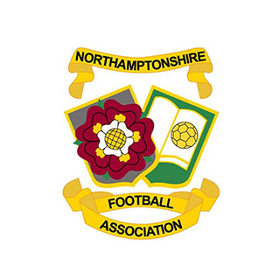

Northants FA Photography Competition - Entry Form
NAME:

CLUB:

CONTACT:

COMPETITION ENTRY (Adult or Youth):

RULES, USE OF IMAGES & DISCLAIMER
No photo should contain people in any form. Any entries that do will be discarded. When submitting an entry all entrants understand and agree that any image submitted to the competition may be used by Northants FA for marketing and promotional purposes. All entrants must disclose the club they are representing and the club needs to have been affiliated with Northants FA during the 2018/19 season.
Participants represent and warrant that (1) the photographs are original and that they own the rights to their photographs, (2) the photographs do not violate the rights of any third party, (3) any additional information they submit about the photographs is accurate.
WINNER NOTIFICATION
The winners in each category will be notified before the official announcement and arrangements will be made for a presentation of the prize.

HOW TO ENTER
To enter, please send your chosen photograph and a completed version of this entry form to CompetitionEntry@NorthantsFA.com

The competition closing date is Friday 14 June. Any entries received after this date will be deemed ineligible for the competition.

