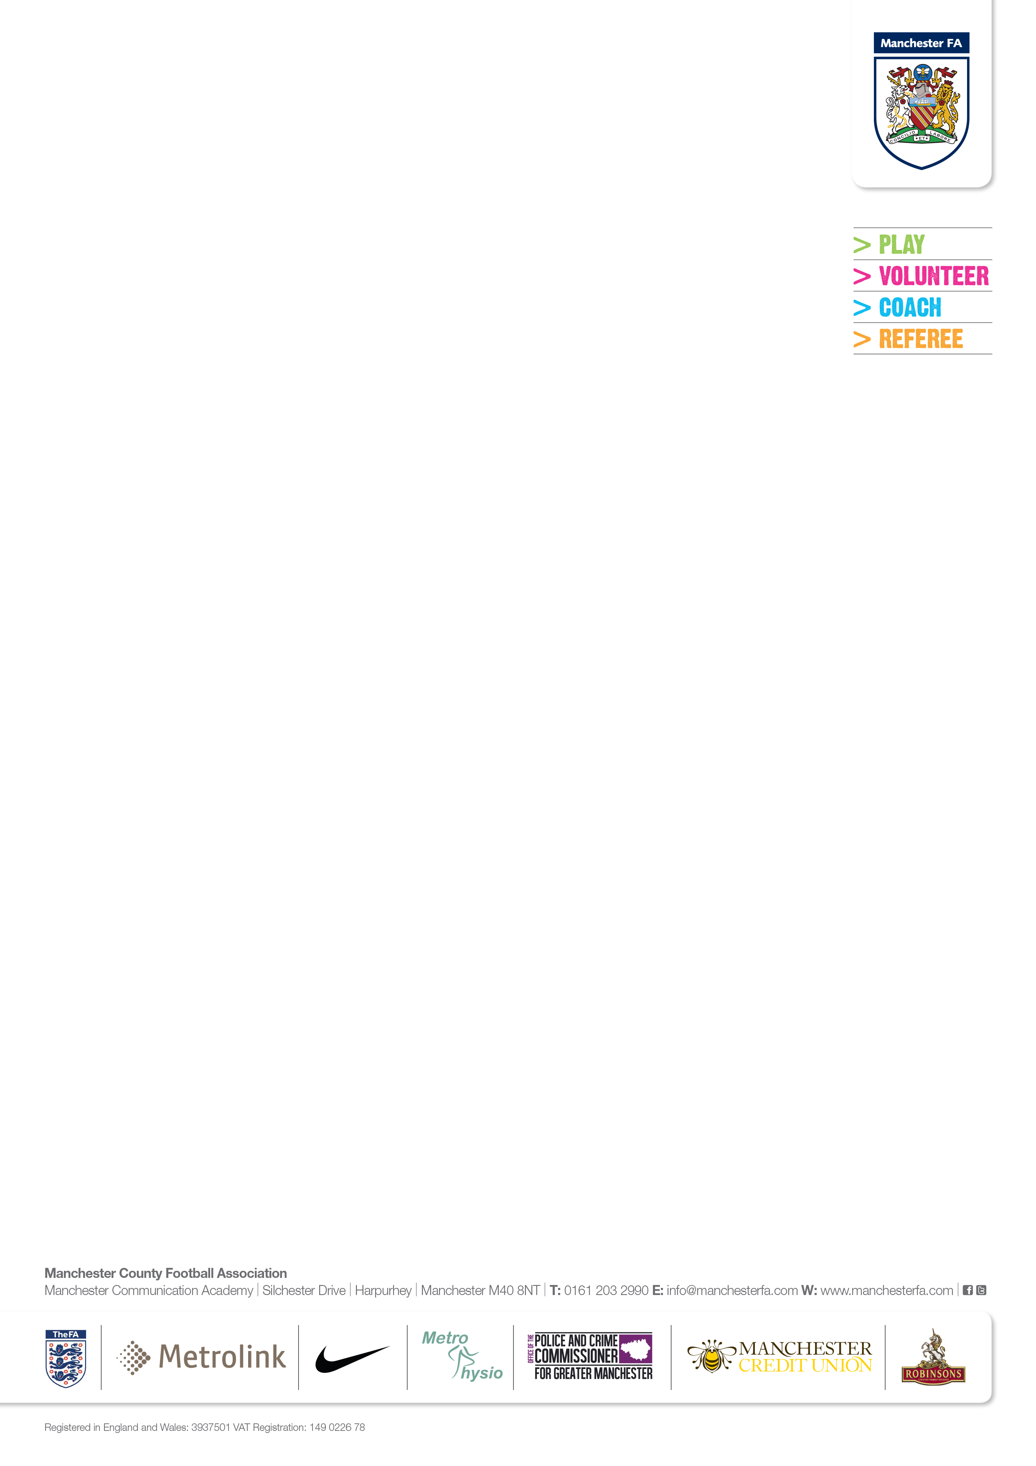



**TOURNAMENT SANCTION FORM 2017 - MEMBERS**

## Please use ‘Block Capitals’ and complete in full and return to Manchester FA at the address below.

## If the competition is being run for a nominated charity, please complete the Charity Number below.

# Charity Number:­__________________

**Tournament Details**

Tournament Name:

Tournament Venue:

Date(s) of Tournament:

**Club Details**

Club Name:

Secretary:

Address:

______________________________________________________________________________

Postcode: Tel No (Home):

Tel No (Work): Mobile No:

**A COPY OF THE RULES, PUBLIC LIABILITY INSURANCE, TEAMS PARTICIPATING AND REFEREES OFFICIATING MUST BE RETURNED WITH THIS FORM.**

Charges may be raised against any competition found to be contravening FA Rules.

# Signed (Secretary):

# Date:

**Manchester FA | Platt Lane Complex | The Complex Building | Yew Tree Road | Fallowfield | Manchester | M14 7UU**

**Registered in England & Wales: 3937501 | VAT Registration: 149 0226 78**