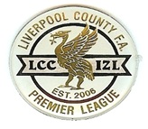
The North West Combined Counties Referees Pool

Referees Appointments Officer.
Season 2024-25

Applications are invited for the above mentioned apppointment, to commence prior to the start of the 2024-2025 Football Season.

The Referees Appointments Officer will be responsible for the appointing of Referees to cover games played in the North West Counties Football League, The Cheshire Football League, and the Liverpool County Premier League.

Initially, applicants should send a brief CV, of their involvement in football in the North West area, to the Pool Secretary, Phil Platt, email address philplatt@live.co.uk

Closing date for applications is Sunday 31st December 2023

After this application period, a number of interviews will be held to determine the best applicant, for the role. A suitable honorarium will be paid.

Phil Platt.
North West Combined Counties Referees Pool Secretary.
9th November 2023.

Manchester, Merseyside and Cheshire Referees Pool

