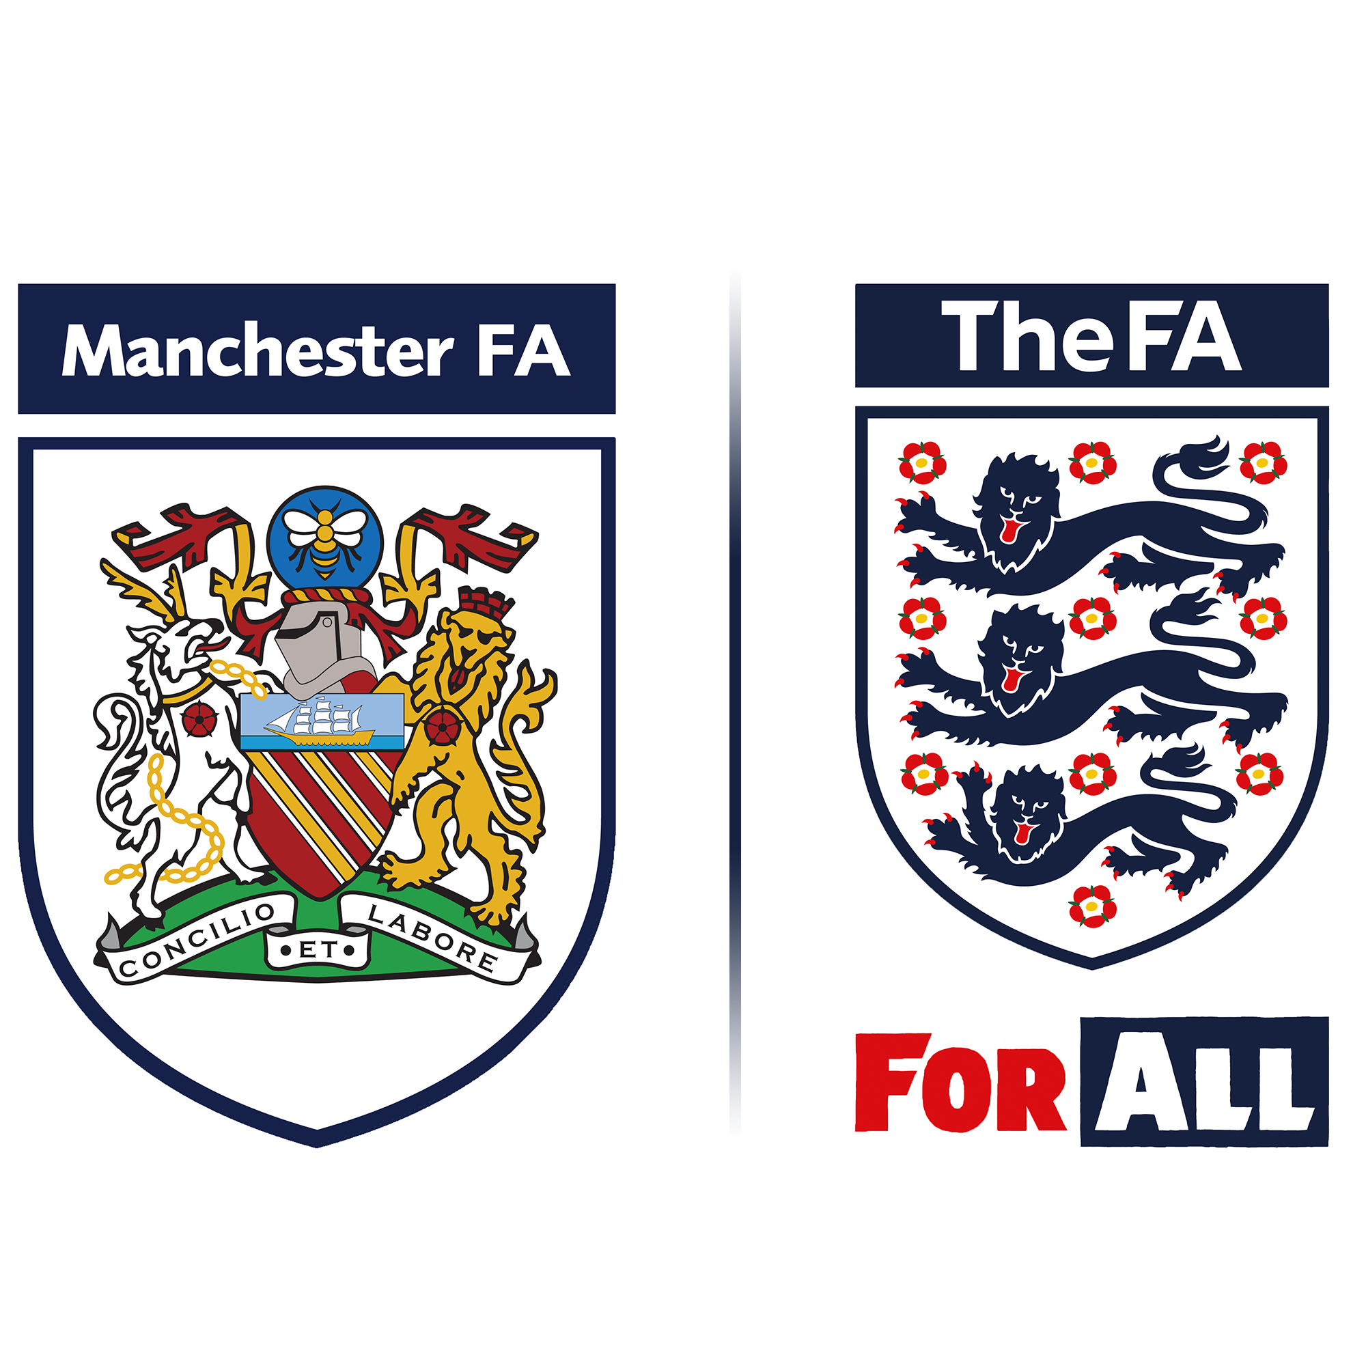

Manchester Football Association

Member Information Pack:
Women & Girls Football in
Greater Manchester

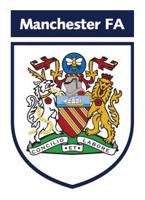
Manchester FA
Women & Girls Football
Our Game In Manchester

An introduction from the
Independent Chair of Women & Girls Football

At Manchester FA, we are looking to recruit a group of passionate and inspiring individuals to join our Women and Girls Working Group (W&G WG). The group will be chaired by Independent Member, Kate Ramsey, and said; “Together with the Women and Girls Football Development Officer (FDO) Kath Jones I am now looking for volunteers to join this group. You may be excited about this opportunity to contribute to the development of Women’s and Girls’ football in Greater Manchester – in which case, we would love to hear from you!”

Members of the W&G WG will identify opportunities to support the hundreds of volunteers already committed to developing the game here in Greater Manchester. You will also get the opportunity to enhance your knowledge of The FA’s strategy, and to contribute to shaping the future of the female game.

The roles are voluntary, and will assist the FDO strategically and help to support the development of our broad football offer for female participants. We are looking for individuals who have a credible knowledge and understanding of Women’s and Girls’ football and have a passion for grassroots football within Greater Manchester. We anticipate that the group will meet bi-monthly and members of the group will actively contribute to Manchester FA’s goal to support the national target of doubling participation in female football.

With the recent changes that have taken place at Manchester FA, including the removal of Council and the advent of ‘Our Game in Manchester’, this truly is an exciting, but challenging opportunity to be part of a local group that would be nationally recognised. Manchester FA is highly regarded by both The FA and grassroots participants for leading change. The aim of Our Game in Manchester is to ensure that the governance and development of the game is undertaken with and from the football community within Greater Manchester, and you could be part of this.

To join the W&G WG you must be able to demonstrate our three core business values of; passionate, inspiring and professional.

We have put together a pack which includes the following:

- Member Role Profile
- The Terms of Reference of the Women and Girls Working Group
(This is a draft which will be finalised by the group, once established)
- The Application Form

The pack provides all the necessary information that you require to submit an application. Should you have any questions about the role or require clarity on the information pack, you can contact Kate Ramsey on 07714 203243 or Kath Jones on 07525 790272.

Manchester FA
Members of the Women & Girls Working Group

Voluntary/Expenses

We are looking for dynamic, self-motivated individuals with a ‘can do’ attitude who want to make a positive contribution to Women and Girls Football in Greater Manchester by joining the new dedicated Working Group (W&G WG).
Members of the W&G WG will work alongside the Football Development Officer for the Women and Girls game. The group will meet at least quarterly and members will work strategically to ensure effective and cohesive delivery of our broad football offer for female participants, making Women and Girls football in Greater Manchester the very best it can be. The successful applicants will need to be able to demonstrate their commitment and experience within Women and Girls football and their ability to deliver Manchester FA’s three core values of; ‘passionate, inspiring and professional’.
What can we offer?
- An exciting opportunity to be part of a forward thinking, progressive business.
- The chance to work with key stakeholders within both the grassroots and professional game.
- A commitment to personal development.

How to apply:
Applications will be accepted upon the completion of the application form contained in this member information pack. It is essential that applicants clearly demonstrate why they wish to be involved in the working group that will be responsible for developing the women and girls game here in Greater Manchester, explaining how their experience and technical skills will assist them.
Recruitment for this voluntary role will be based on experience, the ability to fulfil the role and also the following key behavioural competencies:
- Collaborative Teamwork
- Creating Solutions
- Customer Excellence & Quality
- Influential Communication
- Inspiring Others To Succeed
The interview process:
We are looking to interview potential members and if shortlisted, you will be contacted by Kate Ramsey to arrange a suitable time to meet and discuss the opportunity.
The deadline for applications is 12 noon on Monday 12 February 2018.
As this role may involve direct access to young people under the age of eighteen, within the context of the job or any subsequently related activities or responsibilities, the successful candidate will undergo a thorough screening process, which will include a Criminal Records Check, to ensure their suitability for the role.
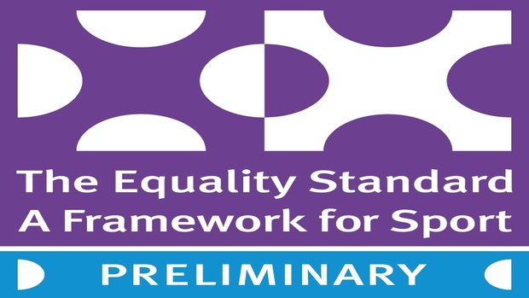

Manchester FA is committed to equality of opportunity and welcomes applications from all sections of the community.
Manchester FA
Member of the Women & Girls Working Group

Role Title: | Member of Women and Girls Working Group – Voluntary Role
1. Role Purpose
- To help support, challenge and guide the delivery of the FA’s Game Plan for Growth to double participation in Women and Girls Football.
- To provide strategic guidance to the Football Development Officer ensuring that participation opportunities are provided for players of all ages and abilities.
- To give guidance and valuable insight on the picture of football within Clubs and Leagues providing Women and Girls opportunities.
2. Principal Accountabilities/Responsibilities
Key Responsibilities
- To support the implementation of plans for mini-soccer (U7-U10) and youth football (U11-U18) across leagues, clubs and schools.
- To ensure there is a clear and accessible pathway from youth to adult female football.
- To provide guidance relating to local partnerships and stakeholder engagement to facilitate collaborative delivery.
- To check and challenge coach and referee education opportunities offered by Manchester FA to female participants, ensuring accessibility and relevance.
- To support and attend MFA meetings and events as and when required.

Strategy & Vision
- To ensure the Women and Girls Football Development Plan for Greater Manchester is comprehensive and, importantly, being delivered effectively.

3. Knowledge/Experience/Technical Skills/Behaviours
a) Knowledge/Experience/Technical Skills
Essential:  - Have credible knowledge of and experience in Women and Girls Football.  - The ability to demonstrate MFA’s three core values.  - Good IT skills and ability to interact remotely via WebEx/Skype.  - Excellent communication and presentation skills.  - Excellent interpersonal and team work skills.  - Knowledge and understanding of sports equity and equality.  - An in-date FA Criminal Records Check. |  |  | Desirable:  - Knowledge and experience of working with Manchester FA Members.  - Knowledge of League and Club Structures.  - Knowledge of The FA’s Gameplan for Growth.  - Knowledge of non-traditional organisations that support volunteers in the grassroots game.
b) Behaviours
- Collaborative Teamwork  - Customer Excellence & Quality  - Inspiring Others To Succeed |  |  | - Creating Solutions  - Influential Communication
Completed by Name/Role: |  | Colin Bridgford/Chief Executive Officer at Manchester FA

Manchester FA
Completing and returning the Application Form

Please complete the application form and return to Katherine.Jones@ManchesterFA,com on or before Monday 12 February 2018 (12 noon). Postal applications are to be addressed; Strictly Private and Confidential, For the attention of Kath Jones, Manchester FA, Platt Lane Complex, Yew Tree Road, Fallowfield, Manchester, M14 7UU.

The decision to invite you for interview will be based on the information you provide on this form. Manchester FA is an Equal Opportunities Employer.

Position applied for:
MEMBER OF THE WOMEN AND GIRLS WORKING GROUP

Personal Details

Please complete in block capitals

First Names: Surname:

Mr/Ms/Mrs or preferred title: Date of Birth:

Address:

Postcode: Email Address:

When is the most convenient day and time to contact you?

What is the best number to contact you on?

Do you hold a full current driving licence?

Do you have an in-date FA Criminal Records Check (CRC)?

If you do not hold an FA CRC, it will be a requirement for this to be completed before appointment.

Experience
Please provide details of the experience, roles, qualifications and training that you have within grassroots football or specific to the Women and Girls game.

Dates | Organisation | Role/Qualification

Why do I want to be a member of the Women and Girls Working Group at Manchester FA and how do I meet the requirements of the role?
Please outline the skills and experience that you have that are appropriate to demonstrate your suitability for the advertised role and how you would meet the knowledge, experience and technical skills required.
Please do include any paid work, unpaid/voluntary work which is relevant to the role we are recruiting for. In your application please ensure you have read and fully understand the role advertisement and the role description provided.

How do I meet the values of Manchester FA?
Manchester FA’s culture and organisational structure is built on three core values. Please provide evidential information and experiences of how you demonstrate these?

Additional Information
Manchester FA is aware of its obligations, under the Disability Discrimination Act 1995, now formally the Equality Act 2010, to carry out reasonable adjustments where needed for job applicants who have a disability. Please detail any adjustments you will require to be made, if you are invited to attend for interview.

Have you ever been convicted of a criminal offence?
(Apart from spent convictions under the Rehabilitation of Offenders Act 1974)

Are there any outstanding charges against you?

If the answer to either or both of these questions is yes, please give the date, nature of the offence and the fine or sentence (if convicted).

References
I agree that any offer of a role with Manchester FA is subject to satisfactory references. Please provide the name and addresses of two referees. If your choice of referees does not include your most recent/present employer we do reserve the right to request a reference from your last employer in place of, or in addition to the two provided below. Personal references should be given only when there is no previous employer or educational establishment to which reference can be made.

 | First Referee | Second Referee
Name:
Address:
Postcode:
Telephone:
Relationship to you:

Declaration
I give my consent to the storage of personal data contained within this form for the purposes only of this application process. I can confirm and declare that the information provided on this form, to the best of my knowledge is complete, accurate and not misleading.

*If returning this application form by email, please ensure your signature is scanned and inserted in the signature box below.

*Signature:

Date:

Please complete and return your application form before 12 noon on Monday 12 February 2018 to:

Katherine.Jones@ManchesterFA.com

Or:

Strictly Private & Confidential
Kath Jones, Women & Girls Football Development Officer,
Manchester FA, Platt Lane Complex, Yew Tree Road, Fallowfield, Manchester, M14 7UU

