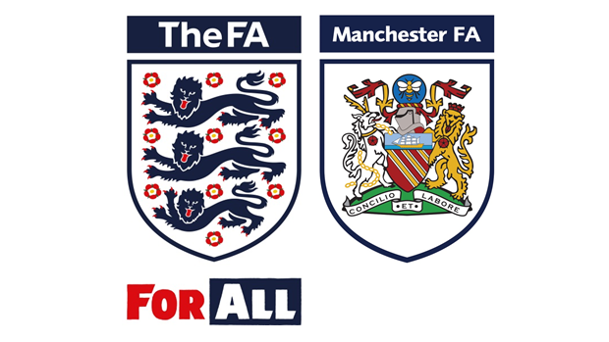
Manchester Football Association

Independent Disciplinary Panel Member Application Pack

Manchester FA
Independent Disciplinary Panel Member
Voluntary / Expenses
We are looking for dynamic, self-motivated representative individuals with a passion for football to join an already diverse team of Independent Disciplinary Panel Members for cases within Greater Manchester.
The role will work alongside the Football Administration Officer (Discipline) to ensure that, by sitting as 1 member of 3, all personal and non-personal disciplinary hearings take place in accordance with FA Regulations and in a fair manner. The successful applicants will need to be able to demonstrate their ability to deliver within our County FA’s three core values; ‘Passionate, Inspiring and Professional’.
The successful applicant must also be able to demonstrate excellent communication and questioning skills.
Title: Independent Discipline Panel Member
Hours: Appointments taken on case by case basis
Working Location: Non personal hearings can take place using an FA Chat system call Webex so the candidate can work from home. Personal hearings vary around Manchester on a case by case basis.
Specific Duties:
- To deal with disciplinary procedures in accordance with the Rules and Regulations of The FA and Manchester FA
- To have an understanding of the Regulations of The FA and Manchester FA relating to Discipline, although training will be given.
- To serve the Association as a Member of the Disciplinary Commissions and Boards of Enquiry.
- To represent Manchester FA at meetings and seminars of The FA and other oganisations relevant to discipline as and when required.
- To remember that the cases that you will be dealing with will require you to remain confidential at all times.
What can we offer?
- An exciting opportunity to be part of a forward thinking, progressive business.
- To work with key stakeholders within the grassroots and the professional game.
- A commitment to empowered and supportive personal development.

How to apply:
Applications will be accepted upon the completion of the application form contained in this recruitment pack. It is essential that applicants clearly demonstrate their ability to meet the requirements of the role, explaining how their experience and technical skills will assist them.
Recruitment for the voluntary role will be based on both the technical ability to fulfil the role and also the following key behavioural competencies:
- Collaborative Teamwork
- Creating Solutions
- Customer Excellence & Quality
- Influential Communication
- Inspiring Others To Succeed

Criminal Records Check - As this role may involve direct access to young persons under the age of eighteen, within the context of the job or any subsequently related activities or responsibilities, the successful candidate will undergo a thorough screening process, which will include a Criminal Records Check, to ensure their suitability for the role.

Manchester County FA is committed to equality of opportunity and welcomes applications from all sections of the community. Manchester County FA’s Equality Statement is available on request.

Independent Disciplinary Panel Member Application Form
Name:
Address:
Contact Number (Daytime):
Contact Number (Home):
Contact Email:
Are you currently employed?  Please delete accordingly | Yes / No / Retired
Do you have access to a PC/Tablet with microphone and speaker?  Please delete accordingly | Yes / No
Please give a general indication of your daytime availability:
Please give a general indication of your evening availability:

Please return this form together with your CV by no later than
31st January 2019
All applications submitted will be treated confidentially.
Please send them marked ‘Private and Confidential’ to:
Independent Disciplinary Panel Applications, Manchester FA, Manchester Tennis & Football Centre, 9 Sportcity Way, Etihad Campus, M11 3DU or by email to: Paul.Roots@ManchesterFA.com
Personal Characteristics
Please tell us how you meet the behavioural competences…
Please tell us your reasons/motives for applying for this role

Independent Discipline Panel Member Conflict of Interest Form
Please list any Clubs that you are involved with for the 2018/19 season

Please list any Leagues that you are involved with for the 2018/19 season

Please list any Clubs or Leagues you have been involved in over the past 10 years

