
The FA Football Development Programme

FOOTBALL DEVELOPMENT TOOLKIT
Development Plan

Seasons 20 |  | / |  | to 20 |  | /

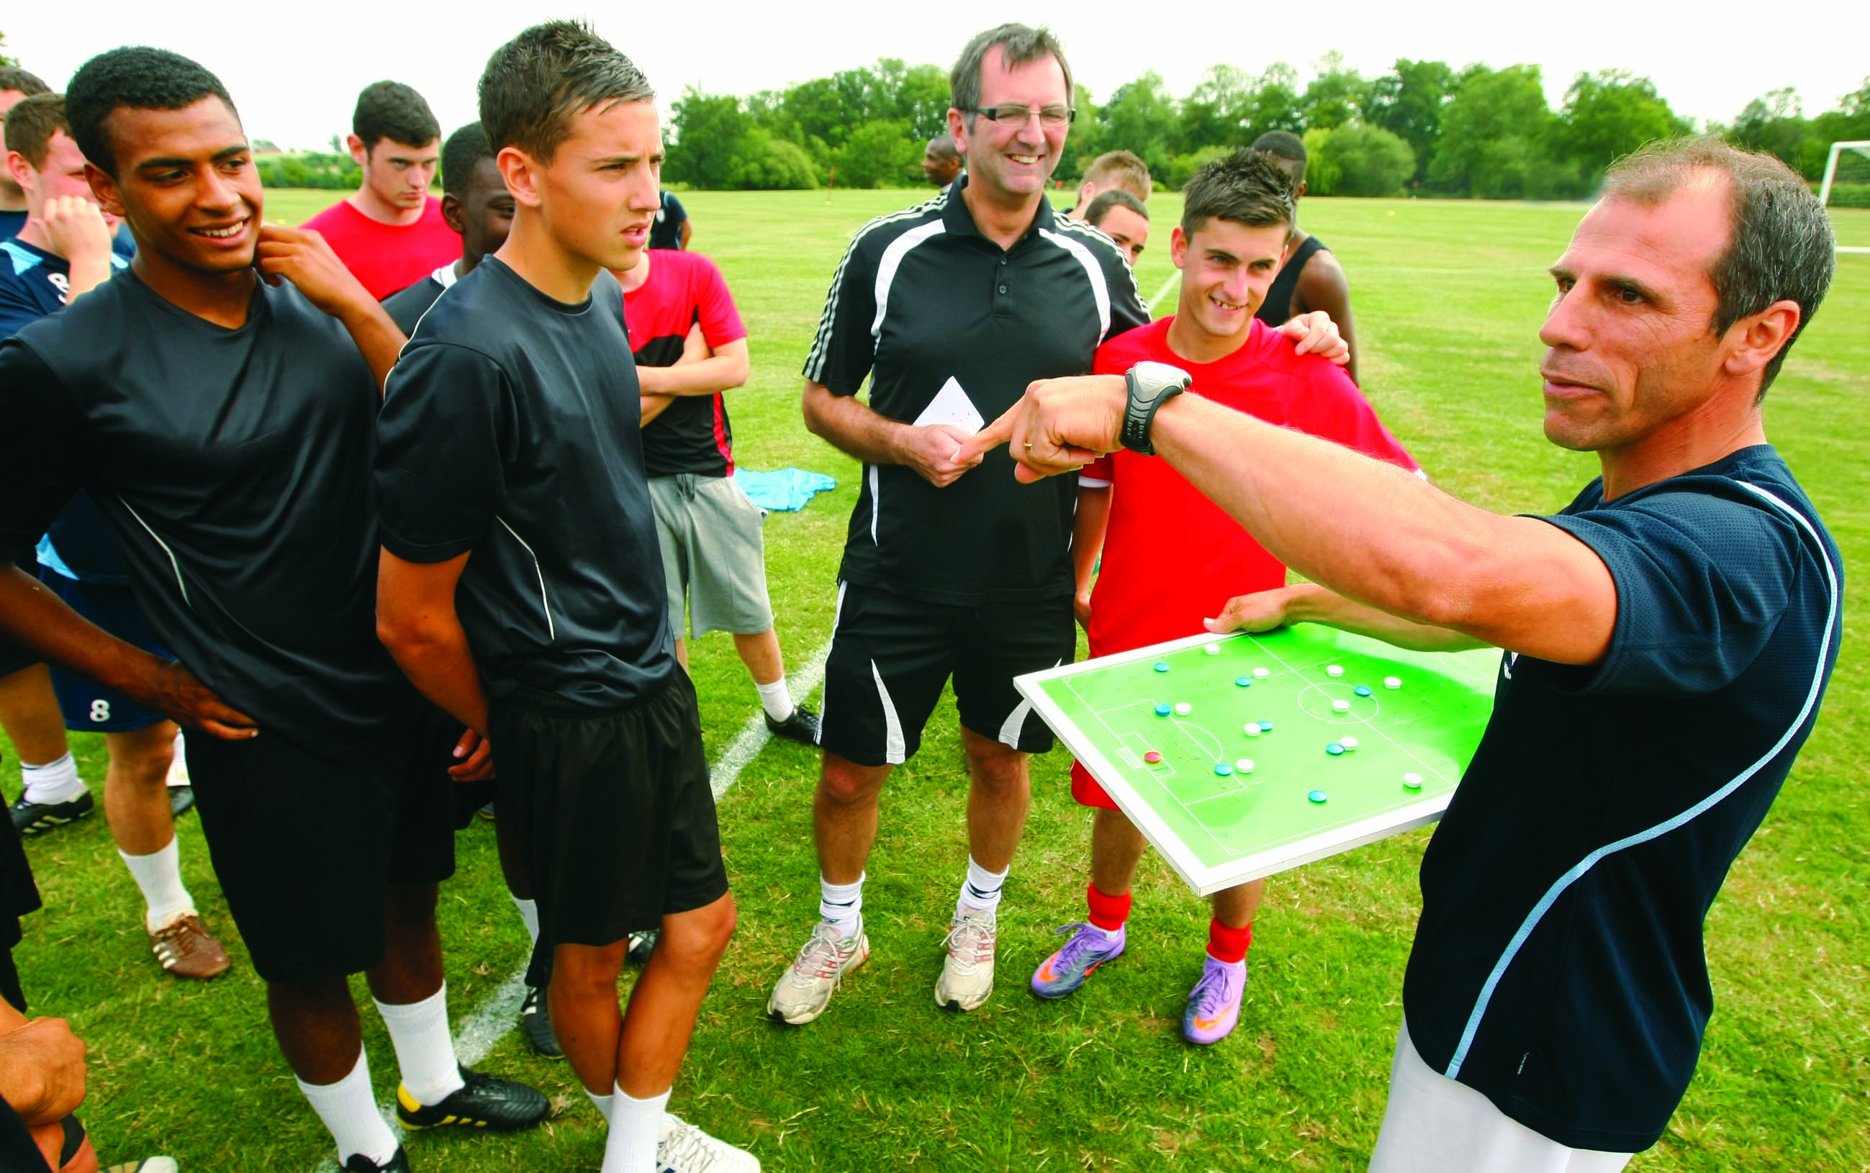

YOUR VISION
CLUB DEVELOPMENT TABLE

Develop a shared vision that is representative of the full club, not just one person! By involving as many people as you can in your organisation you can establish a ‘shared vision’ that is representative of your members and clearly identifies your purpose. By selecting one vision, you add focus and clarity.
Remember to complete the season date and identify the number of teams for each season.

 | Current season |  |  | Year 1 |  |  | Year 2 |  |  | Year 3
  20 |  | /
  20 |  | /
  20 |  | /
  20 |  | /
No. of teams
 | Male | Female | Disability | Male | Female | Disability | Male | Female | Disability | Male | Female | Disability

GROWTH AND RETENTION
Aim:
This section identifies how the club plans to retain and grow provision and develop flexible club formats that will support existing players and introduce new male, female and disabled players from diverse communities into football.

 | Objective | Achievement targets | Timescale | Responsibility | Costs
1
2
3
4
5

 | Objective | Achievement targets | Timescale | Responsibility | Costs
6
7
8
9
10

RAISING STANDARDS AND ADDRESSING ABUSIVE BEHAVIOUR

Aim:
This section identifies ways in which the club can create a fun and safe environment for everyone involved in its structure. This includes how the club will raise standards of behaviour and ensure a safe and positive environment for children and vulnerable adults.

 | Objective | Achievement targets | Timescale | Responsibility | Costs
1
2
3
4
5

 | Objective | Achievement targets | Timescale | Responsibility | Costs
6
7
8
9
10

BETTER PLAYERS
Aim:
This section identifies how the club will support every player to realise his/ her potential - in particular support the development of skills at a younger age. The five to eleven year old group is absolutely crucial to embedding basic skills, enhancing enjoyment of the game, developing healthy lifestyles and creating a new generation of talented players.

 | Objective | Achievement targets | Timescale | Responsibility | Costs
1
2
3
4
5

 | Objective | Achievement targets | Timescale | Responsibility | Costs
6
7
8
9
10

RUNNING THE GAME

Aim:
This section focuses on the identification of ways to improve the efficiency and effectiveness of how the club is run.

 | Objective | Achievement targets | Timescale | Responsibility | Costs
1
2
3
4
5

 | Objective | Achievement targets | Timescale | Responsibility | Costs
6
7
8
9
10

WORKFORCE DEVELOPMENT

Aim:
This section looks at how the club will recruit, train, and develop the workforce that will support the administration, development and promotion of the club.

 | Objective | Achievement targets | Timescale | Responsibility | Costs
1
2
3
4
5

 | Objective | Achievement targets | Timescale | Responsibility | Costs
6
7
8
9
10

FACILITY DEVELOPMENT

Aim:
This section identifies the facilities required by the club to sustain and increase participation.

 | Objective | Achievement targets | Timescale | Responsibility | Costs
1
2
3
4
5

 | Objective | Achievement targets | Timescale | Responsibility | Costs
6
7
8
9
10

PROMOTION

Aim:
Marketing and PR communication campaigns can play a significant role in helping deliver the key messages of the club around raising standards and safety in the youth section together with promoting the club to its membership and potential new sponsors.

 | Objective | Achievement targets | Timescale | Responsibility | Costs
1
2
3
4
5

 | Objective | Achievement targets | Timescale | Responsibility | Costs
6
7
8
9
10

