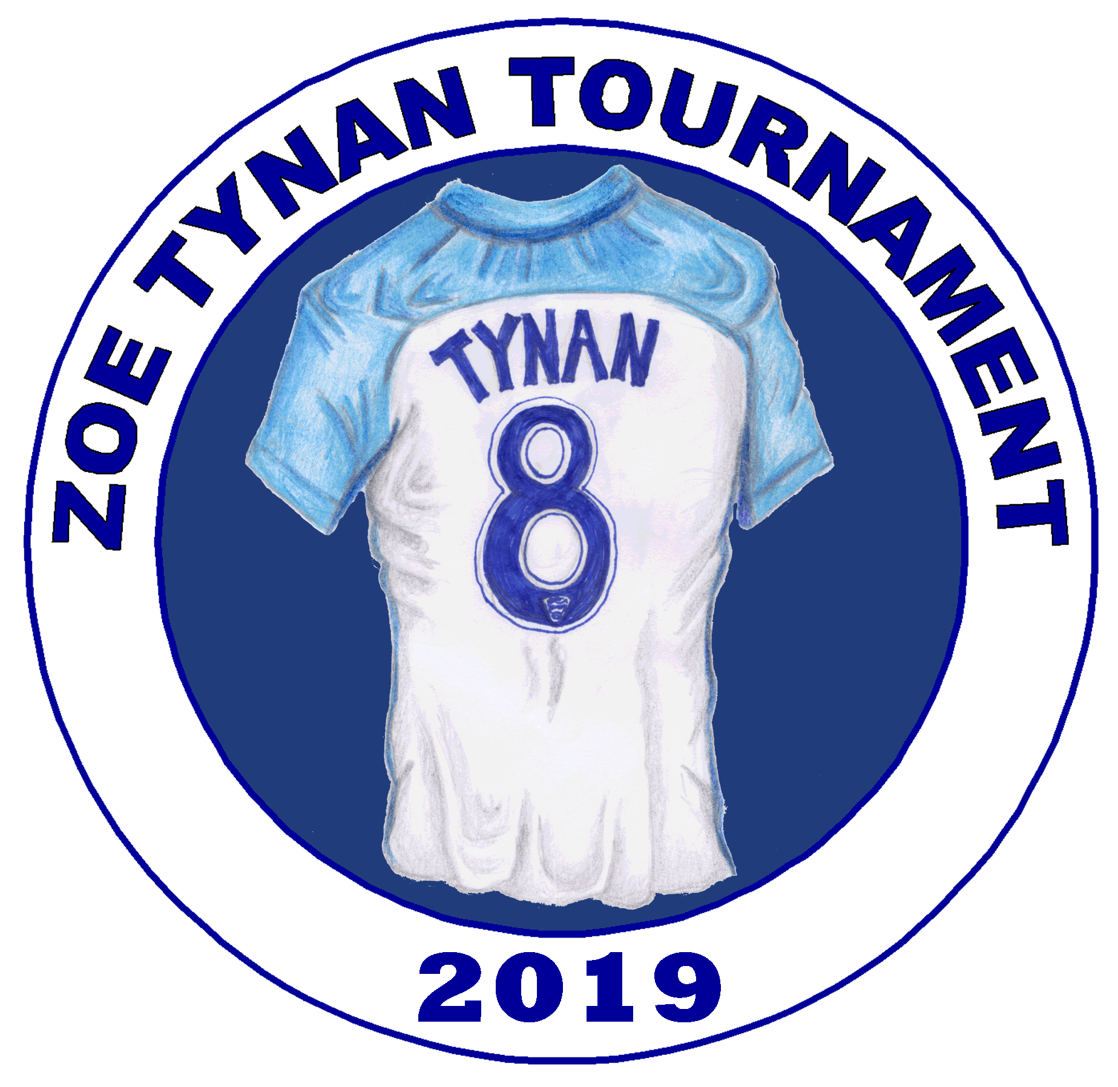

ZOE TYNAN TOURNAMENT
2022
Tournament secretary | Sue Carmichael | 07809150015
Club Treasurer | Janie Moore | 07834164370
Applications to:  10 DEEPFIELD RD  WAVERETREE  LIVERPOOL L155BX | Email return to foxtb0905@gmail.com

SATURDAY MAY 21st 2022
Under 10 , 12 & 14 7 a side
JERICHO LANE Football hub L17 5AR
Register 10 am - Kick off 10.30am.
Team name & AGE
Contact name

Contact address
Contact email
Contact phone
Team manager name
Team manager contact on day
Team kit colours
County FA and number

League for 2021/22 season

Signed

Please make a payment of £50 per team ( cheque to Liverpool Feds or BACS payment to Liverpool Feds 60 – 01 – 11 43182453 ) and return via to the above address or email to foxtb0905@gmail.com by March 21st 2022 Each team will have 4 games in a league of 5 and then compete for either the Cup or Plate in in the afternoon .ALL GAMES ON 4G ASTRO

