Dear Customer,

Following the announcements in Parliament on Thursday 1st October, I would like to update you on the restrictions which will be in place on all sports pitches operated by St.Helens Borough Council from midnight on 2nd October 2020 until further notice. Can I also ask this correspondence is shared with all officials and participants.

Spectators attending matches.

In line with Government and National Governing Body guidance the following applies;

• No spectators are allowed to attend any adult match or training session taking place on St.Helens Borough Council operated sports pitches. Only the referee, players and coaches / manager of each team should attend matches. Please leave promptly at the end of the session/fixture.

• For junior (under 16 years of age) training and matches, a maximum of one parent or guardian will be allowed to attend with their child for the duration of their session/fixture. Please leave promptly at the end of the session/fixture.

We understand that this request may cause some inconvenience, but this is made to enable the safe continuation of grass roots sport in the borough.

We would also like to remind teams that where we have pavilions/facilities on site these remain closed or accessible for use of the toilets only. Changing rooms and showers remain closed. Anyone entering the building needs to scan the QR codes clearly displayed in the communal areas to access the NHS Track & Trace app. Organisers are requested to continue to maintain a record of all in attendance for the purpose of track and trace should this information be required.

If you have any questions about the information above please do not hesitate to contact: Ian Grice Sports Facility Manager - Sutton Leisure Centre & Outdoor Facilities via email - iangrice@sthelens.gov.uk

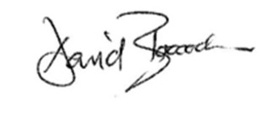
Yours sincerely

David Boocock
Service Manager – Libraries and Leisure

