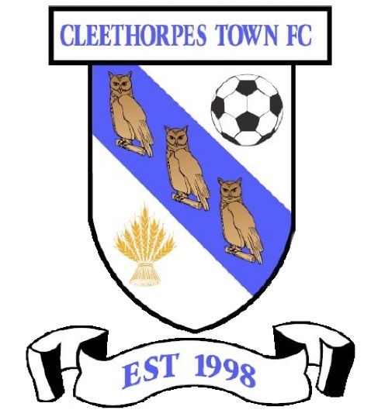
Cleethorpes Town Girls Football Tournament 2020
Linden Homes Club, Clee Road, Grimsby, DN32 8QL
Saturday 13th June
Under 10/12/13/15
All matches are 5-a-side

Maximum Squad Size: 8 Players
Maximum 12 Teams Per Age Group

Entry Fee is Just £30! (2 teams £50)

Total game time reflective of maximum time allowed under FA rules

On-Site Car Parking £2 per day
On-Site Catering and Club House
Bouncy Castle, stalls etc.
Updates, news and offers will appear on www.cleethorpestownfc.co.uk nearer the date
-----------------------------------------------------------------------
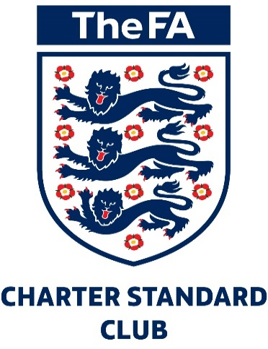
Club Name……………… …………………Age Group(s)…………………………
Affiliation Number… …County FA Affiliated…………….
Organisers Address………………………………………… ……………………….
Phone Number………………..……………………………………………………….
Email………………….………………………………………………………………….
Confirmation and details will be sent to your email address.

FAO Darren Cordingley, Cleethorpes Town FC, C/O The Linden Homes Club Clee Road, Grimsby DN32 8QL
Make Cheques payable to ‘CTFC 2017 LTD’ or Bacs Sort code 40-22-24 Acc No 72363755

