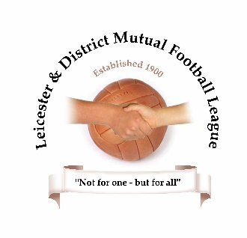

Role Description and Responsibilities
Position - CHAIRMAN
Key Responsibilities:
- Figurehead of League
- Represent League at CFA/Council meetings
- Officer Support and Recruitment of new Committee members
- Ensure League fulfils its responsibilities to safeguarding children.
- Interview new clubs
- Liaise with the General Secretary to set meeting agendas and confirm minutes.
- Being actively involved in creating and following a League development plan.
- Taking responsibility for personal conflicts of interest and declaring, recording and managing these appropriately.

Average hours per month: 3 hours
Resources required to undertake role:
- League/CFA Handbooks
- Awareness of FA/CFA/League priorities and statutory requirements to provide Mini-Soccer
Links: League Officers/County FA/Other Youth Leagues
Assistance needed: depends on experience

