Witness Statement Form
Please complete this form as fully and accurately as possible. Any information in this
form may be used in disciplinary or any other proceedings. This includes the disclosure of this completed form to any participant charged in relation to the incident witnessed. If there is any information that you do not want to be disclosed please do not include it on this form, and please note that we will not be able to use it as evidence in any proceedings.

Your details
Name Click here to enter your name
Role Click here to select your role
Club (if applicable) Click here to enter your Club
Brief description of yourself including shirt number if player, approx. age, height, build, hair/skin colour and any distinguishing features Click here to enter description

Match/training details
Date of match/training Click here to select the date
Kick off time Click here to enter the kick-off time
Venue Click here to enter the venue
Team(s) involved Click here to enter the team(s) involved

Person(s) Involved
Give the name(s) or a full description of any individuals involved to help with identification. Please provide a detailed physical description of the offender(s) including shirt number if applicable, approx. age, height, build, hair/skin colour and any distinguishing features
Click here to enter name(s) or description

Incident Witnessed
Describe exactly what happened in chronological (time) order. This must only include what you
saw or heard. Record any offensive language that you heard directly in speech marks (“ ”)
Click here to describe what happened

When did it happen? For example: immediately prior to kick-off, about 30 mins into match
Click here to enter when the incident happened

Where did it happen? Please provide specific details if possible, for example: on the spectator’s touchline near the halfway line, just outside the centre circle. Please draw or write on the blank football pitch at the end of the form if this helps
Click here to enter where the incident happened

Where were you at the time of the incident? Please confirm if your view was clear or blocked, how far you were from the incident, and include any adverse weather conditions
Click here to enter where you were in relation to the incident

Was any action taken by the referee or anyone else? If so what action was taken and by
whom?
Click here to enter details of any action taken

Did you report this to anyone? Please state who you reported this to (if anyone) and when
Click here to enter details

Please include below any other circumstances leading up to or surrounding the incident, or any other information that may be relevant
Click here to add any further information

Declaration
This statement is true to the best of my knowledge, information and belief. I understand that it may be given in evidence and used at any subsequent disciplinary proceedings.
I would be willing to attend a disciplinary hearing if required ☐(Please mark as appropriate)
Signature Enter name here (taken as signature) Date Click here to enter today’s date

Please return the completed form to discipline@leicestershirefa.com, or post to Holmes Park, Dog & Gun Lane, Whetstone, Leicester, LE8 6FA.

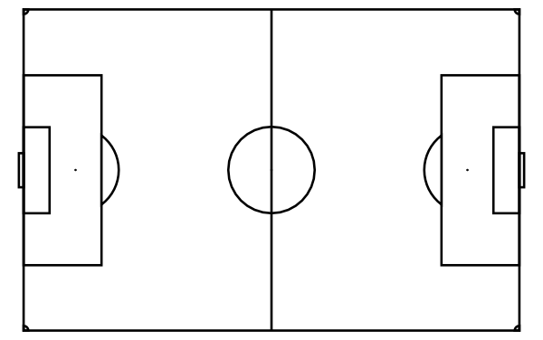

Mark on the incident/people involved and your position, and any other details as necessary.

