Lancashire FA Referees Department

FA Referee Promotions

Season 2018/19

Once again it has been a fantastic year of success for Lancashire FA officials with a large portion of our referees being rewarded for their hard work, commitment and exceptions performances with promotion to the next level. We are delighted to confirm that the following Lancashire FA officials have all been promoted to the next level in their refereeing careers:-

Promoted to Select Group Two (Championship) Assistant Referee
Richard Wild

Promoted to Level 1 (National List Referee)
Leigh Doughty

Promoted to Football League Assistant Referee
Conor Brown

Promoted to Level 2A (Panel Select League Referee)
Elliott Swallow and Lewis Smith

Promoted to Level 2B (Panel Referee)
Ed Duckworth, Richard Holmes and Peter Shacklady

Promoted to Level 3 (Contributory League Referee)
Abid Hussain, Alexander Beckett, Jordan Crossley, Mark Hughes and Matthew McQuillan

Promoted to Level 4 (Supply League Referee)
Ali Rahjoo, Cristiana Hattersley, Curtis Wood, Daniel Hooton, Joseph Wareham, Kavan Hurn and Timothy Eagles

Promoted to Level 5 (Senior County Referee)
Adam Roper, Chelsea Hodgson, Cole Collinge, Dave Martindale, Gordon Weir, Harrison Hodges, Joe Hind, Joshua Pycroft, Joshua Ridley, Lewis Walters, Luke Parker, Matthew Cooper, Matthew Moss, Paul Watson, Peter Fuller, Sam Sutton and Steven Owen

Promoted to Level 6 (County Referee)
Daniel Slater, David Boston, David Chant, George Knott, James Atkinson, James Thomas, Jamie Law, Joe Bibby, Josh Hodges, Mark Bray, Matthew Wolfendale, Morgan Yardley, Ryan Monk and Samuel Oldfield

On behalf of the Referee’s Department we would like to congratulate all of the above officials on their well-deserved success and wish them all the best for the future.

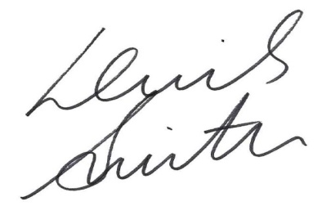

Lewis Smith Shaun Taylor
Referee Development Officer Referee Development Officer

