LANCASHIRE FA
3G ARTIFICIAL GRASS PITCHES

CONTENTS:
- PITCH HIRE TARIFFS
- CONDITIONS OF HIRE
- PERMITTED FOOTWEAR & MOVEMENT OF GOALPOSTS
- BOOKING FORM

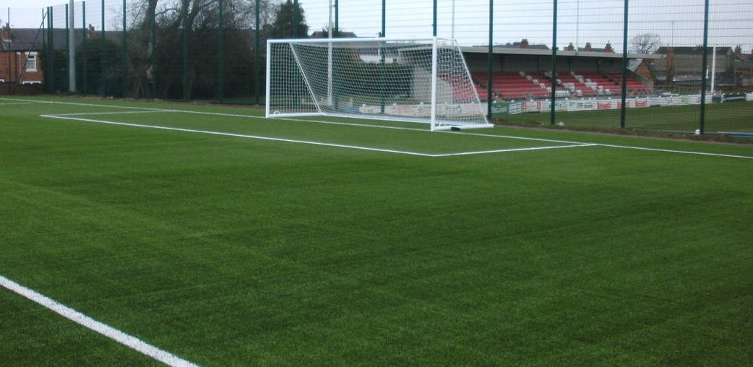

ARTIFICIAL GRASS PITCH TARIFFS
(From 1st April 2017)
STANDARD/WEEKLY PITCH FEES

PITCH REQUIREMENT | TIMINGS | CHARTER STANDARD CLUBS | OTHER CLUBS
HALF PITCH (HOURLY): | Peak times (Weekday evenings 6-10PM) | £35 | £40
 | Off Peak times (Weekdays 9am – 5pm & Weekends 9am-10pm) | £32.50 | £37.50
FULL PITCH (HOURLY): | Peak times (Weekday evenings 6-10PM) | £70 | £80
 | Off Peak times (Weekdays 9am – 5pm & Weekends 9am-10pm) | £65 | £75
GAMES – FULL PITCH FOR 3 HOURS | Full Pitch (Weekends and Evenings, for postponements etc) | £180 | £210
SMALL SIDED PITCH: | Anytime | £45 | £50

BLOCK BOOKINGS – PER 10 WEEKS

PITCH REQUIREMENT | TIMINGS | CHARTER STANDARD CLUBS | OTHER CLUBS | ALL YEAR ROUND USERS
HALF PITCH (HOURLY): | Peak times (Weekday evenings 6-10PM) | £300 | £350 | £290 peak and off peak (+ week before Christmas closure free)
 | Off Peak times (Weekdays 9am – 5pm & Weekends 9am-10pm) | £250 | £300 | £290 peak and off peak (+ week before Christmas closure free)
FULL PITCH (HOURLY): | Peak times (Weekday evenings 6-10PM) | £480 | £560
 | Off Peak times (Weekdays 9am – 5pm & Weekends 9am-10pm) | £440 | £520
SMALL SIDED PITCH: | Anytime | £360 | £400 | £350 peak and off peak (+ week before Christmas closure free)

ARTIFICIAL GRASS PITCH – GENERAL CONDITIONS OF HIRE

- The Hirer shall ensure that the only footwear permitted for use on the 3G surface is multi-studded moulded boots and trainers. Under no circumstances will blades (including rubber ones) or metal studs be allowed on the 3G surface.

- The Hirer will be responsible for supervising the behaviour of persons using the premises.

- At the end of the hiring, the Hirer shall be responsible for leaving the premises in a clean and tidy condition, with any equipment temporarily removed from their usual positions properly replaced under supervision from the site attendant.

- If the Hirer wishes to cancel a booking a booking before the date of the event, the question of the repayment of any fees shall be at the discretion of the Association.

- In the event of the facility or any part thereof being rendered unfit for the use for which it has been hired, the Association shall not be liable to the Hirer for any resulting loss.

- The Association reserves the right to refuse a booking without notice or to cancel this hiring agreement at any time either before or during the term of the agreement upon giving 7 days’ notice in writing to the Hirer.

- In the event of a major fixture (Premier Reserve League, Senior County Cup, etc.) taking place on the Association’s grass pitch, the facility must be cleared 15 minutes prior to any scheduled Kick Off time. In instances where fixtures coincide with a block booking, alternative arrangements will be made where possible. At all times, priorities will be given to block bookings.

- Priority will be given to bookings of the Association which include Development Teams, Coach Education Courses & other Training Events. At least seven days’ notice will be provided prior to such events where bookings may be affected.

- The required application and agreement must be signed and returned before the date of the first hire.

- Payment for a single booking or a weekly block booking must be paid in full prior to first use of the facility. Payments must be received by the Association’s offices prior to close of business (4.45pm) no later than on the day of first use. Should a payment not be received prior to scheduled use, the Hirer will be refused access to the facility. No payments will be taken immediately prior to the use of the facility.

- In no circumstances will the Association accept responsibility for the loss, theft, or damage of or to any goods or property of the Hirer or any visitor to the premises.

- The Hirer shall not use the facilities for any purpose other than that described in the hiring agreement and shall not sub-let the premises. They shall not do, or bring onto the premises anything, which may endanger the premises or render invalid any insurance policies relating to the premises.

- The Hirer shall indemnify the Association for the cost of repair, of any damage done, to any part of the facility or of any associated equipment, which may occur as a result of the hiring.

PERMITTED FOOTWEAR & MOVEMENT OF GOALPOSTS

Listed below is a simple user’s guide for footwear and how to move the goal posts to help ensure that the 3G Artificial Grass Pitch surfaces do not get damaged and so all users can have the benefit of this excellent facility:

FOOTWEAR
The only footwear permitted will be astro turf trainers or plastic / rubber moulded studs.
Under no circumstances will blades (including rubber ones) or metal studs be allowed on the 3G surface.

ALL FORMS OF BLADES, METAL STUDS AND SIMILAR TYPES OF BOOTS TO THOSE PICTURED BELOW ARE NOT PERMITTED AT ANY TIME

Goal Posts - Full Size Pitch
Goals can be moved as required but must be done so in the correct way.

- A minimum of two people must move the goal posts using the handles on either side of the goal.
- The goal posts should be moved via the roller on the rear of the goal posts and the roller should be unobstructed at the back of the goal to ensure easy movement.
- Small sided goal posts – Must be lifted by the handles fixed close to the uprights and
- moved via the roller on the rear of the goal posts

THE GOAL POSTS MUST NEVER BE DRAGGED ACROSS THE 3G ARTIFICAL GRASS SURFACE

Goal Posts - Small Side Pitch
The goal posts on the small sided pitch can be moved to suit the needs of the session, however please move them back to the sides of the pitch out of courtesy following your session.

If you are unsure on any of the above information please do not hesitate to contact the site
attendant who will help you where needed.

REPORTING AN ACCIDENT

Considering the nature of activities it is inevitable that accidents will occur, therefore it is important that all hirers are familiar with established methods for reporting accidents.

- Lancashire FA follows the accident procedure laid out by the Association’s Health & Safety Policy, and so any accidents must be reported at the time of the incident to the Site Attendant in charge.

- The Site Attendant can be contacted at any time during the hire period on mobile telephone number: 07738 321886

- The Site Attendant will have blank Accident Forms available. These forms should be completed by the group leader giving full, exact details of the accident and providing additional witness testimonies if deemed necessary.

- Please note that if there are subsequent developments e.g., the injured person receives hospital treatment related to the incidents, then this information must be phoned through to the Chief Executive, Simon Gerrard, who can be contacted on 01772 624000 the following day during the hours of 8.45am to 4.45pm.

