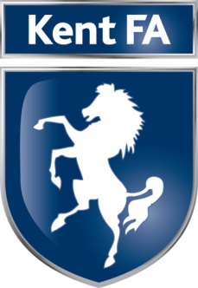

Job Title: Representative Team Manager

Line Manager: Competitions Officer/Vice Chairman Competitions Committee

Job Purpose:

- To be responsible and accountable for the day to day running of the relevant Kent FA Representative Team and to ensure the effective delivery of its Representative Football Plan.
- To be accountable to the Competitions Officer & Vice Chairman Competitions Committee on matters relating to the Kent FA Representative Team Plan including the squad on match days, coaching team, player recruitment and selection, administration of player appearances, and public relations with clubs and leagues.

Key Responsibilities:
- Running of the team on match days (from arrival to departure).
- Recruitment of team coaching staff with the relevant qualifications (CRC, emergency aid, safeguarding, Level 2).
- Co-ordinating the players and coaching staff with pre match instructions from the Competitions Officer.
- Effective working relationship with players, and parents for those under 18.
- Watching relevant league matches to monitor talent and progress of players.
- Develop and manage relationships with club managers which enhance/support the Representative Team.
- Correct communication of young players in accordance of safeguarding policies and procedures.
- Maintain a suitable player database.
- Squads announced 14 days before matches.

Essential Skills and Experience Required:

- Level 2 coaching certificate (minimum).
- Experience of managing/coaching in youth and/or women’s football.
- Attend all competitive and friendly matches as well as any training or trials.
- Ability to work with committees, club officials, players and parents.
- Demonstrate excellent communication and organisational skills.
- Understanding of Equality, Equal Opportunities, Safeguarding policies and procedures and best practice.

Desirable Skills and Experience Required:

- UEFA B Coaching certificate or higher.
- Youth Award Level 1 or higher.
- Sport/Football experience.
- Passion and knowledge of grass roots football.
- An understanding of Representative football.

