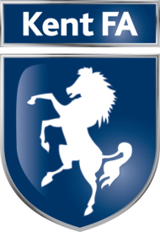

Job Title: Football Development Assistant

Line Manager: Football Development Manager

Job Areas:

- To support the Football Development department.
- To support the delivery of The FA National Game Strategy in partnership with key stakeholders.

Job Responsibilities

- Deliver and support programmes to retain and grow participation.
- Analyse and use data/insight to design customer focused services.
- Deliver a programme of services to clubs and leagues.
- Recruit, retain and develop club and league volunteers.
- Lead and support the review and delivery of competition and league structures to ensure they meet the needs of all players.
- Contribute to raising the profile and the perception of the Kent FA in leading and developing grass roots football.
- Identify, manage and develop relationships with key partners to meet the objectives and targets of the Kent FA.
- Support the marketing and communication of programmes to players and volunteers.

Job Tasks:

- Provide full administration support to the Football Development department.
- Deal with telephone and email enquiries; providing a very high level of customer service to internal and external customers.
- Provide administration support to Standing Committees and Working Groups where necessary.
- Support the administration of The FA Charter Standard programmes (clubs and leagues).
- Lead the delivery of Walking Football provision throughout Kent including the Kent FA Walking Football League and County Cup.
- Provide more flexible formats of football through delivery of the JustPlay programme.

