Huntingdonshire
Football Association

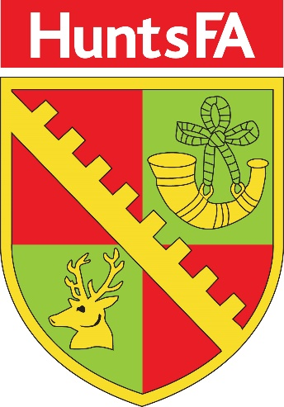

Inclusion Advisory Group (IAG)
Member Application Pack
2020

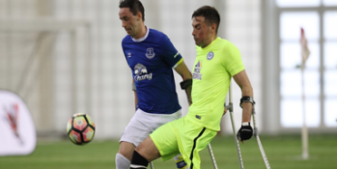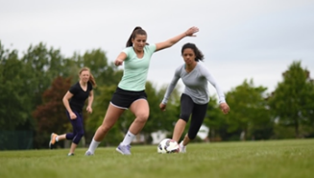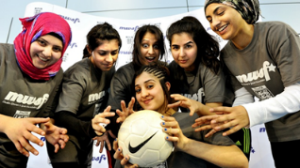

Dear Applicant,

Thank you for reading our Inclusion Advisory Group (IAG) Prospective Member Application Pack.

Terms of Reference

Purpose

The IAG will support and advise Huntingdonshire Football Association (HFA) to increase awareness, understanding and knowledge of inclusion, equality and diversity –
Huntingdonshire FA to better engage with and thereby better meet the needs of all of our local football communities to help to ensure football is available to everyone.
The IAG shall be working on behalf of The Huntingdonshire Football Association, with the remit of increasing the diversity of football's talent pool.
The IAG will also help fulfil HFA business and legal duties and responsibilities.

Key Ares of Responsibilities

- Advance equality of opportunity amongst all our football communities
- Foster good relationships with and between all our football communities
- Eliminate unlawful discrimination, harassment and victimisation- and promote inclusion
- Increase diversity in footballs’ talent pool
- Clarify regulations and sanctions related to discriminatory behaviour
- Enable transparency and confidence when dealing with discriminatory behaviour

Key Deliverables

- Utilise data to inform action planning and recommendations to HFA
- Produce an IAG Action Plan; setting clear and realistic targets, to form part of the HFA County Plan to address the needs of the whole of our football community
- Support community engagement, consultation, development programs and disciplinary procedures
- Act as Ambassadors for HFA in our football communities
- Bring a diverse perspective to the HFA
- Identify any equality issues, support the identification and delivery of solutions
- Promote and encourage the benefits of addressing equality issues within the football community
- Assess and advise on equality impacts arising out of strategic planning
- Coordinate consultation sessions with the wider community on strategic issues
- Identify key issues and trends that will promote the growth of the game through inclusion and diversity interventions
- Through the IAG Lead Officer to provide updates to HFA Board as appropriate
- Monitor and evaluate HFA Key Performance Indicators for inclusion and diversity
- Meet a minimum of four times a year

Essential Skills

- Recognise equality issues and identify possible solutions
- Demonstrate relevant knowledge of inclusion and diversity legislation
- Work across a broad spectrum of ethnic and cultural backgrounds
- Build effective relationships with members of staff and members of the football community
- Be a positive team member and help provide direction to the IAG and onward to WFA Council, Directors and professional staff
- Communicate effectively and confidently, both in written form and verbally
- Have a positive attitude towards the requirements of the role
- Handle confidential information sensitively
- Work positively as part of a team
- Act in a professional manner as a representative of the Huntingdonshire FA
- Work outside of normal working hours and attend meetings where required
- To be able to identify key equality issues and to support the identification and delivery of solutions

Desirable Skills

- Have a good understanding of grassroots football
- Bring a level of experience from the sports/football industry
- Recognise how to utilise and use appropriate and relevant social media
- Possess basic presentation skills
- Be competent in analysing data to assist in making informed decisions
- Have existing contacts within football and the wider community
- Have a positive and progressive attitude
- Have existing contacts within the business community
- Have a good knowledge of community groups
- Experience of working with diverse groups and individuals who have different ethnicity and cultural backgrounds

Social Media
We live in a society that promotes free speech and freedom of expression. Social media is continuing to grow and it’s in our interest to sensibly and proactively embrace it.
Please be aware that the following types of comments on any matter, not just football are prohibited for members of the IAG:
• Abuse
• Insults
• Indecent tweets
• Threats
• Bringing the game into disrepute
Guidance on how to apply

If you are interested in applying to be a member of Huntingdonshire Football Association Inclusion Advisory Group (HFA IAG), please complete the role profile and application form and return it by email or post, marked Private & Confidential, along with your current CV to:

FAO: Sarah Hudson
Huntingdonshire FA
Ambury House
4 Sovereign Court
Lancaster Way
Ermine Business Park
Huntingdon
PE29 6XU

Or by email to: sarah.hudson@hunts.com

Completion of the role profile form is optional however it provides an opportunity to track the breadth and depth of applications from different parts of the community.

The appointments are on a voluntary basis for a period of two years following which members can be re-appointed. Relevant travel expenses may be paid in line with the HFA expenses policy.

If you require more information about the role or need assistance with your application, please do not hesitate to get in touch contact: Sarah Hudson– 01480 447489 / 07904 028735
Conversations will be both informal and confidential.

A selection panel will meet following the above date to shortlist those who will be invited to attend interview.

Application Form
Section 1 – Personal Details
Full Name
Address
Post Code
Email Address
Contact Tel (Home)
Contact Tel (Mobile)
Occupation
Connection with Football (if any?)
Section 2 – Relevant Experience
Please outline all experience relevant to the role, include details of any voluntary and paid experience, and how you meet the requirements of the person and role specification.
(Please note the content of this section will be made available for IAG members to view on the Huntingdonshire FA Website – www.huntingdonshireFA.com)

Section 3 – Reasons for applying
Please outline why you would like to become part of the Huntingdonshire FA IAG.
(Please feel free to relate this to your career, hobbies, aspirations and philosophy).

Section 4 – Signed Declaration
I confirm that to the best of my knowledge and understanding that the information on this form is correct and accurate.

Signed: |  | Date:

Please send your completed role profile, application form and CV, marked Private & Confidential to:
FAO: Sarah Hudson
Huntingdonshire FA
Ambury House
4 Sovereign Court
Lancaster Way
Ermine Business Park
Huntingdon
PE29 6XU

Or by email to: sarah.hudson@hunts.com
Thank-you for your interest and for taking the time to complete this application.

About You Equal Opportunities Monitoring
Huntingdonshire FA is proud to be a diverse County FA, on and off the pitch, and wants to ensure everyone – from our staff and players to volunteers and the wider community, feel welcome and valued across all areas of local football life.
As part of this, we’d like you to fill in this short survey which asks questions about your diversity. We call this equality monitoring. It helps us to understand more about the diversity of the football across Huntingdonshire, ensure that everyone that who takes part feels welcome and included and think about what we can do to encourage diverse communities to get involved.
All questions are confidential and optional, although it’s much more helpful to us if you choose “I prefer not to answer this question” rather than leave any answers blank.
In line with data protection legislation, your responses will be stored anonymously and confidentially.
1. Are you
☐ Female
☐ Male
☐ I identify in another way / prefer to self-describe [please specify]
☐ Prefer not to say

2. Age
☐ 18 – 24
☐ 25 – 34
☐ 35 – 44
☐ 45 – 54
☐ 55 – 64
☐ 65 – 74
☐ 75+
☐ Prefer not to say

3. Sexual Orientation
☐ Bisexual
☐ Gay man
☐ Gay woman / lesbian
☐ Heterosexual
☐ I identify in another way / prefer to self-describe [please specify]
☐ Prefer not to say

4. Do you identify as transgender?
☐ Yes
☐ No
☐ Prefer not to say

5. Disability
Equality Act 2010 definition of disability
Under the Equality Act 2010, a person is considered to have a disability 'if they have a physical or mental impairment, and the impairment has a substantial and long-term adverse effect on his or her ability to carry out normal day-to-day activities’. ‘Substantial' is defined by the Act as 'more than minor or trivial'. An impairment is considered to have a long-term effect if:
- it has lasted for at least 12 months
- it is likely to last for at least 12 months, or
- it is likely to last for the rest of the person’s life.

Do you have a disability?
☐ Yes
☐ No
☐ Prefer not to say

If the answer is yes, please specify below;
☐ Hearing impairment
☐ Visual impairment
☐ Physical impairment - ambulant
☐ Physical impairment - wheelchair user
☐ Learning impairment/disability
☐ Learning difficulty
☐ Social/communication impairment
☐ Long term illness
☐ Mental health condition
☐ Other
☐ Prefer not to say

6. Ethnic group
A. White
☐ Welsh/English/Scottish/Northern Irish/British
☐ Irish
☐ Gypsy, Roma or Irish Traveller
☐ Eastern European
☐ Other, please specify:
B. Mixed/multiple ethnic groups
☐ White and Black Caribbean
☐ White and Black African
☐ White and Asian
☐ Other, please specify:
C. Asian/Asian British
☐ Indian
☐ Pakistani
☐ Bangladeshi
☐ Chinese
☐ Other, please specify:
D. Black/African/Caribbean/Black British
☐ African
☐ Caribbean
☐ Other, please specify:
E. Other
☐ Arab
☐ Other, please specify:

☐ Prefer not to say

7. Religion or belief

☐ Christian (all denominations)
☐ Buddhist
☐ Hindu
☐ Jewish
☐ Muslim
☐ Sikh
☐ Other, please specify:
☐ No religion
☐ Prefer not to say

8. Marriage/ Civil Partnership
☐ Married or in a civil partnership
☐ Neither
☐ Prefer not to say

9. Are you currently pregnant or taking parental leave?
☐ Yes
☐ No
☐ Prefer not to say

