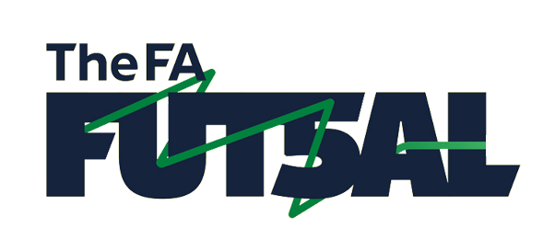
Hampshire County FA
National Youth Futsal Cup
Competition Rules

Pitch - Futsal is played on a marked pitch and the ball can go out of play.
Head Height - There are no height restrictions.
Ball - A Futsal ball will be supplied.
Equipment - all players must wear shin pads and trainers. Any player without the correct equipment will not be allowed to play.

Eligibility and Number of Players - It is crucial that you adhere to the following eligibility criteria as any teams that qualify for the National festival but do not meet the criteria will be removed from the festival:

- All categories are open to all football clubs, however, to proceed and represent Hampshire you will need to be affiliated to Hampshire County FA.
- All teams must be Futsal affiliated teams, this can be completed by you secretary contacting Sam.Charles@HampshireFA.com with the following information:
  - Team Name
  - Age Group
  - Managers Name
This will cost £5 which has been taken into consideration when setting the entry fees
- You need to make sure you do not have a fixture on the following dates:
Saturday 30th November 2019 (Female Applications Only)
Sunday 22nd December 2019 (Southern Applications Only)
Saturday 4th January 2020 (Northern Applications Only)
Sunday 12th January 2020 (Finals Day Qualifying Applicants Only)

- Any player that is registered with an Academy, Centre of Excellence or FA Female Regional Talent Club or has been during the 2018/19 season or Representative Sides will not be permitted to play.
- Teams should enter the festival in the age group they play in during season 2019/2020.

Player age qualification is as follows:

Age Brackets | Category
Under 9/10’s | U10
Under 11/12’s | U12
Under 13/14’s | U14
Under 15/16’s | U16

All sections will play 5v5 - one player shall be the Goalkeeper. A squad of up to 12 players may be used.

Substitutions - up to 12 players can be used in one match and there is no limit on how long a player must stay on or off the pitch. Players must enter and leave the field of play from in front of their respective team’s bench.

Kick In - In order to restart the game, the ball is kicked back into play from the touchline and from corners. The ball must be placed stationary on the touchline.

Four Second Rule - For kick ins, free kicks, goal clearances and corner kicks; the player in possession of the ball has four seconds to restart play, which the referee will count with their fingers in the air. If play isn’t restarted within four seconds an indirect free kick will be awarded to the opposing team. The goalkeeper is not allowed to control the ball for more than four seconds in their own half.

Three Metre Rule - Players are required to keep 3m from the player in possession of the ball on free kicks, corners, goal clearances, kick ins and penalties.

Goalkeepers - Goalkeepers are allowed to come out of and players are allowed to go into the penalty area.

Goal Kicks and Back Passes - A goal clearance must be thrown out and the goalkeeper cannot touch the ball again until a member of the opposition has touched the ball or the goalkeeper is in the opponents half.

Sliding Tackles - are only permitted in the South East Regionals. They are NOT permitted in the Hampshire FA tournaments.

Accumulated Fouls - Each team will be allowed to give away three direct free kicks in each game, then on the fourth foul (and all subsequent direct fouls) a direct kick will be awarded to the opposing team and the defending team is not allowed to position any players (other than the goalkeeper) between the ball and the goal. The kick may be taken from the 10m mark or, if the foul was committed closer to the goal than the 10m mark, then the kick may be taken from the position where the foul took place.

Duration of Game for Festival - All matches will be played with a running clock whereby the clock will not be stopped whenever the ball is out of play. The duration of the match will be determined by the competition organiser of each heat.

Determining Places - 3 points for a win, 1 point for a draw and 0 points for a loss. In the event of two teams having the same number of points, goal difference will be counted then goals scored shall count, If there is still a tie the winner shall be determined by kicks from the Penalty Mark.

