[INSERT LOGO]

[NAME OF CLUB]

[INSERT LOGO HERE]

Welcome,

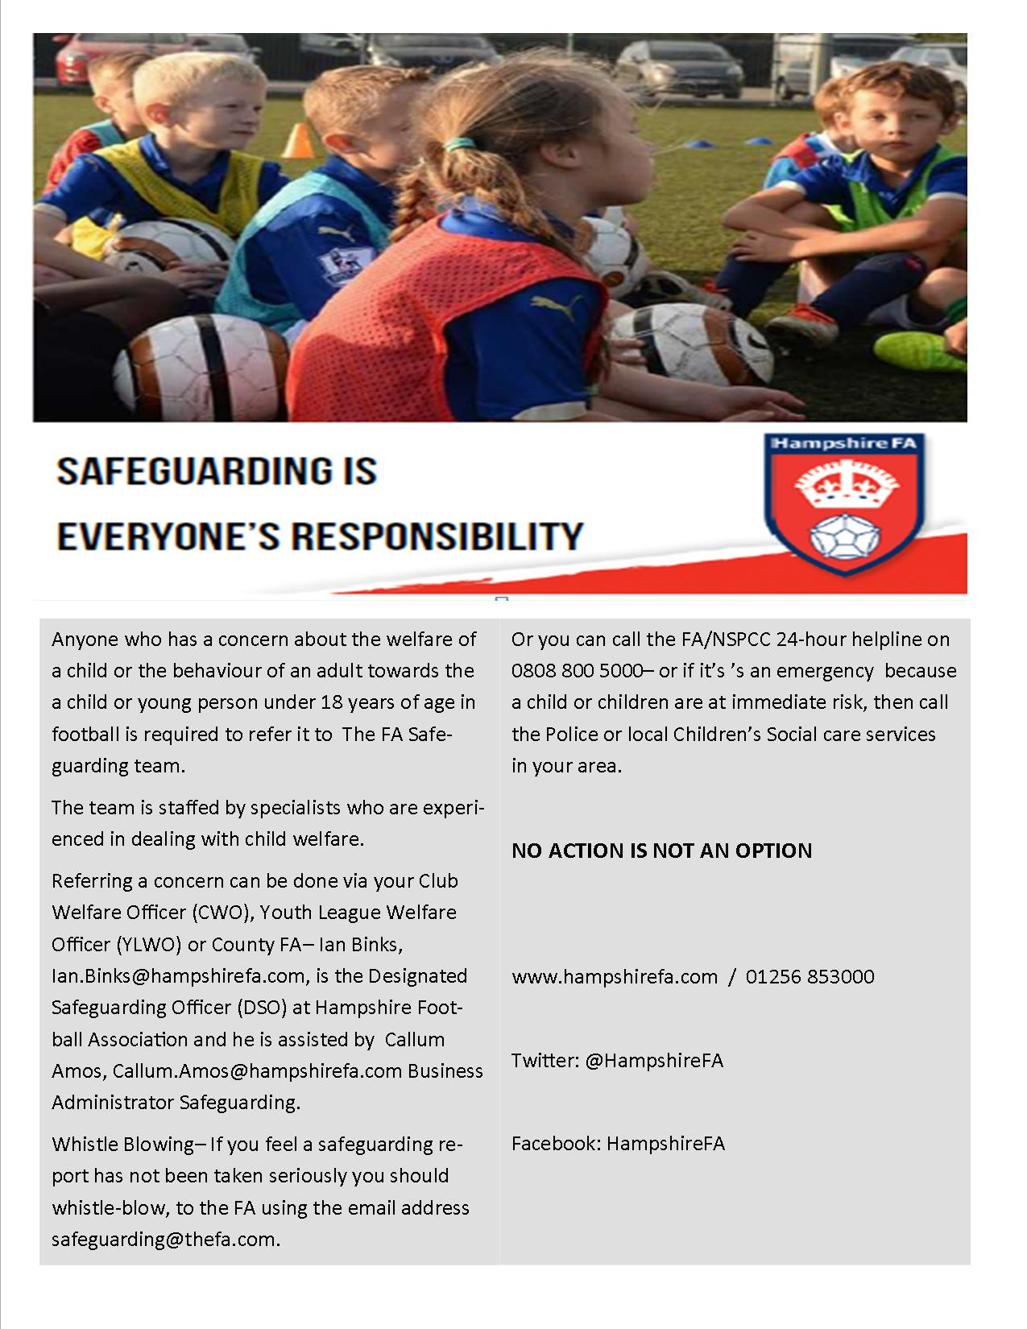
WELCOME TO [Insert Club Name Here]

Firstly let me say thank very much for volunteering to help out as without willing volunteers this club would cease to exist. This pack has been put together in order to give you an introduction to the club and provide as much information to help you in the running of your team.

[CLUB NAME] was founded for [INSERT FOR WHOM, AGE GROUPS ETC] and after successfully achieving [INSERT CHARTER STANDARD STATUS HERE] in [YEAR] we have been successful in renewing this in subsequent years.

We play in the [INSERT LEAGUES HERE].

As part of their commitment to the FA Charter, each age group has at least one Coach with a recognised FA coaching qualification and all volunteers have an in-date CRC. Predominantly home matches are played at the [INSERT LOCATION HERE].

The Committee meets [NUMBER OF WEEKS] and requires [INSERT PEOPLE/ROLES] to be in attendance throughout the season September – June. The AGM is held in [INSERT MONTH].

I hope your involvement in the Club brings you as much pleasure as it has to me; should you need any assistance please do not hesitate to contact the Club Secretary the Club Vice Chairman.
Club Secretary Details:
[INSERT NAME]
[INSERT CONTACT DETAILS]

Vice-Chairman Details:
[INSERT NAME]
[INSERT CONTACT DETAILS]

Kind regards,

Chairman

Attached with this welcome letter are some brief guidance notes on

- Child Protection
- Training and Coaching
- Match Organisation

We ask your attention to be drawn to the documents detailed below all of which can be found on the club website

- Club Constitution and Rules
- Equality
- Emergency Action Plan
- Anti Bullying Policy
- Respect Guides
- Data Protection (GDPR as of 25th May 2018)
- Player Form
- Coaches’ Code of Conduct
- Players Code of Conduct (Youth)
- Players Code of Conduct (Mini Soccer)
- Parent’s Code of Conduct

Finally please can you complete the Volunteer Form available on the website and return it to the Club Secretary so we can get you
started.

CHILD PROTECTION

- Child protection is a vital part of what we do as a football club and a cornerstone of our FA Charter Status.

- No adult is allowed to join in with any training session until they have filled in a volunteer registration form and handed it in to the designated manager (for that age group) or Child Welfare Officer.

- If an adult is taking part regularly then they must complete a CRC application through the Child Welfare Officer.

- Best Practice guidelines advise a minimum of 2 adults to be present at all times.

- Carry contact details for all parents/guardians with you at all sessions and have a means of contacting them with you at all times.

- The club provides first aid kits and one is to be present at each and every session.

- Codes of Conducts are provided for Club Officials, parents and players and are to be strictly adhered to (a signed copy needs to be held by the Club Secretary).

- Joining forms for contact details and Codes of Conducts should be handed to the player/parent as soon as possible. Failure to return the signed forms can result in a player not being allowed to take part in future sessions/matches.

- In the event of a potential Child protection issue contact the Child Welfare Officer (CWO) at the first opportunity.

- Any such issue is confidential and communication should be restricted to the CWO only unless the CWO advises or requests that another person/s become involved.

TRAINING AND COACHING

- Training is vital to the growth and development of both the individual player but the team as a whole. Best practice: The club is dedicated to providing a minimum of [INSERT HOURS of football per week for INSERT NUMBER OF WEEKS].

- The use of the training facilities every [INSERT TRAINING DAYS AND INSERT VENUE LOCATIONS AND TIMES].

- The [INSERT ROLE] is in consultation with the committee and parents to set training venues and times. Costs for facility hire is one of our biggest expenses and venues are shared to keep costs down where possible. Current venues are [INSERT VENUES HERE].

- Optional to include, only if Charter Standard FA Charter Standard Status sets rules for coaching standards, a minimum of a level 1 FA Coach must be present for every session. No session is allowed to take place unless a coach is available. Non-qualified helpers must be supervised at all times.

- Coaching courses should be booked independently through Hampshire FA with all costs generally met by the club [SPECIFY HERE].

- Fees for training and matches are currently set at [INSERT COST] per month or per season.

- It is club policy to purchase [INSERT IF YOU DO PURCHASE KITS AND/OR JACKETS ETC, EVERY ‘X’ SEASONS].

Club committee: receipts should be passed to the club Treasurer for any and/or all purchases regardless of the amount

- Sponsors must not be involved with Alcohol or Smoking based concerns in accordance with FA guidelines. All Sponsors need to be cleared by the Club Committee.

- Coaches are encouraged to develop their skills and under FA guidelines must undertake some football related course once every 3 years. This is usually achieved through CPD of which Hampshire FA organise throughout the year. Click here to view CPD events and workshops.

MATCH ORGANISATION

- Matches are organised by the League Divisional Secretaries responsible for each age group, these details are passed to our Club secretary who will pass the details to each team manager. Delete and/or add as appropriate

- U7, U8’s, U9’s and U10’s play mini-soccer

- U11 and U12’s play 9v9 format

- U13 and older play 11v11 format

- Maximum Squad sizes are set by each league and vary through the age groups.

- In mini-soccer it is usual for a parent to referee each game and you are advised to have a contingency plan and/or alternatives (if the parent is refereeing on more than one occasion, it is best practice for them to obtain a CRC as a safeguarding measure). It is not best practice for the manager to referee the game but can be if there is no alternative.

- When acting as a Match Official you are not allowed to coach.

- A Referee will normally be appointed for you for 11-a-side matches; fees are set by the league and payable on the day from club funds.

- The cancellation of league/cup games is the responsibility of the Club Secretary. If you need to cancel a game this should be communicated to the Club Secretary at the earliest opportunity.

- Friendlies are a team manager’s responsibility but you are advised to contact the Club Secretary when you wish to organise a home game. Any pitch hire costs for friendly games should be split 50/50 between the club and the opposition.

- Club Policy is to try and give as many players as possible an even chance to play, particularly at the younger age groups. For example; the club ethos is all about inclusion rather than exclusion particularly during the mini-soccer years.

- The 9v9 format is proving to be a great success as players develop both physically and psychologically. Some players adapt better than others and performance in mini-soccer isn’t always an indication so inclusion is important here too.

- Experience has taught us that at 11-a-side the players begin to put greater emphasis into winning and playing well rather than just taking part. The trick is to strike the right balance.

- Good communication between coach, parent and player is key.

- The club should be signed up to the Respect Campaign and emphasis that it will not tolerate any poor practices or behaviour by managers, players or parents. This should be continuously communicated.

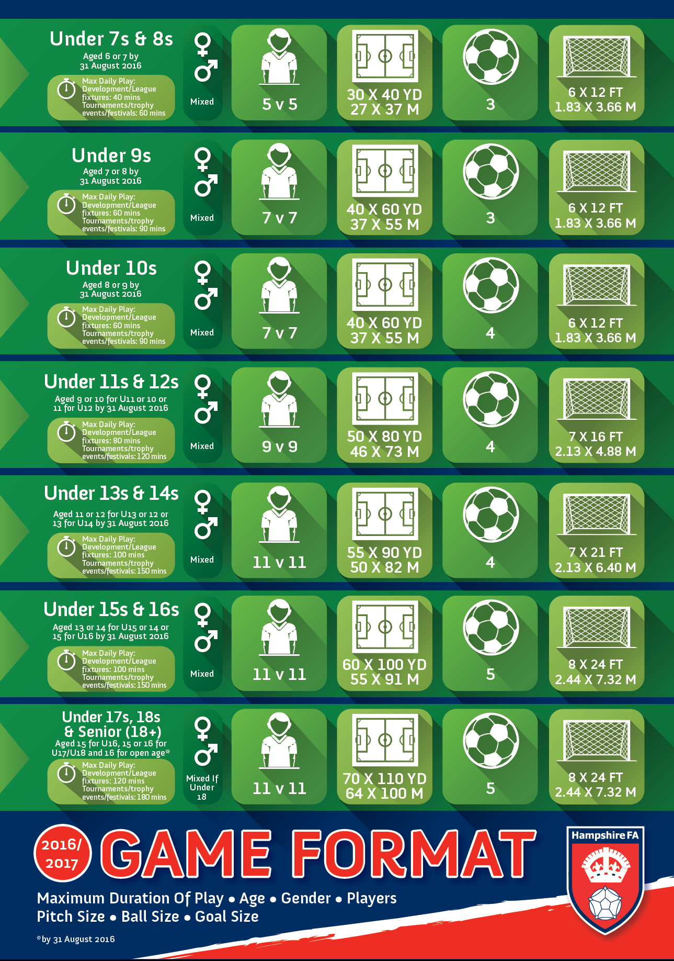

Key Links

Hampshire FA Safeguarding & Welfare
Taking Safeguarding Online

Safeguarding at Hampshire FA
Safeguarding Policies & Reporting Concerns

The FA Safeguarding

Contacts
Ian Binks
Designated Safeguarding Officer
E. Ian.Binks@HampshireFA.com
T. 07718 122900 / 01256 853000

Callum Amos
Business Safeguarding Administrator
E. Callum.Amos@HampshireFA.com
T. 01256 853004

In the absence of the above contacts, please call 01256 853000 where we will then direct you to the next appropriate individual.

All Hampshire FA staff members have undertaken the necessary Safeguarding operating Standards training and are equipped to deal with your enquiries.

