HAMPSHIRE FA
CUSTOMER SERVICE CHARTER
OUR CUSTOMER CHARTER
Introduction by the Chief Executive, Neil Cassar.

“At Hampshire FA we are committed to a reliable, responsive service that has your best interests – and those of the game – at heart.
We have therefore consulted with customers, stakeholders and our own staff and volunteers to better understand what matters most to you, how well we are doing and where we need to improve.
You’ve told us how important it is for us to become your local ‘hub’ for all things ‘football: a centre of knowledge, learning and guidance that helps raise standards and grow the game. You want us to listen closely to you and to remove any obstacles that prevent you from enjoying the game. You want us to live the values that come with being custodians of the game, to lead in the right way, with the best interests of the game at heart.
In response to this we have used your feedback to develop the Hampshire FA Customer Charter.
This Customer Charter sets out the standards of service and quality of experience you should expect from us. It covers all of the areas that we know are most important to you, from keeping you informed and dealing with your enquiries to resolving technical issues or putting things right when mistakes have been made - and if you are unhappy with any aspect of our service, the Customer Charter explains clearly what we will do to resolve the problem.
We will monitor these commitments by consulting with customers and stakeholders, we will commit to publishing our performance regularly and we will use your feedback to review and improve the Customer Charter year on year.
These promises set out a clear commitment to meeting and exceeding the needs of everyone involved in the game at every level. They will help us remove obstacles, build on strengths and contribute to driving up interest and participation in our National Game.”
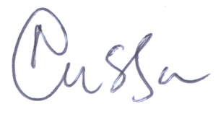
Neil Cassar
Chief Executive
Hampshire FA

WE WILL LISTEN, ACKNOWLEDGE & ACT

Keeping up to date with your experiences, needs and expectations is vital if we are to deliver the best service possible. To this end, we will ensure that your views are heard.

- We will deploy a range of methods to seek your views on the quality of service we provide as well as on our Customer Charter performance. This year we will commit to being present at a number of sports fairs, family events and other events etc to hear your views and remain easily accessible. Additionally, we have implemented a Hampshire FA Testimonials page which aims to collate positive feedback with the option to also leave comments on any areas requiring improvement. The testimonials page allows members to leave their feedback and at the same time remain anonymous, allowing us to address any areas of concern directly with those identified via the confidential form
- We will aim to ensure our communication is always up to date and relevant for people in Hampshire by producing a number of press releases on current/upcoming events and opportunities on our Hampshire FA site, utilise our social media sites to promote and publicise relevant information including Linkedin, YouTube, Instagram, Twitter & Facebook so that visually we are also getting the message across whilst our monthly emagazine publications draws attention to what’s occurring in football in Hampshire. If you are currently not on the database and don’t receive our news, you may register via this link. Additionally, we have set up a Google Business Page allowing our customers to leave reviews which will appear publically when searching for Hampshire FA. It is pivotal that we utilise as many means as possible to spread the word and to be as transparent in our approach.

- We will make it easy for you to contact us with comments and/or feedback on events, on programmes and/or other initiatives, as well as being able to comment on our customer service or provide feedback on our staff and departments. Simply email Isabella.Pearson@HampshireFA.com or write to Isabella Pearson (Marketing & Communications Manager), Hampshire FA, Winklebury Football Complex, Winklebury Way, RG23 8BF or telephone 01256 853013.

- We will publish, via our website and various other publications, feedback from stakeholders and customers and explain what we are planning to do to improve the specific area of service commented upon. In our partnerships section (found under our ‘about’ section on the homepage) we have listed our Member Benefits and have dotted round our website the various offers (i.e. Koolpak and First Aid discounts found under Emergency Aid) as well as our Commercial Opportunities so that as a business we are also creating opportunities in addition to the opportunities presented in football in the County, targeting different audiences.

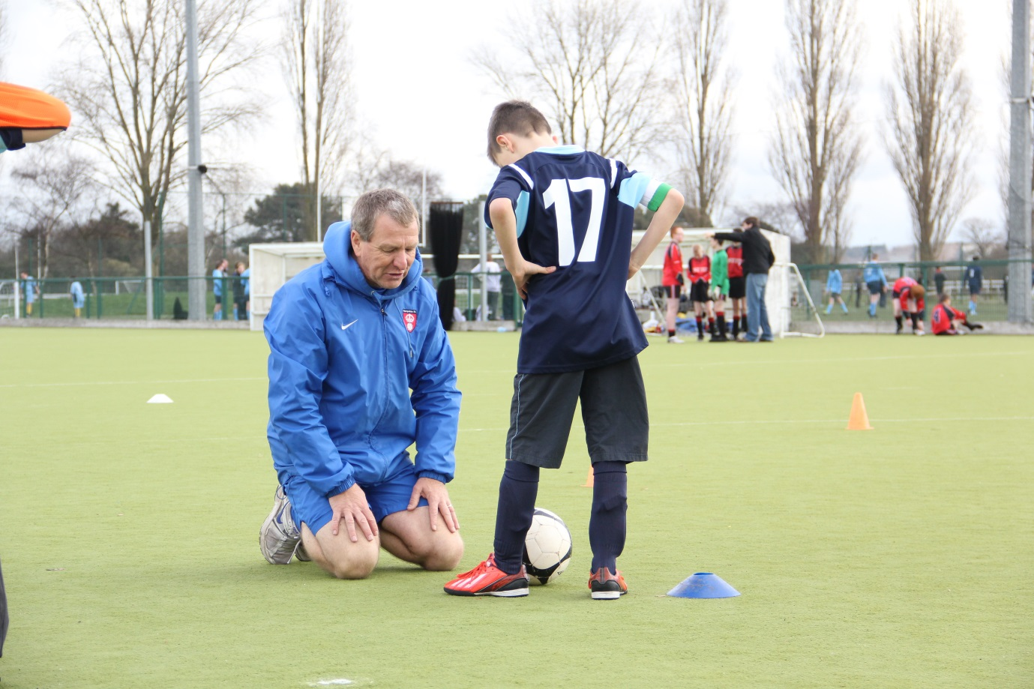

WE WILL KEEP YOU INFORMED
You rely on us for correct, up to date, user-friendly information, so in order to ensure you are as successful as possible in driving up participation and interest in football, we make the following commitments:
- Information on all of our programmes and services will be easily accessible, accurate and up to date. It will be published on our website and in our other publications.
- Disciplinary procedures will be published in our County FA Handbook and on our website.
- Our staff will offer impartial advice on disciplinary matters upon request.
- We will strive to ensure that technical details and procedures are explained as clearly as possible.
- Where changes take place, we will place particular emphasis on communicating them through our website, app, social media sites, our e-zines and via other publications.
- We will continue to develop our digital media capabilities to ensure our customer and stakeholder groups are able to access information and interact with us in ways that are most convenient for them.

- We will continue to consult with our customers and stakeholders to expand our communications.

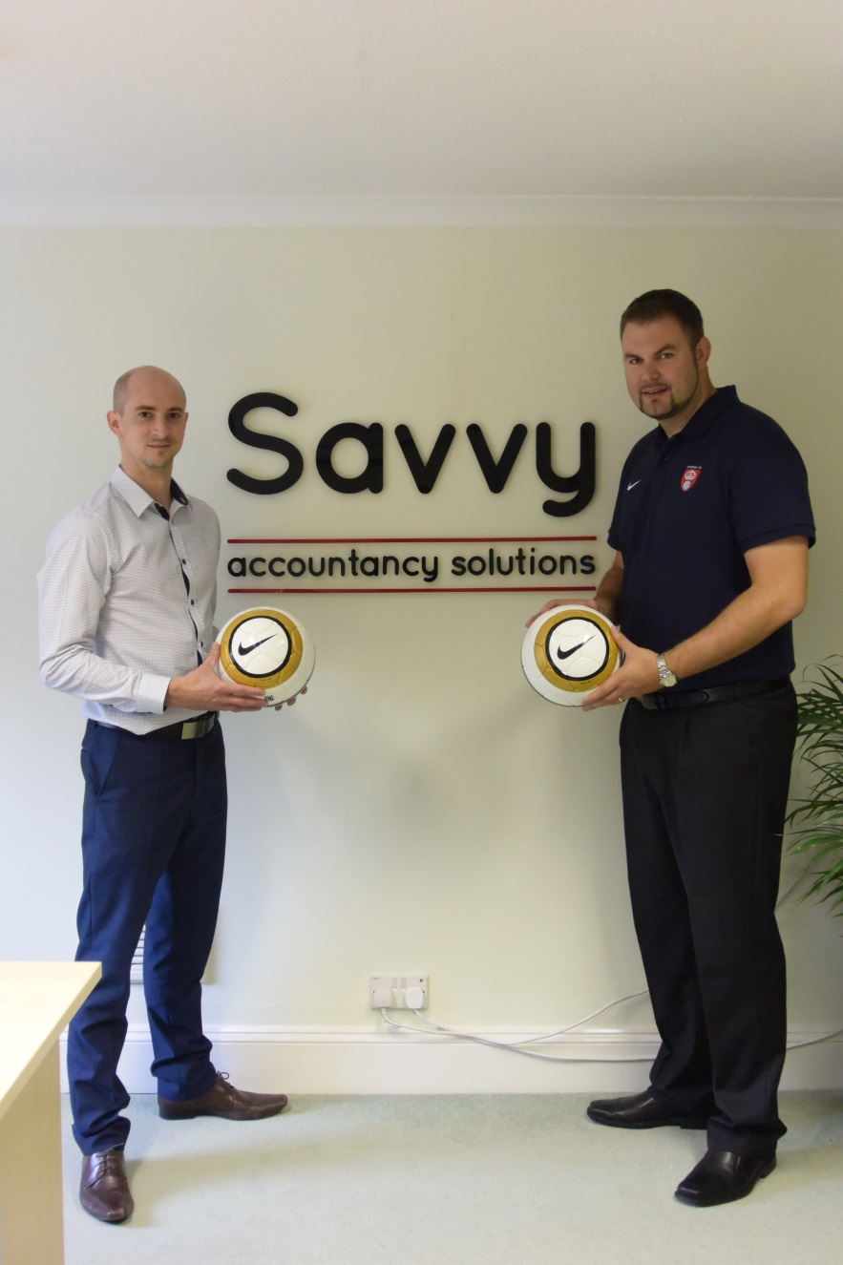

WE WILL MAKE IT EASY FOR YOU

We want to put you in control by making sure that it is easy for you to work with us. Whether you have an urgent enquiry, a need for information, a technical query or a problem, the process of interacting with the County FA should be both effective and efficient. Whatever your needs or personal requirements, we’ll keep our promise to see things through.
- We will use your feedback to ensure that our programmes, workshops and other services are deployed in ways that make it easy for you and that maximise participation as a consequence.
- You can telephone our office between the hours of 8.30am – 5.15pm, Monday to Friday. Additionally, at other sites operated by Hampshire FA (Front Lawn Recreation Ground), you may be able to contact the site from 9am – 9:30pm Monday to Friday, 8:30-5:30pm on Saturdays and on Sundays from 8:30am to leave a message for Hampshire FA.
- We will continue to work on finding better ways to allow you access to County FA expertise outside of usual working hours. Our social media sites are monitored at different hours in the day well into the evenings and have become a first point-of-call for many enquiries. Customers will expect to still receive an automated message (Facebook) confirming the opening times so there is an acknowledgement of their message.
- We will answer telephone calls as quickly as possible. If the specific colleague you wish to speak to is not available, you will always be able to leave a message, speak to another available colleague or expect a call back within a 24 hour working day.
- If you write to and / or fax us, we will endeavour to provide a full response within 7 working days. If this is not going to be possible we will acknowledge your letter within 7 days, clearly explain why the process may take longer and tell you when to expect a full response.
- If you email us, you should expect a response within 3 working days. If the person you are emailing is unavailable, you should expect an automated ‘out of office’ reply together with a number to call if your enquiry is urgent. Due to the nature of our work some members of staff may be away from their desks / email for several days at a time. In such circumstances, customers will receive an automated response to emails advising them who to contact if the matter is urgent.
- Additionally, we have a Support email for all enquiries which will be passed onto relevant members of the team to respond to your enquiry if you are unsure of who to contact.
- You can also access services through our Member Services portal:
https://www.hampshirefa.com/MembersServices/Templates/SystemTemplates/MembersServices/MembersDefault.aspx.

WE WILL DEOMONSTRATE THAT WE HAVE YOUR BEST INTERESTS AT HEART

The majority of people working to develop and administer grassroots football give their time voluntarily, so the best way we can match this passion and commitment is by demonstrating that we have your best interests – and those of the game – at heart at all times.
We therefore commit to recruiting, training, supporting, coaching and developing colleagues who excel at customer service and promoting a customer service culture in all of our operations.
- We will listen carefully to you and ensure we fully understand your needs.
- We will always be polite and helpful.
- We will always act with integrity.
- We will always treat you with respect.
- We will always be open and transparent.
We will strive to provide the best possible service to all of our customers and stakeholders, irrespective of their gender, race, ethnic origin, disability, age, nationality, national origin, sexuality, religion or belief, marital status and / social class.
All of the talents and resources of Hampshire FA will be fully utilised to maximise the levels of service offered.

WE WILL MAKE YOUR PROBLEM OUR PRIORITY
It’s only when things go wrong, that our true commitment to customer service comes to light, so if you have any issues you must be able to count on your County FA to react accordingly.
We therefore make the following promises.
- We will make it easy for you to contact us with comments and improvement suggestions. Simply email the Marketing & Communications Officer, Isabella Pearson: Isabella.Pearson@HampshireFA.com, write to us directly at: Hampshire FA, Winklebury Football Complex, Winklebury Way, RG23 8BF or telephone 01256 853013 where your comments will be acknowledged. We may contact you to find out more.

- If you have a complaint, please telephone us in the first instance on 01256 853013 or email Isabella.Pearson@HampshireFA.com and we will do whatever we can to resolve the problem.

- If you prefer to write to us please address your letter to Isabella Pearson, Hampshire FA, Winklebury Football Complex, Winklebury Way, Basingstoke, RG23 8BF, or email Isabella.Pearson@HampshireFA.com explaining your concerns and enclosing all of your contact details. We will then provide a full response within 7 working days.

- If the matter requires more time to resolve then we will acknowledge your letter within 48 hours, clearly explain why the process may take longer and tell you when to expect a full response.

In order to provide the best possible service, to better understand your needs and to speed up problem resolution, we encourage the resolution of complaints by email. Rest assured, however, that we take every complaint seriously and will endeavour to resolve the issue at hand with immediate effect.
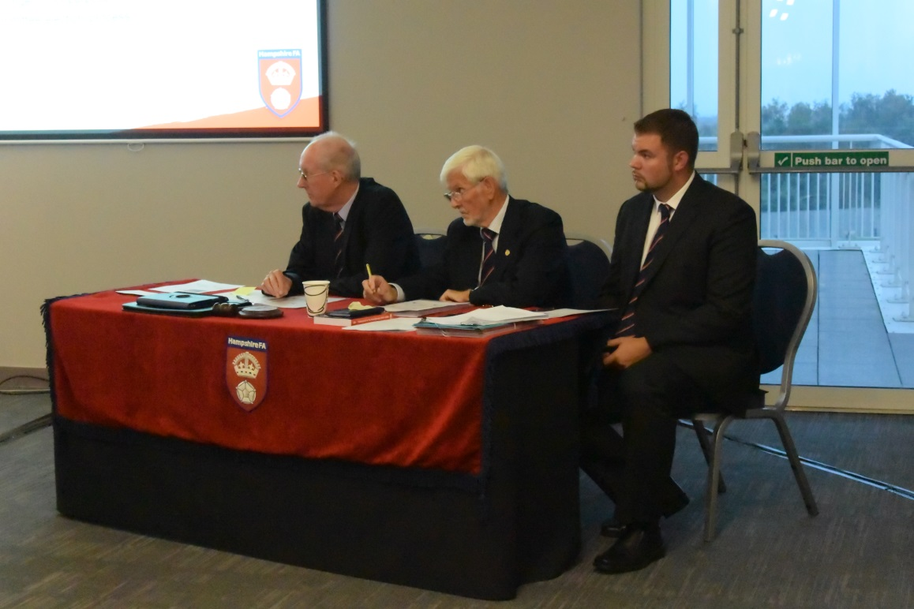

WHAT WE EXPECT FROM YOU

We expect you to:

- Treat our staff politely with respect and understanding

- Give us relevant, accurate, timely and up to date information to help us resolve queries as quickly as possible

- Complete any forms supplied, accurately and fully, attaching any supporting papers that may be needed

- Tell us immediately about any changes to your Club or personal contact details

- Quote any relevant reference number used in the Disciplinary process or any other correspondence from this office if applicable

- Respond to our letters, faxes and emails as quickly as you can, but in no longer than 14 days

Please note that improper behaviour towards our staff, volunteers, other customers or our property is unacceptable and will not be tolerated. This may lead to further action being taken at the discretion of the Chief Executive.

