- Log in (Using FAN or email & password) to https://learning.thefa.com/index.php
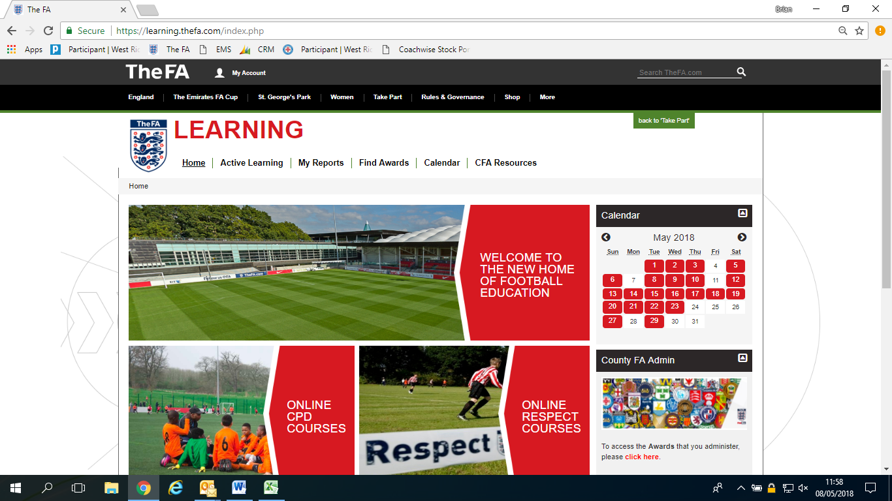
- Hover over active learning then click required learning
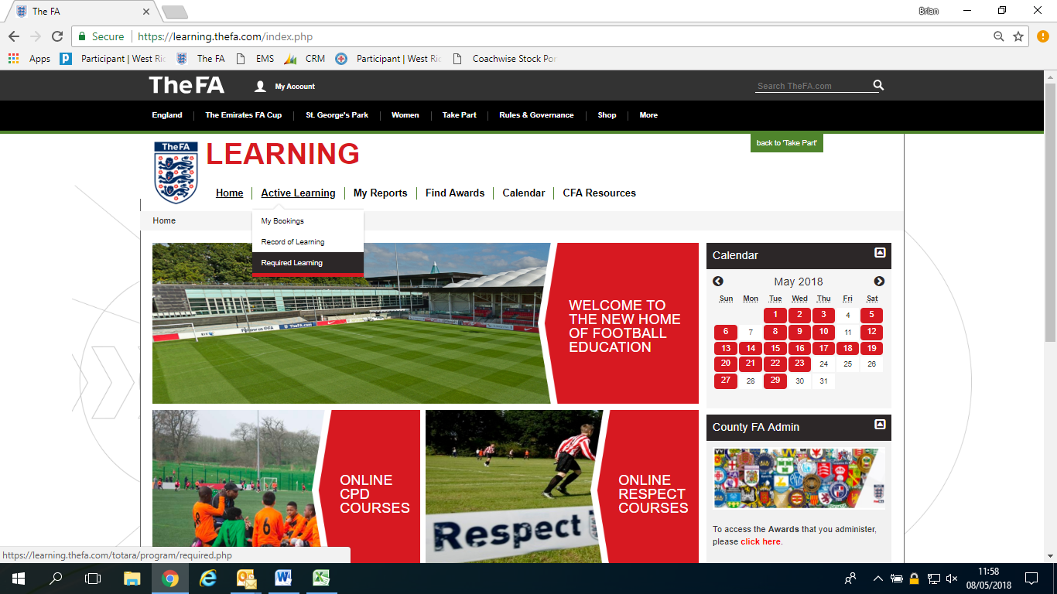
- Click Level 1 in Coaching Football
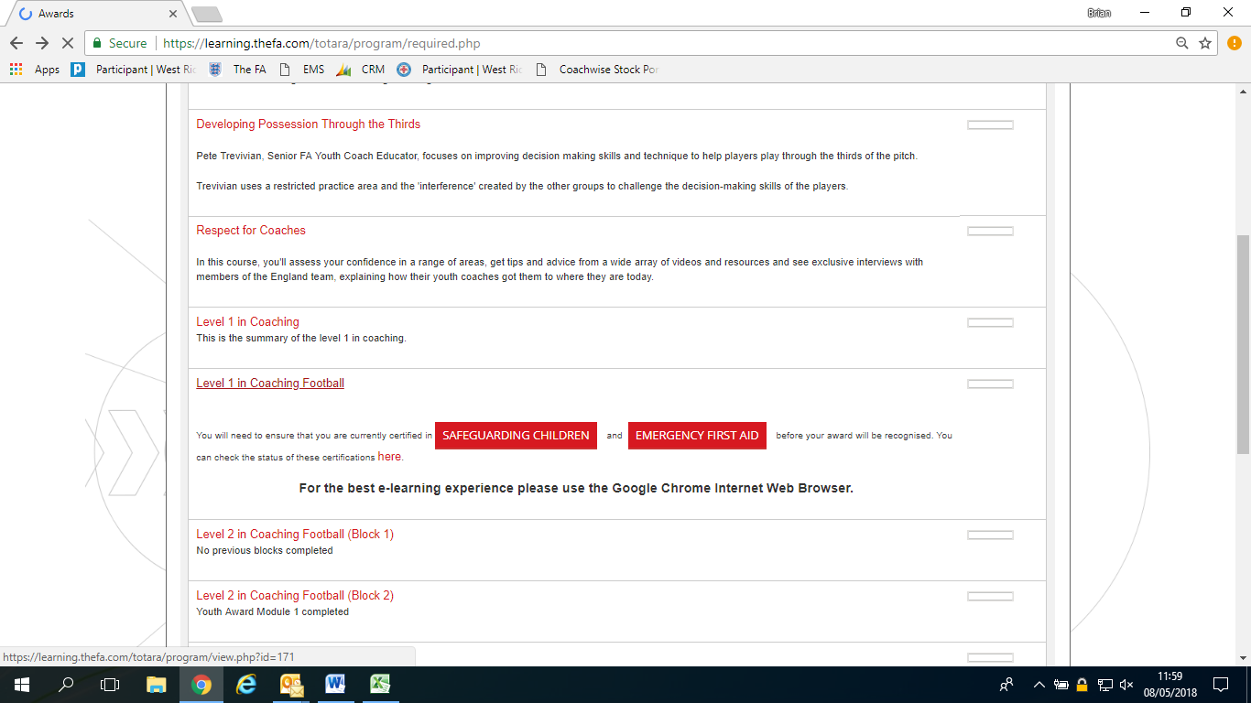
- You are now through to your online module home page
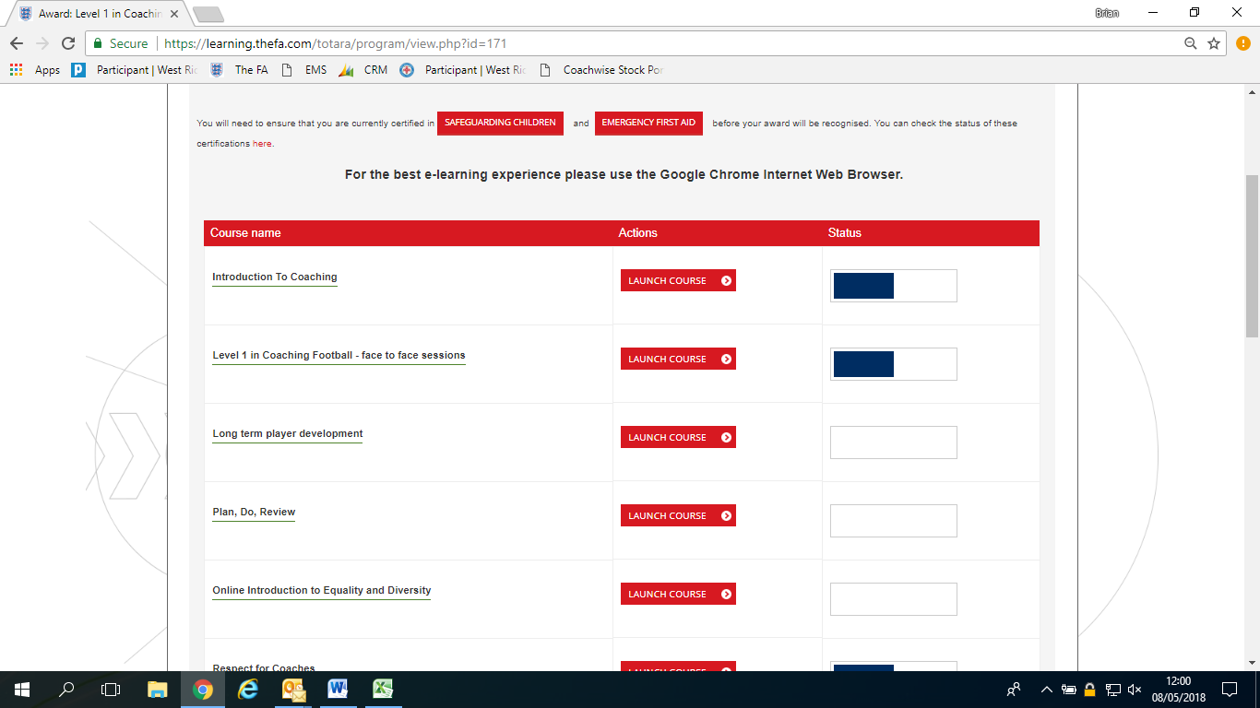
- Click Launch course on the respective modules listed in the email and complete them through to the end.
- To access the Safeguarding Children – How We Support either click safeguarding children at the top of the page or scroll down to see it. (Please note: You have completed Safeguarding Children How We Support, Not Safeguarding Children Workshop. They are the same course but you complete an hour online module)

