Essex County FA
Futsal Support Document
2019-20 Season

Introduction
Futsal is an exciting, fast-paced small sided football game that originates from South America in the 1930s. It is widely played across the world, and is the small sided football format that is officially recognised by both UEFA and FIFA. The nature of the game places a large emphasis on technical skill and ability in situations of high pressure, and is subsequently an excellent breeding ground for football competencies that can be translated into the 11-a-side format of the game.

Research indicates that individual’s playing Futsal receive the ball six times more often than they would do when they are playing 11-a-side football, allowing players to perform more individual techniques such as passes, controls, fakes, feints, dribbles and runs with the ball. As well as touching the ball more often, players will often receive the ball under pressure from opponents developing their confidence on the ball particularly in pressurised environments

Essex County FA has been supporting the development of Futsal in the county for a number of seasons, providing clubs and players an opportunity to try Futsal in a competitive environment. These competitions held locally have then enabled those successful teams to progress through into the FA National Youth Futsal Cup.

In previous years here in Essex, our U14’s and U16’s male and female winners who progressed onto the regional finals were from educational backgrounds. However this year The FA, English Schools FA (ESFA) and Independent Schools FA (ISFA) have recognised the need for an educational pathway as well as a club pathway. This increases the number of opportunities here in Essex for players to take part in the game.

The current competition structure is as follows;

Club Competitions | Schools’ Competitions
Under 10,  Under 12,  Under 14,  Under 16  Age groups in both a male and female competition | Under 13  Age groups in both a male and female competitions

The pyramid below demonstrates the competition structure from local level through to the finals for both the clubs and educational pathway;

Group area qualifiers
National Finals
Regional Finals
County Finals

Competition Structure – Male Grassroots Football/Futsal Teams

Competition Structure – Female Grassroots Football/Futsal Teams

Competition Structure – Male and Female Schools Teams

Final Dates
U13’s Boy’s & Girl’s Schools: Friday 13th December 2019
U10’s, U12’s. U14’s & U16’s Girl’s: Saturday 14th December 2019
U10’s, U12’s, U14’s & U16’s Boy’s: Saturday 21st December 2019
The FA has preannounced their dates in advance for the regional stages of the competition and these can be found below;
Regional Finals* to take place during March 2020 (TBC)
National Semi Finals will take place in April 2020 (TBC), a winner from each regional final will progress to this competition in each age group and gender.
National Finals will take place in May 2020 (TBC) at St Georges Park. Two teams from each gender and age group will qualify for this national final event and play a game to be crowned National Champions.

Rules
- General Rules
The below rules are adapted playing rules specific for the FA Youth Futsal Cup. Any situation not covered within these rules will automatically revert to either FIFAs Futsal Laws of the Game or The FA Rules and Regulations
- All players, including goalkeepers, must wear shin-pads at all times when on the pitch. Any player without the correct equipment will not be allowed to play.
- A player must not use equipment or wear anything that is dangerous to themselves or another player, including any kind of jewellery.
- Players must wear appropriate flat-soled, non-marking footwear.

- Duration of Play and Timeouts
- All matches will be played with a running clock whereby the clock will not be stopped when the ball goes out play.
- No timeouts will be allowed at this event.
- All games will be straight through and no half time (unless stated otherwise).

- Playing squad and Substitutions
  - Up to 12 players can be used in one match and there is no limit on how long a player must stay on or off the pitch. Roll-on roll-off subs can be made at any stage in the game; players must enter and leave the field of play from in front of the respective team’s bench.

- Restarts
- For kick-ins, free kicks, goal clearances and corner kicks the player in possession of the ball has 4 seconds to restart play which the referee will count with their fingers in the air. If play isn’t restarted within four seconds, an indirect free kick will be awarded to the opposing team.

- Technical Rules
- All games will be straight through and no half time.
- Futsal is played on a marked pitch and the ball can go out of play.
- There are no height restrictions.
- If the ball crosses the side line a kick-in is used to restart play, the ball must be placed stationary up to 25cm behind where the ball left the court or on the touchline and the feet of the player taking the
kick-in must not cross the line.
- The goalkeeper is not allowed to control the ball for more than 4 seconds in their own half.
- Players are required to keep 5m from the player in possession of the ball on free kicks, corners, goal clearances, kick-ins and penalties.
- From a goal clearance, the GK must release the ball from their hands Goalkeepers are allowed to come out of and players are allowed to go into the penalty area.
An indirect free kick is awarded to the opposing team if a goalkeeper commits any of the following offences:
- controls the ball with their hands or feet in their own half of the pitch for more than four seconds
- after playing the ball, touches it again in their own half of the pitch after it has been
- Deliberately kicked to them by a team-mate without an opponent playing or touching it
- touches the ball with their hands inside their own penalty area after it has been deliberately kicked to them by a team-mate
- touches the ball with their hands inside their own penalty area after they have received it directly from a kick-in by a team mate
Sliding tackles are allowed in Futsal and players are allowed to slide on the pitch, for example to stop the ball from going out of play. Anything Deemed dangerous by the referee will result in a free kick.
(This rule will change depending on venue. Before the competition the referee will inform you if slide tackling is allowed).
- Accumulated Fouls and Misconduct
- Each team will be allowed to give away 3 direct free kicks (instead of the standard 5) in each game, then on the fourth foul (and every foul made after this) a 2nd penalty spot kick (10m) is awarded to the opposing team and the defending team is not allowed to position any players (other than the goal keeper) between the ball and the goal. The foul count may vary due to changes in time. Please check with the referee before the event.
(Where the games duration is longer the accumulated foul count may increase – teams/players will be informed of this during the debrief)
- If a player is sent off then the team to which the player belongs must remain with 4 players until either two minutes have passed, or the opposition have scored a goal. If a player is sent off the tournament committee will decide length of ban depending on offence.
- Determining the winner
- To ensure a winner is determined fairly and following the SCORYF the below structure will be used;

- Points
- Head to Head
- Goals Difference
- Goals Scored
- Drawing of Lots

RESPECT Codes of Conduct
As a reminder during these competitions the RESPECT codes of conducts for all should be adhered too;
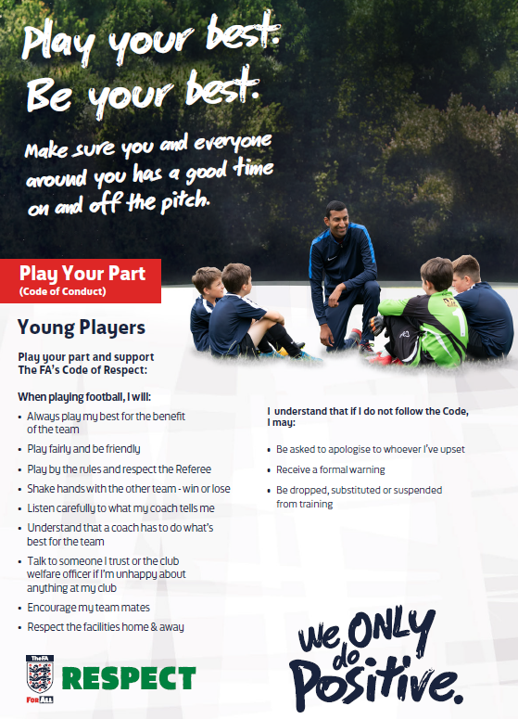

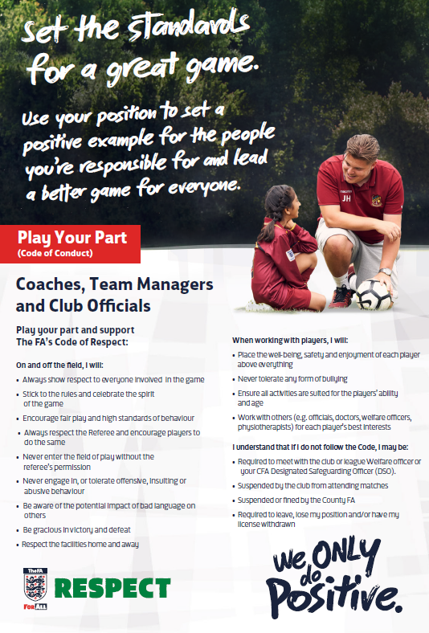

Eligibility and Number of Players – Club Competition
It is crucial that you adhere to the following eligibility criteria as any team(s) that are found breaching the below will be removed from the competition with immediate effect;

- A player shall not play for more than one competing CLUB TEAM throughout the duration of the competition structure
- Players must be registered with the club during the club year for 2019/20 season.
- Teams MUST enter players at the correct age group for the 2019/20 season. Player age qualification is as follows:

Age Group | School Year
Under 10's | 4 & 5
Under 12's | 6 & 7
Under 14's | 8 & 9
Under 16's | 10 & 11

Academy Players

Due to the FA ruling NO players that have been registered with an academy, Regional Talent Club (RTC) or COE at any point in the 2019/20 season both male and female can play in the competition. Please note that Academy, representative or Centre of Excellence teams are NOT allowed to compete at this stage. This ruling is implemented in U10’s through to U16’s.
Definition of ‘academy’ deemed ineligible for these competitions are players registered with a PL or EFL Club as an ‘Academy player’ may not play for another club in this competition as defined by the professional game Youth Development Rules (www.thefa.com). Note: An ‘Academy Player’ is a defined term within The FA Regulations.

Grassroots Teams/Futsal Clubs

Due to the current pathway structures within Essex in this year's FA Youth Futsal Cup we need to ensure that both grassroots clubs and futsal clubs are represented fairly. With this in mind if you are entering the competition as a futsal club and you have players whose primary registration is for a grassroots football team, we suggest the following; with best practice in mind communication is had with the grassroots team to ensure participation in the competitions can be maximised. Therefore allowing entries from both futsal and grassroots clubs. These lines of communication will become even more paramount if you are successful in the competition structure.

If Essex County FA staffs are made aware of any players taking part in the competition that is not deemed eligible, appropriate investigations will be had after the competition. If it is proven a team has played a player who is not eligible the team will not progress any further in the competition. If there is any doubts please contact your football development officer either on the day or prior to the competition, their details can be found at the back of this document.

Eligibility and Number of Players – Schools Competition

It is crucial that you adhere to the following eligibility criteria as any team(s) that is found breaching the below will be removed from the competition with immediate effect;

- A player shall not play for more than one competing SCHOOL team throughout the duration of the competition structure
- Players must be registered with the school during the academic year for 2019/20.
- Teams MUST enter players at the correct age group for the 2019/20 season. Player age qualification is as follows:

Age Group | School Year
U13’s | Year 7 and 8

Academy Players

Players registered to Professional Academies for the 2019/20 CAN play in the schools competition.

Definition of ‘academy/professional academies’ deemed eligible for these competitions are those associated/attached to semi and professional football clubs. In addition any female programme which are on the FA Girls Talent Pathway.

If Essex County FA staffs are made aware of any players taking part in the competition that is not deemed eligible, appropriate investigations will be had after the competition. If it is proven a team has played a player who is not eligible the team will not progress any further in the competition. If there is any doubts please contact your football development officer either on the day or prior to the competition, their details can be found at the back of this document.

Booking Process
The booking process will be different last year; we will require schools and clubs to enter schools/club details, lead coach/manager/teachers details, player details, and photo consent. This will all be collated through participant in which the whole form and payment must be completed to confirm booking.
begin the payment process you will need the following;
- FAN (Personal to you) If you do not have a FAN or cannot remember your password please use the below link; https://secure.thefa.com/fan/register.aspx
- Credit/Debit card as you will be sent to our online payment platform.

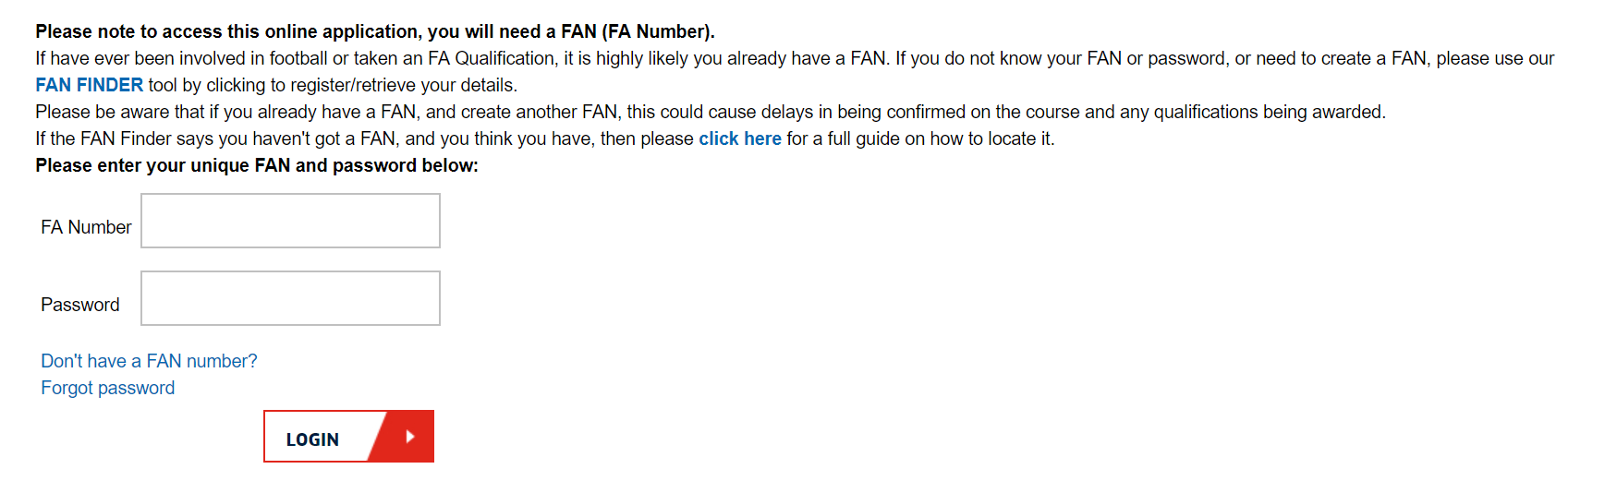
You will automatically receive a payment confirmation, which will state the event you have booked onto and the total fee.

*PLEASE NOTE A PLACE WILL NOT BE SECURED UNTIL PAYMENT IS MADE* If you are unsure if your payment has been successful/did not receive an email confirmation then please contact your relevant football development officer.

Contact Details
If you have any further questions/queries in regards to any of the information attached please contact the Futsal Finals Coordinator or your football development officer.

Group 1 Football Development Officers
- Lana Gillard Lana.Gillard@essexfa.com 01245 393 092

Group 2 Football Development Officers
- Karl Sear Karl.Sear@essexfa.com 01245 393 094
- Emma Burden Emma.Burdern@essexfa.com 01245 393 073

Group 3 Football Development Officer
- Rhys Elmer Rhys.Elmer@essexfa.com 01245 393 099

Group 4 Football Development Officer
- James Ellis James.Ellis@essexfa.com 01245 393 092

