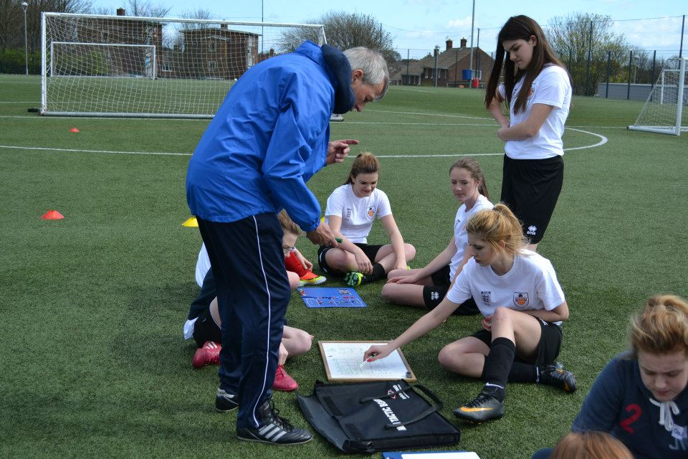

**DurhamFA.com**



## **Durham County FA Young Leadership Launch Day 2018**

|  |  |  |
| --- | --- | --- |
| **Venue:** | **Sunderland Bede College, Durham Rd, Sunderland SR3 4AH** | |
| **Wednesday** | 14th February 2018 | 9.00 – 5.00pm |

**Every candidate will have the opportunity to take part in the following workshops:**

* Coaching – **Age Appropriate Practices**
* Refereeing – **Basic Laws & Different Formats of Officiating**
* Disability - **Durham County Disability Offering (Inclusion League)**
* Recreation - **Durham County Recreational Offering (Walking Football)**

**Candidates will be asked to order the workshops from 1-4 in preference of which you would like to participate in on the day.**

**The Launch Day is on a first come first serve basis. Candidates are not guaranteed to get their preferred choices but we will endeavour to do our best.**

**Tel**: 0191 3872928 **Email**: [*Laura.Pye@DurhamFA.com*](mailto:Laura.Pye@DurhamFA.com) **Web**: [*DurhamFA.com*](http://www.durhamfa.com/)

**Durham County FA Young Leadership Launch Day**

**DurhamFA.com**



**Durham FA Coach Education Cancellation Policy**

If you need to cancel your attendance on the course you should inform Durham FA immediately. All our courses are in demand and by not advising us you are preventing another candidate from attending.

By submitting an application you agree to all of the terms above

**Getting your  Guidance Notes**

If you are a League Official, Club Official, Referee, Coach and/or Player it is extremely likely you have a **FAN** already.   
Please email: ***GetOnline@TheFA.com*** with your name, date of birth and address and your **FAN** and password will be emailed to you.

You can also register for a **FAN** at ***www.TheFA.com/FAN***

**FA Coaching Course  
Durham FA Coach Education Cancellation Policy**



**Young Leadership Launch Day 2018**

**For whom the conference is intended**

* Males or Females. Aged 14-24
* Members of the Football Futures Programme
* Prospective Members of the Football Futures Programme
* School, College, University and Sixth Form Students

**Course Requirements**

* Writing materials / Notepad
* Suitable playing kit, tracksuit, shorts, socks
* Footwear – appropriate to the surface
* Water bottle
* **Shin pads are compulsory**
* Lunch

The workshops are designed to help develop each leader’s ability and knowledge across different fields of football. There will be a mixture of theory and practical work.

**Course Code: CYP18**

**Application Form  
Durham FA Coach Education Cancellation Policy**

Title: …………..   
  
Forename: ………………………………………… Surname: ………………………………………………..

Address: ………………………………………………………………………………………………………………….

………………………………………………………………………………… Post Code:..………………………..

Date of Birth: ……../……../………. Tel: …………………………………………………….

FAN must be complete. If you do not know your FAN please see guidance notes



E-mail: …………………………………………………………………………………………………………………….

Disability/Medical Condition: …………………………………………………………………………………..

Which Club / School / College / University do you belong to:  
 **……………………………………………………………………….(Year Group)…………………………**

Which Workshop would you like to participate in on the Launch Day**: (This will be done on a first come first served basis)**

**1 - ……………………………………………………… 2 - ………………………………………………………**

**3 - ……………………………………………………… 4 - ………………………………………………………**

Which size of Nike T-Shirt would you require? **(Please Circle)**

**S / M / L / XL / XXL**

**Declaration:** I understand that Durham County FA and its servants, agents and employees are not under any liability whatsoever in respect of personal injury, loss or damage however caused, while taking part in any activities of the Association. I have read and agree to the Durham County FA Coach Education Cancellation Policy.

Please return to Durham County FA, Riverside South, Chester le Street, DH3 3SJ

**Completed applications should be returned to:   
Durham County FA, Football Development, Riverside South, Chester-le-Street, DH3 3SJ**