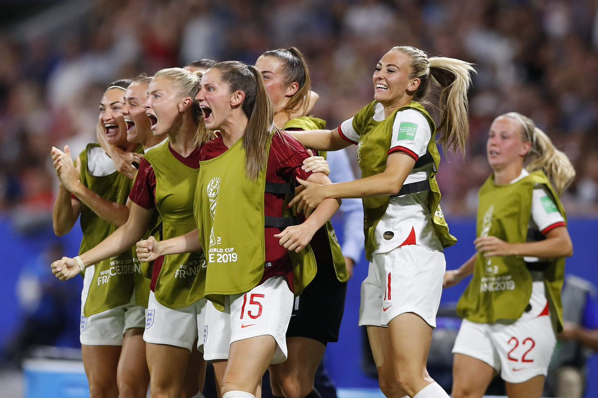

Durham County Football Association - Girls Player Development Centre 2019-2020
Application Form
Player Details:
Player’s Name:
Date of Birth:
Age Group: U10s | U12s | U14s:
Name of Club Currently Playing For:
Preferred Playing Position:
Do you consider your daughter to have a disability? If so, please specify.
Medical Information:
Does your child have any medical conditions? If so, please specify.
Does your child take / need to bring any medication with them? If so, please specify.
Is your child allergic to penicillin?
GP’s name and contact number:
Do you consent to any medical treatment being undertaken in the event of an accident?
Photography:
Your child may have photographs taken during the activities which may be used in promotional material and publicity in conjunction with the programmes of Durham County FA, including the website and social media. These images will be produced within the guidelines set out by The FA.

Please confirm if you give permission for photos of your child to be taken: YES | NO
Contact Details:
Parent’s / Guardian’s Name:
Contact Number:
Emergency Contact Number:
Email Address:
Declaration:
Signed:
Date:

DurhamFA.com
Information on how we use your personal data can be provided upon request.
Please return completed application forms no later than Friday 23rd August to:
Richard.Shuffleton@DurhamFA.com

