Devon County FA
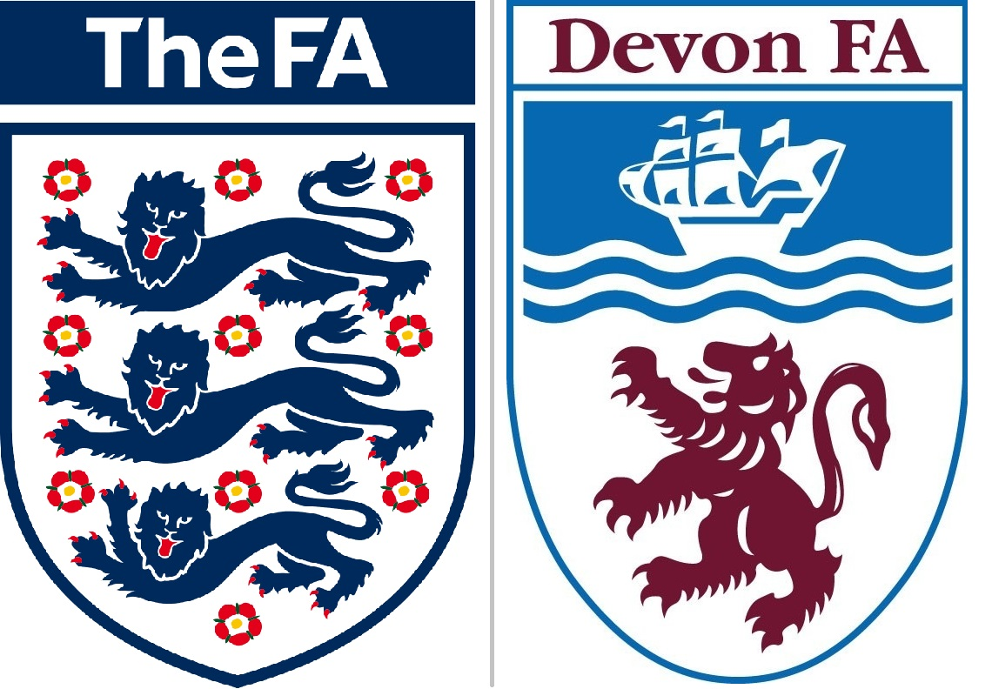
Inclusion Advisory Group (IAG) Chair
(Voluntary / Expenses)

Devon County FA is seeking to recruit an Independent Chair for our Inclusion Advisory Group (IAG).
This is a voluntary role, although expenses will be paid.
The FA announced a three year equality, diversity and inclusion plan called ‘In Pursuit of Progress’ in August 2018. This forms part of our commitment to ensure the diversity of those leading, governing, playing, refereeing, coaching and volunteering in football is representative of the demographics of and communities in Devon.
The Inclusion Advisory Group meets 3-6 times per year, and provides advice on equality and strategic input into our annual Operation Plan. Currently the group has membership from Devon & Cornwall Police, Football v Homophobia, Active Devon and the local football community. The successful candidate will have the opportunity to work with us and recruit further membership as required.
Additionally members of the Inclusion Advisory Group are embedded within our Strategic Groups for Female Engagement, BAME Engagement, and Health & Older Participation, which meet with key partners including Football in the Community Trusts, Local Authorities, Education and others. The IAG Chair is not necessarily expected to attend all of these groups, but these do provide updates to the IAG which in turn reviews progress. The IAG Chair is a key figure in leading independent review of Devon County FA objectives with the IAG, and making recommendations for our Operational and Business Plans.
Responsibilities:
We are looking for a dynamic, motivated and proactive individual who wants to make a positive difference to grassroots football in Devon. The IAG Chair will:
• Lead the IAG to advise Devon FA and promote Inclusion & Diversity throughout the organisation
• Work closely with the Senior Football Development Officer and other staff to ensure resources are effectively prioritised for inclusion success
• Prepare the Agenda for IAG meetings, and ensure that IAG action points are documented and actioned
• Represent the IAG on the Devon County FA Council, and provide updates to the Board of Directors
• Attend The FA National Inclusion Conference
This will be supported by the Devon County FA Equality Champion on the Board of Directors, and by the Senior Football Development Officer.
What we can offer:
Devon County FA is the governing body for football in Devon.
• An exciting opportunity to be part of a forward thinking, progressive Business
• Opportunity to work with key stakeholders within the grassroots game
• A commitment to support personal development
• Travel expenses when attending meetings & events
Knowledge / Experience / Skills required:
Essential | Desirable
• Be able to plan, drive and chair meetings  • Ability to review and analyse data, to assist in making informed decisions  • Build relationships with members of staff, members of the IAG and members of the community  • Knowledge of key legislation around inclusion & diversity  • Identify key issues and identify possible solutions to promote inclusion and diversity in grassroots football  • Work as part of a team, in a professional manner as a representative of Devon County FA | • Good understanding of grassroots football  • Existing contacts within local football and the wider community  • Knowledge of community groups and/or local business networks  • Basic presentation skills  • Experience of strategy planning / consultation
Application Process
Please complete and return the application form via email to info@devonfa.com or post your application to Devon County FA, Coach Road, Newton Abbot, TQ12 1EJ.
Closing date for applications: Monday 20th May.
Shortlisted applicants will be invited to interviews w/c 3rd June. We can be flexible with interview times where required.
Note this is a voluntary role. For an informal discussion, or further information, please contact Dai Carpenter, Senior Football Development Officer – 07792 634577 / david.carpenter@devonfa.com

