FA Communications FAQs
Sin bins
For: Communications Team [CONFIDENTIAL]
Updated: 25/07/2019

Frequently Asked Questions
Topic: | Details:
Why? | QUESTION: Why has The FA introduced sin bins into grassroots football?  ANSWER: In March 2017, the International Football Association Board (IFAB) gave all National Associations the ability to implement Temporary Dismissals – more commonly known as sin bins – at the grassroots level of the game. The FA chose to focus on matters of dissent to improve the match day experience and in support of the RESPECT programme.  QUESTION: Has it been trialled? I assume the trial was successful? Has it seen an improvement in player behaviour, and why has it taken so long to introduce sin bins?  ANSWER: In 2016/17 season there were over 73,000 cautions for dissent – making up around 25% of all cautions. With this in mind we decided to pilot sin bins across all types of the game at Step 5 and below of the National League System and Tier 3 and below of the Women’s game in a bid to reduce levels of dissent. In total, 31 leagues have used the system over the past two seasons.  During this period we saw a 38% reduction in dissent across the selected leagues. It also showed a reduction on dismissals for receiving a second caution in a game and abusive language. A survey carried out to obtain feedback from around 1,400 users showed that:  - 72% of players wanted to continue with sin bins;  - 77% of managers/Coaches wanted to continue with sin bins;  - 84% of referees wanted to continue with sin bins.  The pilot has shown that participant behaviour / match day experience has improved. It also showed players self-policing the game to prevent their colleagues from getting into trouble.  QUESTION: Are there plans to introduce sin bins in the professional game?  ANSWER: This is not a matter for The FA as IFAB only permits the use of Sin Bins at grassroots level. We initially trialled sin bins across various leagues at Step 7 and below, and after a successful trial period we are now rolling it out across all leagues at grassroots level, including at youth level.  QUESTION: Will it be taken up by European and/or international competitions?  ANSWER: The FA governs English football and therefore only implements rules which affect the English game. IFAB only permits the use of sin bins at grassroots level within each National Association. It would be down to the governing bodies and organisations that control those particular European competitions on whether they’d like to implement sin bins.  QUESTION: Is it in the women’s game as well?  ANSWER: Yes. From the 2019/20 season, sin bins will be in the third tier of women’s football and below. The trial was also implemented in Tier 5 and below in women’s football.  QUESTION: Is this an admission that our discipline procedures aren’t up to scratch now we are we copying from other sports?  ANSWER: Not at all. We are always looking at ways to improve the experience and participation for everybody involved in football and IFAB gave National Associations the discretion to introduce it. The FA could see the benefit so we introduced it at grassroots level.
What for? | QUESTION: For what offences would a player get sent to the Sin Bin for?  ANSWER: Dissent – by word or by action – which is a behavioural matter rather than a football matter. By reducing dissent, we hope to improve the retention of referees while improving the image of the game.  QUESTION: OK, so what is dissent?  ANSWER: Dissent can fall into two categories, either via word or action in the opinion of the referee.
Timings | QUESTION: How long are you sin binned for?  ANSWER: 10 minutes in adult football and eight minutes in youth football.  QUESTION: When does the sin bin time start? From the moment the referee shows the card or from the moment the player leaves the field of play?  ANSWER: The player is technically in the sin bin the moment he/she is advised he is being cautioned for dissent but the sin bin time begins from the moment play restarts.  QUESTION: How is the sin bin timed?  ANSWER: It will be timed by the referee.  QUESTION: How are the timings going to work if the referee has more than one player in the Sin Bin?  ANSWER: The referee will monitor these issues simultaneously. Our research of over 135,000 matches showed that less than 1% of matches have more than three cautions for dissent. The chances of those occurring in the same 10-minute period are remote. However, by following the correct caution procedure, the referee can manage multiple players in the Sin Bin.
The card | QUESTION: Does a sin binned player still get shown a card? If so, is it a yellow card or a different colour?  ANSWER: All cautions for dissent must be dealt with by the sin bin process. The referee will signal this by issuing a yellow card in the normal way and pointing to the touchline where the player must go. It can only be administered to active players who are participating.  QUESTION: If a substitute, or substituted player, or a manager/coach commits an act of dissent, what happens?  ANSWER: Substitutes or substituted players will be cautioned for dissent, as per the ‘usual’ process that currently applies across football. As from this season the laws have been amended for red and yellow cards to also be applied to technical area occupants – but this is separate to the Sin Bin process.
Players leaving the field of play | QUESTION: Is there an actual ‘bin’? Where does a sin binned player go?  ANSWER: There isn’t a physical sin bin. In grounds where there are technical areas, the player in question must go to their team’s technical area. Elsewhere, players must leave the pitch and watch from the touchline with other non-playing staff.  QUESTION: How many players can be in the sin bin at one time?  ANSWER: Our research of over 135,000 matches showed that less than 1% of matches have more than three cautions for dissent. The chances of those occurring in the same 10-minute period are remote.  There’s no limit on the amount of players that can be in the sin bin at any one time. If a team is reduced to less than seven players due to sin bins, the game will be abandoned as covered under the current Law.  QUESTION: Can a sin binned player leave the sin bin area?  ANSWER: Yes, sin binned players can leave the sin bin area to warm up.  QUESTION: What happens if a player commits an offence while leaving the field of play?  ANSWER: This may result in further action for misconduct being taken.  QUESTION: What happens if a player commits an offence whilst in the sin bin?  ANSWER: The player would receive either another yellow card or, if serious, a red card. The player will not be able to resume play and would not be permitted to be substituted.
Players re-entering the field of play | QUESTION: How does a player come back on after the 10 minutes is up? Is it at the next break in play? Or are they waved on during play, similar to a player who has left the field for treatment of an injury?  ANSWER: Similar to a player who has left the field for treatment for an injury, the player can be waved back onto the field of play by the referee during play.
Discipline and fines | QUESTION: Can you be sin binned more than once in a match?  ANSWER: Yes. Upon a second temporary dismissal the player would not be able to re-enter the match nor be substituted.  QUESTION: What happens if the goalkeeper commits an act of dissent? Do they also go in to the Sin Bin? Who can replace them?  ANSWER: Yes, goalkeepers are covered under the same law as other players and can go into the sin bin. Much like when a goalkeeper is sent off, any other player must go in goal but the team must remain with 10 players. Upon returning, if during play, the goalkeeper can become an outfield player, and then return to being the goalkeeper during the next stoppage in play.  QUESTION: At the end of the Sin Bin time, can the team bring on a substitute for the Sin Binned player?  ANSWER: Yes, at the end of the Sin Bin time, a substitute can take their place rather than the player in question returning to the pitch, providing they have not used all of their allocated substitutions.  QUESTION: Does the sin bin yellow card count towards a players’ seasonal tally of yellow cards?  ANSWER: Yes the caution tally would include any sin bin Offence.  QUESTION: Does a player still have to pay the yellow card fine if they’re sent to the sin bin? And what happens to the money County FAs would usually make from yellow cards for dissent?  ANSWER: Players will not be required to pay the administration fee for going into the Sin Bin as the punishment has already been served during the match for a single Sin Bin offence. Administration fees will still apply to all other cautions and send offs.  We want to encourage better behaviour to improve the match day experience for everybody involved. This isn’t a financial matter and The FA continues to work with CFAs to ensure they have the resources necessary to support their clubs. Repeat offenders will also be fined £25 as well as a one match ban.  TABLE SUMMARY OF MULTIPLE OFFENCES:  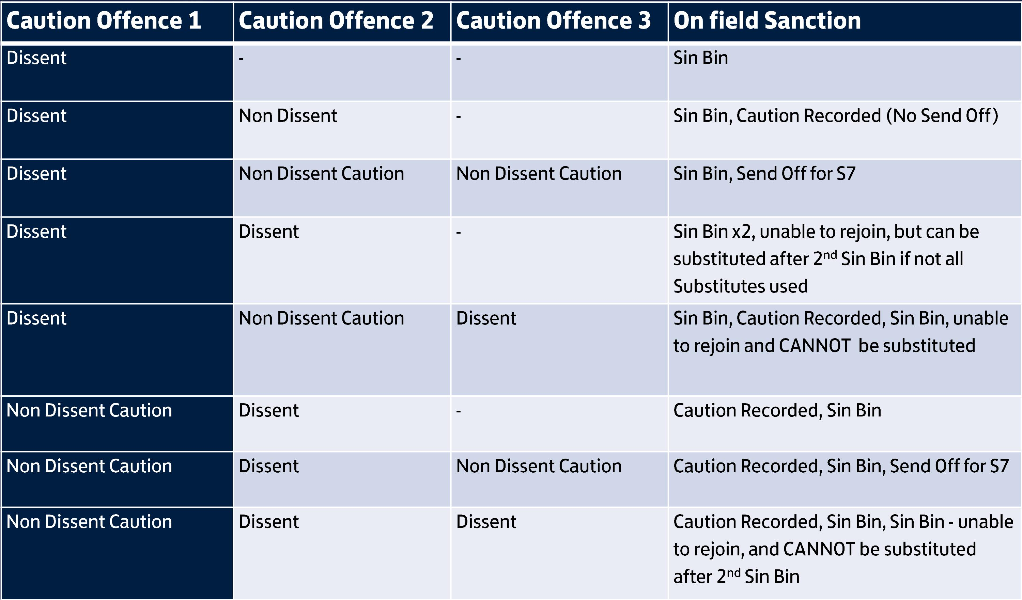
-END-

