Match Postponement Form (to be completed in BLOCK CAPITALS in black ink)
This report is to be completed in the following circumstances:
When the match referee postpones the game after an inspection of the field of play
When a referee other than the match referee postpones the game after an inspection of the field of play
When the Competition agree to a postponement, prior to the scheduled date of the match, without an inspection of the field of play
It is the duty of the Home Club to inform the Match Officials, their Opponents and the relevant Competition Secretary of the postponement without delay.
CHESHIRE FA Junior Cup

(H): | (A):
Date: | Match Official:

REASON FOR THE POSTPONEMENT AND RULE COVERING CIRCUMSTANCES:

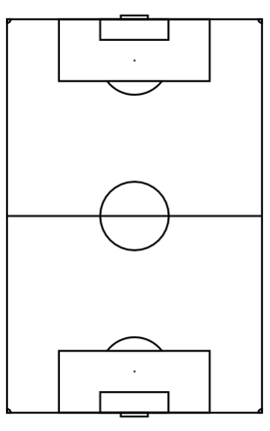
IDENTIFY AREAS OF THE FIELD WHICH ARE UNPLAYABLE (WHERE APPLICABLE):

Signature:
Time:
Date:
Name of home club official (where applicable):
Signature:
Time:
Date:
Name of inspecting match official (where applicable):
CheshireFA.com/cups-and-competitions @CCFACountyCups
Please return this form completed to: alfroberts@talktalk.net

