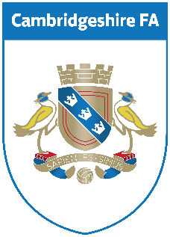
Bobby Moore Walking Football Festival
Sunday 8th September 2019: One Leisure, St Neots, PE19 2SA
£25 Entry Fee
Team name
Manager Contact Details:
Name
Contact Number
Email address
Photographic consent

Please pay £25 deposit to secure your team place by either cheque or BACS, cash will be accepted on the day.
Cheques made payable to:
Cambridgeshire Football Association
Or by bank transfer -
Payment reference: CAMBS FIVES and Team name
Bank: Barclays
A/C Name: Cambridgeshire Football Association Limited
Sort Code: 20-17-35
Account no: 30539155

