GUIDANCE NOTES NO:

1.1
FOOTBALL’S SAFEGUARDING CHILDREN POLICY

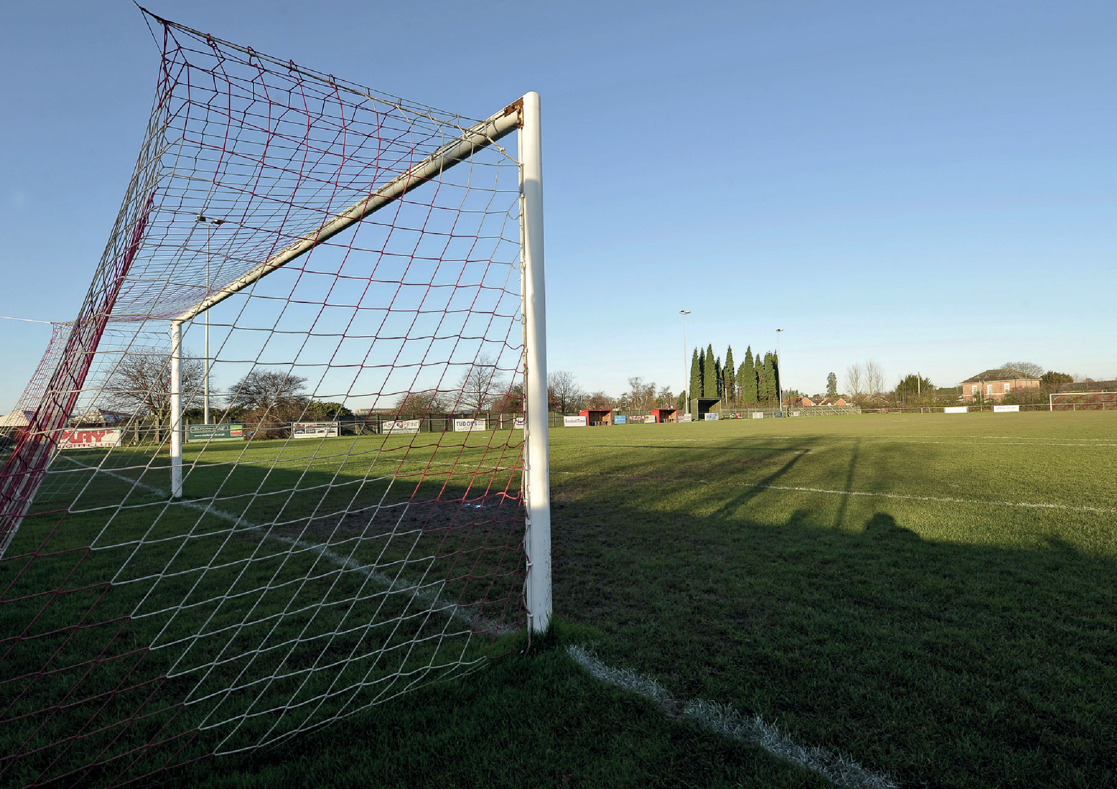Signed up to by the Football Authorities governing the affiliated English game:

VERSION 1.3
PUBLISHED: DECEMBER 2020

CONTENTS

PAGE PAGE

- INTRODUCTION 3
FOOTBALL’S COMMITMENT, SAFEGUARDING FRAMEWORK AND POLICY STATEMENT
- FOOTBALL’S COMMITMENT 4
- SAFEGUARDING FRAMEWORK WITHIN FOOTBALL 5
- FOOTBALL’S SAFEGUARDING CHILDREN POLICY STATEMENT 6
- SAFEGUARDING RESPONSIBILITIES 7
PRINCIPLES, CULTURE AND PRACTICE
- SAFEGUARDING PRINCIPLES, CULTURE AND
SAFER WORKING PRACTICE 8
- SAFER RECRUITMENT 9
- APPROPRIATE BEHAVIOURS AND ABUSE OF TRUST 10
- CONTEXTUAL SAFEGUARDING 11
- RADICALISATION
- ADDITIONAL VULNERABILITY
- SAFEGUARDING TRAINING AND DEVELOPMENT 12
- WORKING IN PARTNERSHIP WITH STATUTORY AGENCIES
RESPONDING TO CONCERNS, WHISTLEBLOWING AND COMPLAINTS
- RESPONDING TO CONCERNS 13
- WHISTLEBLOWING 14
- SAFEGUARDING COMPLAINTS 15
- CONFIDENTIALITY AND INFORMATION SHARING
POLICY REVIEW, ACKNOWLEDGEMENTS & GLOSSARY
- POLICY REVIEW 16
- ACKNOWLEDGEMENTS
- GLOSSARY OF TERMS 17
APPENDICES
APPENDIX 1 – DEFINITIONS OF ABUSE 19
APPENDIX 2 – LEGISLATION AND STATUTORY GUIDANCE 22
APPENDIX 3 – FOOTBALL AUTHORITIES - RESPONSIBILITIES AND ACCOUNTABILITIES 23
APPENDIX 4 – COMPLAINTS 27
APPENDIX 5 – USEFUL CONTACTS 30

1.1 | FOOTBALL’S SAFEGUARDING CHILDREN POLICY 2

INTRODUCTION

Football provides a hugely positive experience for the majority of circa 4.5 million children who participate in it. The game promotes a healthy lifestyle, is fun and helps to create lifelong friendships. It also teaches life skills such as teamwork, leadership
and resilience.
Sadly however, this is not the experience of every child.
Football is made up of many different parts – for example clubs, leagues, local and national associations, representative bodies, trusts and foundations. In England football is formalised and overseen by the Football Authorities1 , who oversee the affiliated game.
This overarching Safeguarding Children Policy is for anyone who wants to understand the Football Authorities (“Football’s”) shared commitment and framework to work together to safeguard children across all aspects of football’s landscape. It is underpinned by each
organisation's procedures and action plans wherever children are –
or might be – involved. This includes the Grassroots Football Safeguarding Children Policy and Procedures, published by The FA.
Collectively and individually, we take our responsibilities to safeguard the welfare of children very seriously and we continuously strive to make the game ever more inclusive, safe, and enjoyable for every child, whatever their role – whether as a player, match official, mascot or volunteer.
This ensures that Football has a safeguarding framework that promotes safer working practice and deals effectively with inappropriate behaviour at every level of the game.
From the NSPCC's Child Protection in Sport Unit:
The NSPCC CPSU welcomes this safeguarding children policy that ensures safeguarding children remains at the heart of football. The NSPCC CPSU works closely with the football authorities to support safeguarding and child protection across the sport.
Michelle North, Head of Service, CPSU
The collective safeguarding responsibility also extends to adults, and our collaborative approach to adult football, which is governed by different legislation and guidance, is covered in our Safeguarding Adults Policy which you can read here.

1 Affiliated Football (“Football”) refers to the following organisations collectively: The Football Association (The FA and through The FA, all County FAs), Premier League, English Football League (EFL), Professional Footballers Association (PFA), League Managers Association (LMA), Professional Game Match Officials Limited (PGMOL), League Football Education (LFE), Premier League Charitable Fund (PLCF) and EFL Trust.

  - | FOOTBALL’S SAFEGUARDING CHILDREN POLICY 3

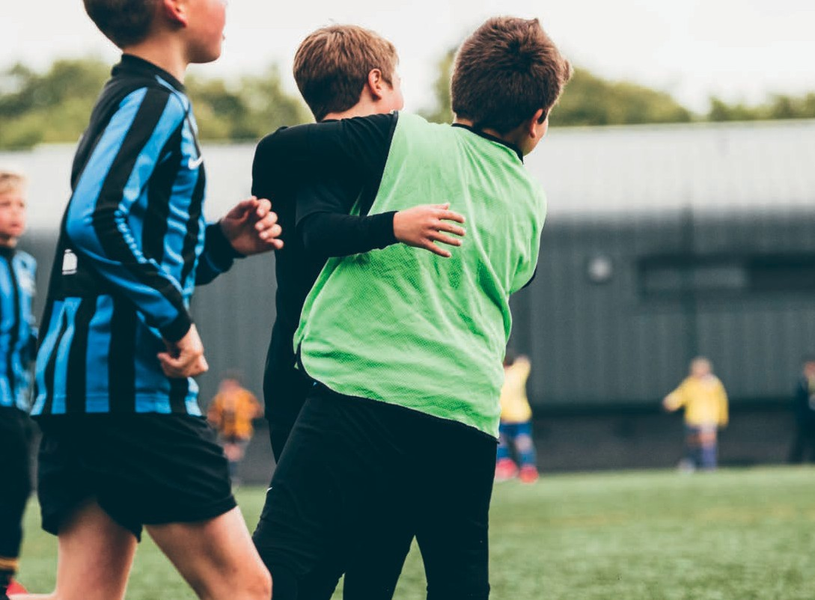FOOTBALL’S COMMITMENT, SAFEGUARDING FRAMEWORK AND POLICY STATEMENT

FOOTBALL’S COMMITMENT

The Football Authorities have a shared ongoing commitment to make our national sport as safe, enjoyable and inclusive as possible for everyone.
To do so, we continue to work collaboratively in line with legislation, Government guidance and industry best practice to:
- Implement preventative safeguarding measures, supported by regulations and/or rules, policies, procedures, standards, safer recruitment checks, guidance and training;
- Make the reporting of concerns as easy as possible;
- Ensure safeguarding and child protection concerns are investigated swiftly and effectively in conjunction with statutory agencies –
and with demonstrable outcomes;
- Review and continuously develop our practice.

This commitment underpins both this Policy and our own individual organisation’s policies.

1.1 | FOOTBALL’S SAFEGUARDING CHILDREN POLICY 4

FOOTBALL’S COMMITMENT, SAFEGUARDING FRAMEWORK AND POLICY STATEMENT

SAFEGUARDING FRAMEWORK WITHIN FOOTBALL

Football’s safeguarding framework means that there are rules, regulations and requirements that must be met at every level of grassroots and professional football to safeguard children. This includes the leagues that The FA directly administers - the Barclays FA Women’s Super League and Women’s Championship and the National League System.
The FA's Safeguarding Operating Standard sets out the requirement for County FAs to adhere to, including the oversight of
preventative safeguards in grassroots clubs with Under-18s.
The Premier League and EFL have specific safeguarding rule-based requirements for their clubs, which, the respective Leagues are responsible for overseeing
and supporting.
In addition to setting the preventative standards, as the national governing body, The FA’s regulatory framework means that it has the power to investigate safeguarding concerns and act against any club or participant who breaches its safeguarding policy and/or safeguarding regulations.
Through its regulations The FA assesses participants who pose or may pose a risk of harm to children and can put appropriate safeguards in place, including education,

mentoring, supervision agreements, interim and permanent suspensions, as well as making referrals to the Disclosure and Barring Service. For more information on the safeguarding regulations please refer to
The FA Handbook.
For more information on accessing each organisation’s specific rules, policy and procedures. (See Appendix 5.)
Football works collaboratively with Sport England, the NSPCC Child Protection in Sport Unit (CPSU) the Home Nations, other National Associations, UEFA and FIFA to ensure that we play our part in safeguarding football at every level.
Meeting the safeguarding requirements set out by the NSPCC CPSU, UEFA and FIFA is part of Football’s ongoing commitment to continuous improvement. Working in partnership with other sports and football internationally, is essential to safeguard children effectively.

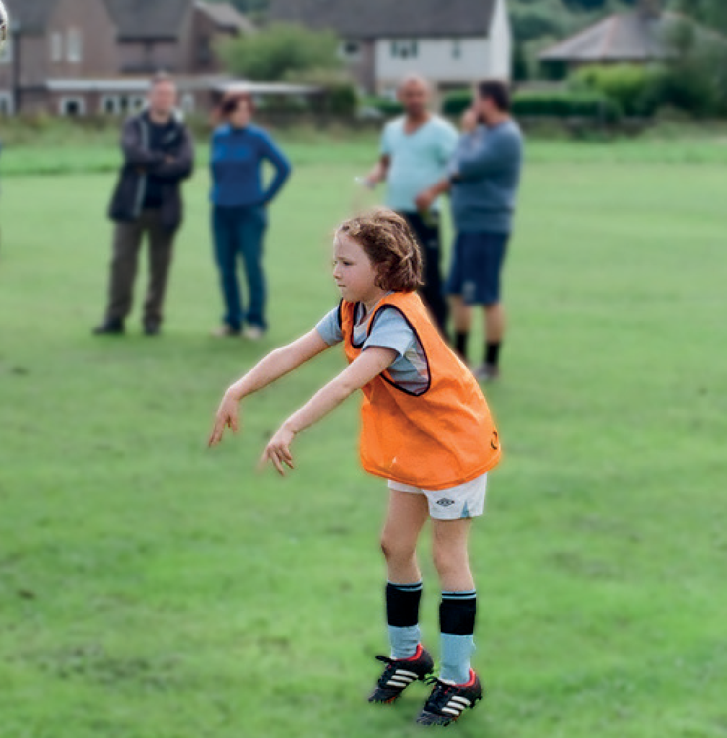

1.1 | FOOTBALL’S SAFEGUARDING CHILDREN POLICY 5

FOOTBALL’S COMMITMENT, SAFEGUARDING FRAMEWORK AND POLICY STATEMENT

FOOTBALL’S SAFEGUARDING CHILDREN POLICY STATEMENT

Football recognises and is committed to its collective and individual responsibilities to help safeguard children, across all aspects of football and its organisations. This includes staff, volunteers, contractors and commissioned service providers, everyone attending our events, those within our venues and participating in football.
Football commits to ensuring our safeguarding policies for children are at the centre of all that we do to provide a safe, fun and inclusive environment for all. The welfare of children who participate in our football and non-football activities, visit our venues and work or volunteer is paramount. In particular:
- We are committed to ensuring our activities are inclusive and uphold that every child has a right to be protected from abuse regardless of their age, disability, gender reassignment, sex, sexual orientation, religion or belief, race, pregnancy and maternity, marriage and civil partnership;
- Every action (decisions, conduct, training methods, education programmes, case management, etc.) related to children in football must take into account their best interest as the primary consideration.

- Children’s rights, as set out by the UNCRC, must be respected and promoted throughout the game of football. With this in mind:
- Every child has the right to take part in football in a safe, protective and inclusive environment free from all forms of maltreatment, harassment, abuse or exploitation;
- The child is to be put before the player, referee, supporter or any other role they may have in football;
- Any form of maltreatment or abuse disrespects the rights of the child and will not be tolerated;
- Children have the right to participate and be heard across the game and have their views and opinions be taken in consideration in all decisions and actions concerning them.

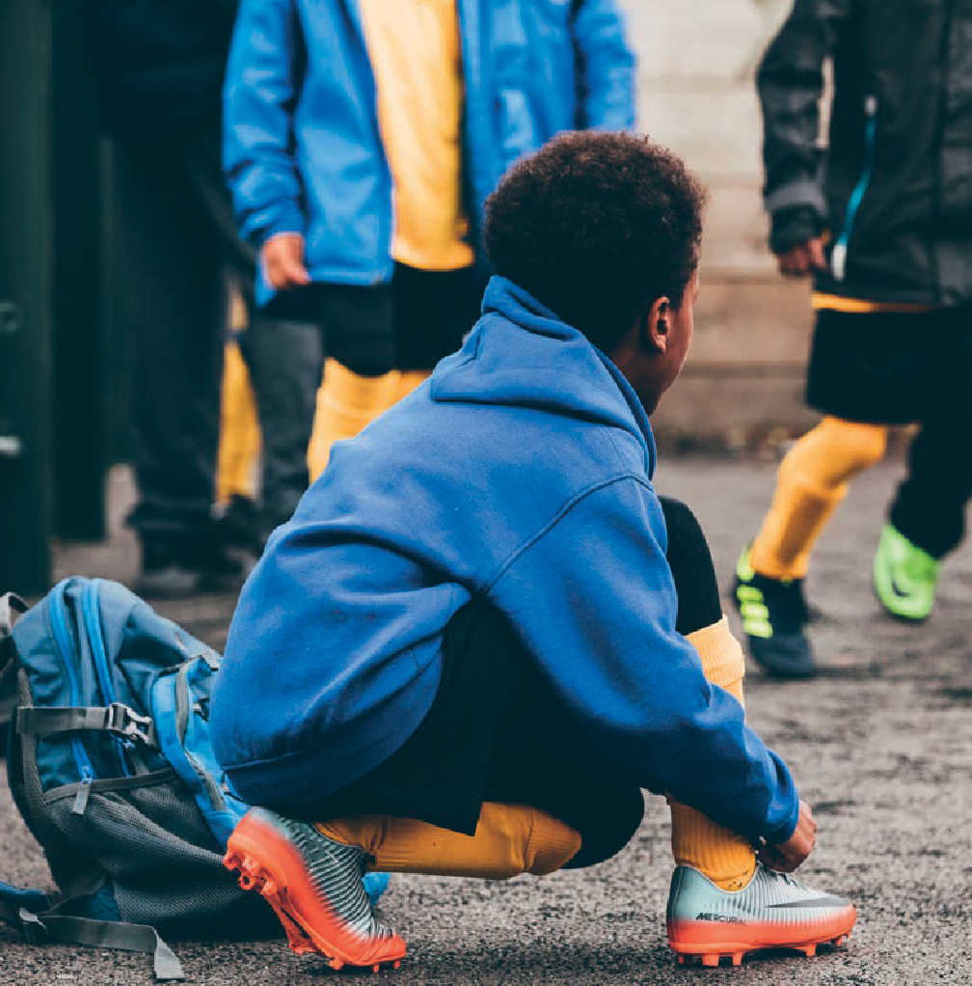

1.1 | FOOTBALL’S SAFEGUARDING CHILDREN POLICY 6

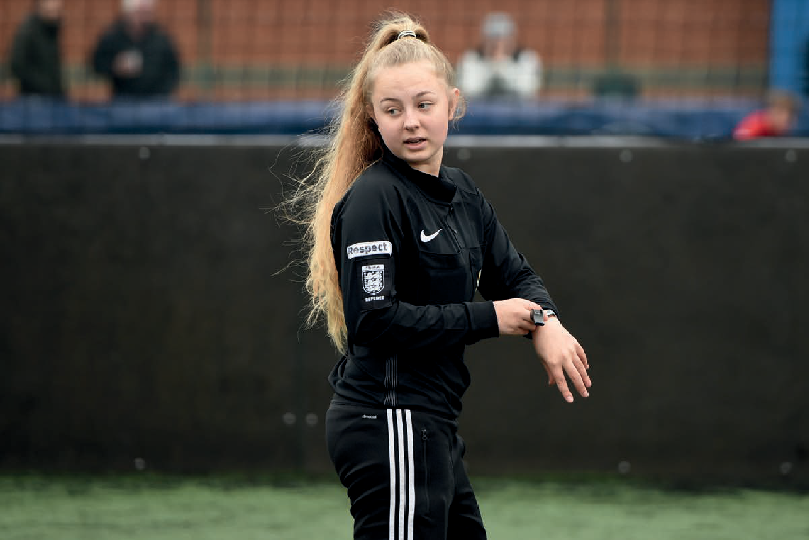FOOTBALL’S COMMITMENT, SAFEGUARDING FRAMEWORK AND POLICY STATEMENT

SAFEGUARDING RESPONSIBILITIES

Safeguarding is the responsibility of
everyone within Football: this includes staff, volunteers, contractors and commissioned service providers. For safeguards to be effective across the game we recognise the need for proactive leadership from our senior management teams, CEOs, Chairs, Boards, Trustees and committees.
There are staff appointed at all levels of the game with specific designated safeguarding responsibilities. Their roles are to advise and guide, drive the implementation of safeguards across football and work with colleagues to monitor compliance with
the safeguarding requirements and to manage safeguarding and child protection concerns and referrals. Every club providing activities for children must have appointed a Designated Safeguarding Person in line
with our Safer Recruitment principles (7) and Training and Development principles (12).
Each of the Football Authorities have outlined key safeguarding responsibilities
– further information can be found in
Appendix 3.

1.1 | FOOTBALL’S SAFEGUARDING CHILDREN POLICY 7

PRINCIPLES, CULTURE AND PRACTICE

SAFEGUARDING PRINCIPLES, CULTURE AND SAFER WORKING PRACTICE

All staff, volunteers, trustees, board members and committees must understand:
- That safeguarding is everyone’s responsibility;
- Creating fun, safe and inclusive football environments should be at the heart of everything we do, to support the best outcomes for children;
- How our behaviours and actions can make a difference;
- The importance of ensuring that children and young people have a voice and are heard;
- The role and duties of those with specific safeguarding responsibilities;
- When and how to report concerns relating to our organisation;
- The process to use when a concern does not relate to our organisation;

A range of supporting procedures and guidance are applied across football, ensuring appropriate safeguards are applied to specific contexts.

Everyone has a responsibility to consistently and continuously apply the procedures and guidance.

1.1 | FOOTBALL’S SAFEGUARDING CHILDREN POLICY 8

PRINCIPLES, CULTURE AND PRACTICE

SAFER RECRUITMENT

Football is committed to recruiting safely and fairly including:
  - Ensuring DBS checks are undertaken and renewed in line with the Disclosure and Barring Service and our own guidance;
  - Creating a culture of ongoing vigilance, including (i) the use of inductions which incorporate safeguarding, (ii) ensuring safeguarding responsibilities are embedded in staff and volunteer role profiles and are reviewed as part of regular reviews of objectives with line
managers; (iii) taking up references and checking qualifications/professional registrations); and
  - Ensuring contractors and commissioned service providers operate safer recruitment practices.

1.1 | FOOTBALL’S SAFEGUARDING CHILDREN POLICY 9

PRINCIPLES, CULTURE AND PRACTICE

APPROPRIATE BEHAVIOURS AND ABUSE OF TRUST

Everyone who works or volunteers with children is responsible and accountable for the way in which they behave towards them and every child has a right to be treated with respect and dignity. Each of the Football Authorities is required to communicate clearly about what is considered acceptable and unacceptable behaviour for staff, players, club and league officials, parents/carers and spectators in their context.
Harming or abusing a child is never acceptable under any circumstances and must be reported to the relevant statutory agency, in line with the relevant reporting procedures (14). Poor Practice is unacceptable in football and must be treated seriously with
appropriate actions taken.
It’s expected that all adult-child relationships maintain clear and appropriate boundaries at all times, are supportive, positive and aimed at improving the child's skills, development and progress. Adult-child relationships should all focus on the respective activity/event.
The Sexual Offences Act 2003 (the “Act”) prohibits someone in a position of trust, within certain regulated environments, to engage in sexual activity with a child in their care, including where a child is over the age of consent (16 or over)2.
Whilst sport, including football, is not a regulated environment under the Act3, Football considers it appropriate to apply this principle and it is underpinned by our safeguarding regulations, rules and policies.
2 Sexual Offences Act 2003
3 https://www.legislation.gov.uk/ukpga/2003/42/contents

Position of Trust means any position where an individual is in a relationship of trust with any person with responsibility and/or authority in relation to that person, and shall include without limitation those who care for, advise, supervise, train, coach, teach, manage, tutor, mentor, assess, develop, guide, treat or provide therapy to children.
No intimate or sexual relationship should take place while a member of staff or volunteer is in a Position of Trust with a child. In addition, inappropriate, intimate or sexual relationships between an adult and a child aged 16
and 17 may be unlawful, irrespective of gender and sexual orientation.
Therefore, if an adult engages in an intimate or sexual relationship with an under-18, whether they are a player, or another role as a young referee, coach, volunteer etc, is a breach of The FA’s Regulations, and as such may result in disciplinary action. Where appropriate, a referral will
be made to the statutory agencies, including the Police, applicable Local Authority bodies, and to the Disclosure and Barring Service (DBS).
Where a Position of Trust exists, it does not make any difference whether or not the relationship is consensual. The imbalance of power makes it an abuse of the Position of Trust.

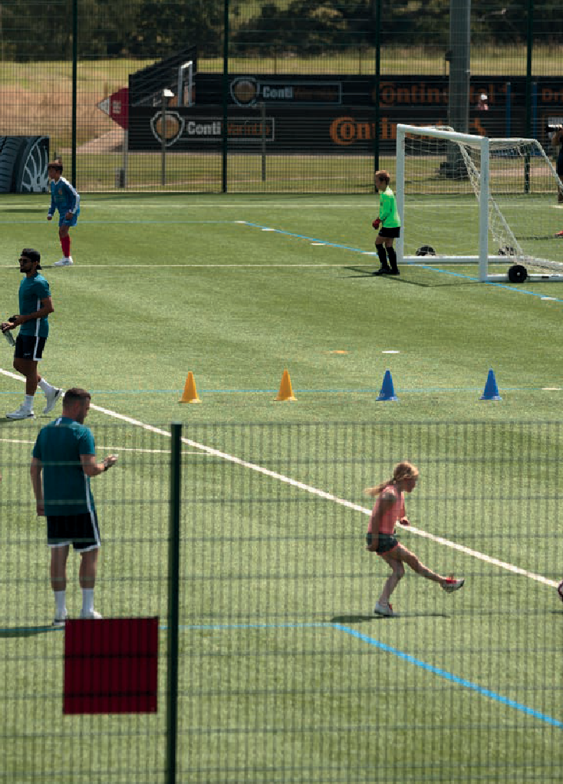

1.1 | FOOTBALL’S SAFEGUARDING CHILDREN POLICY 10

PRINCIPLES, CULTURE AND PRACTICE

CONTEXTUAL SAFEGUARDING

Children are engaged in physical places and spaces beyond their families through both football and non-football activities. Therefore, Football is committed to recognising Contextual Safeguarding principles4 in its safeguarding practice.

RADICALISATION

Radicalisation shares similarities with other forms of exploitation and grooming, it is therefore a safeguarding issue which Football must be aware of. We recognise that this may pose a risk to those participating in our activities and visiting our venues, so we must consider these factors when implementing safeguards to protect children.

ADDITIONAL VULNERABILITY

We recognise that some children are disadvantaged by their experiences. This could be as a result of family circumstances, poverty, discrimination, disability, mental health, domestic violence, child abuse, or substance and alcohol misuse.
The more challenges facing a child the greater their vulnerability to abusive behaviour, grooming, exploitation and/or radicalisation. We recognise these additional vulnerabilities and consider them when implementing our safeguards to protect children.

4 Contextual Safeguarding Network
https://www.csnetwork.org.uk/assets/documents/Contextual-Safeguarding-Briefing.pdf

1.1 | FOOTBALL’S SAFEGUARDING CHILDREN POLICY 11

PRINCIPLES, CULTURE AND PRACTICE

SAFEGUARDING TRAINING AND DEVELOPMENT

Football is committed to ensuring our staff, volunteers, trustees, board members and committees, receive a safeguarding induction and training appropriate to the level and requirements of their role which are both updated regularly.

WORKING IN PARTNERSHIP WITH STATUTORY AGENCIES

Football is committed to working in partnership with local and national statutory partners, including the Police, Children’s Social Care, Local Safeguarding Children Partners, and the Disclosure and Barring Service (DBS) in accordance with their procedures. Multi-agency working is essential to enable partner organisations to carry out their statutory duties to investigate concerns and protect all children.

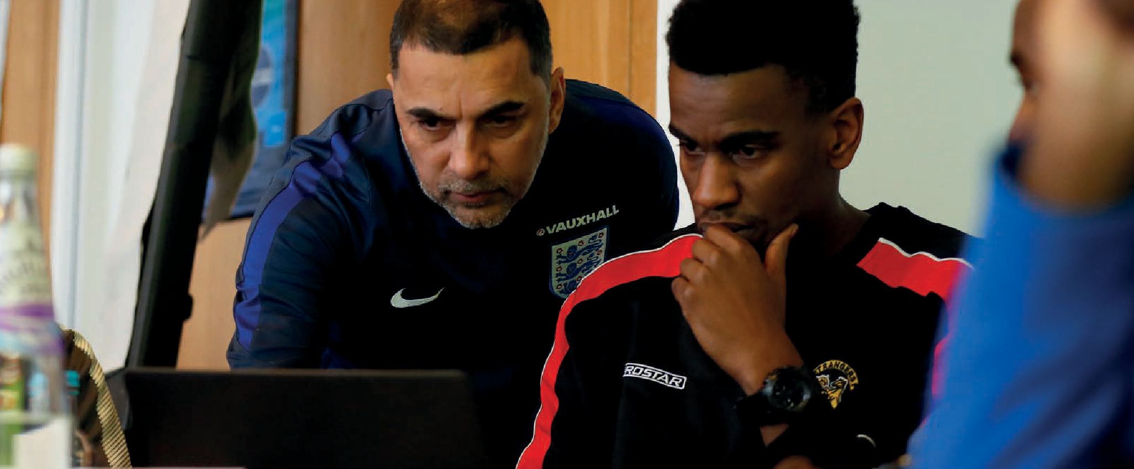

1.1 | FOOTBALL’S SAFEGUARDING CHILDREN POLICY 12

RESPONDING TO AND DEALING WITH CONCERNS, WHISTLEBLOWING AND COMPLAINTS

RESPONDING TO CONCERNS

Each of the Football Authorities have robust procedures that communicate clearly how to refer concerns about a child’s welfare and how to manage poor practice concerns.

CONCERNS ABOUT A CHILD'S WELFARE (INCLUDING POSSIBLE ABUSE)
If there is concern about a child or an adult's behaviour towards a child, or a child that is not at immediate risk of harm, the relevant football authorities' procedures must be followed. If you need to report a concern, you can access the links in Appendix 5.
Failure to report a concern about the welfare of a child may result in action taken by
The FA under its Disciplinary Regulations.

If there is a concern that a child is at risk of immediate harm, contact should be made with either the Police or Local Authority Children’s Services or the NSPCC Helpline: 0808 800 5000.

The relevant Designated Safeguarding Person should also be contacted to inform them of the action taken as soon as is realistic.
Safeguarding concerns relating to football can be referred to The FA’s Safeguarding Case Management team via
safeguarding@TheFA.com.
This is not a 24-hour service, but all matters will be triaged during working hours, i.e.
Mon-Fri between 9-5pm. Some concerns may be passed to the relevant statutory agency, league, club or County FA as appropriate.
For information on making a complaint relating to an individual football authority please see Appendix 4.
Each football authority has a procedure on how to appeal any decisions made; for further information refer to Appendix 4.

POOR PRACTICE CONCERNS
Football takes Poor Practice seriously. All cases should be dealt with in line with the relevant football authorities
safeguarding and disciplinary processes.
To allow Poor Practice to continue unchallenged may result in an environment developing in which abuse may be able to take place and subsequently have a negative effect on a football environment and culture. If unchallenged unacceptable behaviour may become normalised.
If the concern is one of possible Poor Practice, the relevant football authorities' procedures should be followed.

1.1 | FOOTBALL’S SAFEGUARDING CHILDREN POLICY 13

RESPONDING TO AND DEALING WITH CONCERNS, WHISTLEBLOWING AND COMPLAINTS

WHISTLEBLOWING

Whistleblowing can be used as an early warning system or when it’s recognised that appropriate actions have not been taken.
It is about revealing and raising concerns over misconduct or malpractice within an organisation or within an independent structure associated with it.
Anyone with concerns about an individual or an organisation’s practice can call
0800 169 1863 and ask for The FA's Safeguarding Team, or via email on safeguarding@TheFA.com.
Alternatively, concerns can be reported direct to the Police or Children’s Social Care, or to the Child Protection in Sport Unit via
cpsu@nspcc.org.uk or the NSPCC Helpline via 0808 800 5000 or by emailing help@nspcc.org.uk.

The UEFA Integrity Platform allows for concerns to be raised (including anonymous reporting). Written complaints can also be sent to childsafeguarding@uefa.ch, or a person of trust within UEFA can be spoken to directly in order to report a concern.

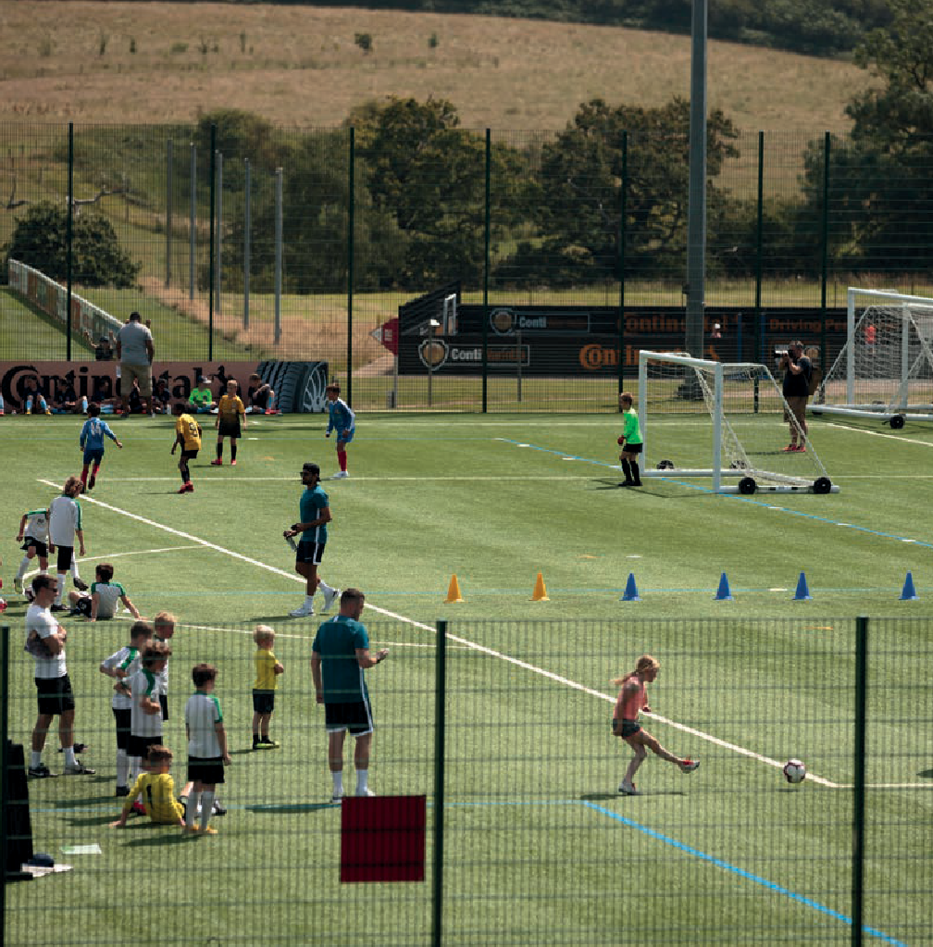

1.1 | FOOTBALL’S SAFEGUARDING CHILDREN POLICY 14

RESPONDING TO CONCERNS, WHISTLEBLOWING AND COMPLAINTS

SAFEGUARDING COMPLAINTS

All complaints must follow due process and the escalation stages as outlined for the relevant organisation, set out in Appendix 4.

CONFIDENTIALITY AND INFORMATION SHARING

We are all committed to ensuring that the confidentiality of all disclosures, safeguarding incidents and allegations and wellbeing concerns, is maintained for all concerned.
Information should be handled and disseminated on a ‘need to know’ basis only, including with relevant partners, in order to ensure children are kept safe. Information will be stored securely and handled in accordance with data protection legislation5 and each of the relevant football authorities' data protection and safeguarding privacy policies.

5 General Data Protection Regulations (GDPR) (2016), Data Protection Act (2018)

1.1 | FOOTBALL’S SAFEGUARDING CHILDREN POLICY 15

POLICY REVIEW, ACKNOWLEDGEMENTS AND GLOSSARY

POLICY REVIEW

This policy will be updated every three years or sooner where there is significant change within Football or where there are legislative or statutory guidance changes. The next scheduled review will be in time to publish in September 2023.

ACKNOWLEDGEMENTS

In developing this policy, Football has drawn from work undertaken by the NSPCC Child Protection in Sport Unit and MIND, alongside HM Government Guidance.
We have also aligned with aspects of the FIFA Guardians’ Child Safeguarding Toolkit published in June 2019 and the UEFA Child Safeguarding Policy published in December 2019.

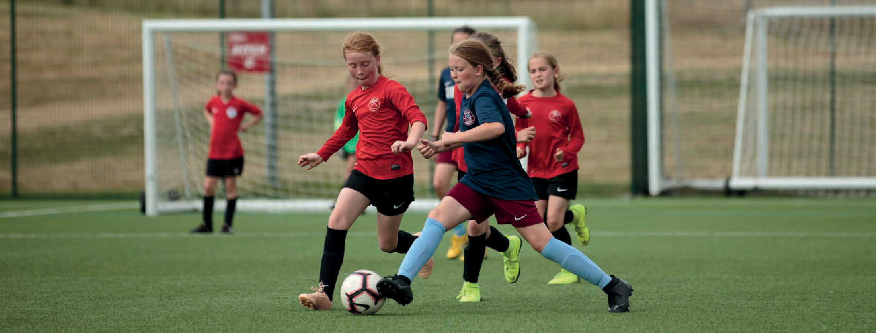

5 General Data Protection Regulations (GDPR) (2016), Data Protection Act (2018)

1.1 | FOOTBALL’S SAFEGUARDING CHILDREN POLICY 16

POLICY REVIEW, ACKNOWLEDGEMENTS AND GLOSSARY

GLOSSARY OF TERMS

For the purposes of this policy:

Abuse of children is defined as: a violation of a child’s human or civil rights by any other person or persons and, for the purposes of safeguarding, shall include physical abuse, emotional abuse, sexual abuse, neglect, bullying and hazing. Abuse may be single act or omission or series of acts or omissions.
Affiliated Football (“Football”) refers to all affiliated Football activity across the
game from Grassroots Football to the Professional Game.
Football Authorities refers to the following organisations collectively: The Football Association (The FA), Premier League, English Football League (EFL), Professional Footballers Association (PFA), League Managers Association (LMA), Professional Game Match Officials Limited (PGMOL), League Football Education (LFE), Premier League Charitable Fund (PLCF) and
EFL Trust.
Child6 means anyone who has not yet reached their 18th birthday.
Child protection7 is a part of the safeguarding process requiring immediate action to protect an individual that has experienced or has been identified as being at risk of experiencing - significant harm or abuse.
Contextual Safeguarding8 is an approach to understanding, and responding to, the risk of harm or incidents of harm to which children can be exposed or which they can experience, beyond their families. Children
form relationships with their peers and adults within the places and spaces (contexts) where they live and participate in activities. This could include our environments.
Parents/Carers may have little influence over these contexts, the risk of harm to which children can be exposed, or harm which they can experience, outside of the family.
Designated Safeguarding Person means an individual allocated to take responsibility for, manage, and/or undertake specific safeguarding responsibilities e.g. Head of Safeguarding, Safeguarding Officer, Club Welfare Officer etc.
Disclosure and Barring Service (DBS) refers to the executive non-departmental public body, sponsored by the Home Office, and established to help organisations make safer recruitment decisions by processing and issuing DBS checks for England, Wales, the Channel Islands and the Isle of Man. DBS also maintains the adults’ and children’s Barred Lists and determines whether an individual should be included on one or both of these lists and is therefore barred from engaging in certain regulated activity.
Harm is defined as: ‘Ill treatment and forms of ill treatment (including sexual abuse
and forms of ill-treatment which are not physical) and also the impairment of or an avoidable deterioration in physical or mental health and the impairment of physical, intellectual, emotional, social or behavioural development. ‘Harm’ may be caused by acts of commission and acts of omission.
Poor Practice means behaviours which contravene existing codes of conduct, infringes an individual’s rights and/or reflects a failure to fulfil high standards of care.
Position of Trust means any position where an individual is in a relationship of trust
with any person with responsibility and/or authority in relation to that person, and shall include without limitation those who care for, advise, supervise, train, coach, teach, manage, tutor, mentor, assess, develop, guide, treat or provide therapy to children.
Regulated Activity in football includes managing, training, coaching and supervising as well as giving advice or guidance on well- being, caring for children or driving a vehicle solely for children on behalf of a club or organisation.
Radicalisation is the action or process of causing someone to adopt radical positions on political or social issues, which can result in children becoming radicalised and committing acts of terrorism.
Terrorism9 involves committing violent acts for political, religious or ideological reasons, and these acts can be committed as part of an organised group or alone. Examples of
extremism includes, but is not limited to, Islamic Extremists and Right-Wing Extremist groups.

6 HM Government, Working Together to Safeguard Children (2018)
https://assets.publishing.service.gov.uk/government/uploads/system/uploads/attachment_data/file/779401/Working_Together_to_Safeguard-Children.pdf
7 Child Protection in Sport Unit (CPSU): https://thecpsu.org.uk/help-advice/introduction-to-safeguarding/what-is-safeguarding/
8 Contextual Safeguarding Network: https://www.csnetwork.org.uk/assets/documents/Contextual-Safeguarding-Briefing.pdf
9 HM Government, The Prevent Duty;
https://www.gov.uk/government/publications/prevent-duty-guidance/revised-prevent-duty-guidance-for-england-and-wales#f-glossary-of-terms

  - | FOOTBALL’S SAFEGUARDING CHILDREN POLICY 17

GLOSSARY OF TERMS

For the purposes of this policy:

Safeguarding10 and promoting the welfare of children is:
    - Protecting children from maltreatment;
    - Preventing impairment of children's mental and physical health or development;
    - Ensuring that children are growing up in circumstances consistent with the provision of safe and effective care;
    - Taking action to enable all children to have the best outcomes.
Staff means any full and part time staff (whether paid or unpaid), volunteers, consultants and those providing a contracted service.

Welfare and Wellbeing
Welfare - describes a child’s health, happiness, safety, prosperity, and general wellbeing.
Mental wellbeing11 - describes the wider set of feelings and thoughts that influence emotions and day-to-day behaviour. Having good mental wellbeing can strengthen a child’s resilience to developing a mental health problem – or help a child cope better with an existing mental health problem.

A child’s mental wellbeing can change, from day-to-day, month-to-month or year-to- year. They may:
  - Feel relatively confident in themselves
– they value and accept themselves and judge themselves on realistic and reasonable standards;
  - Feel and express a range of emotions;
  - Feel engaged with the world around them – they can build and maintain positive relationships with other people and feel they can contribute to your community;
  - Live and work productively;
  - Cope with the stresses of daily life and manage times of change and uncertainty.

10 HM Government; Keeping Children Safe in Education (2020)
https://assets.publishing.service.gov.uk/government/uploads/system/uploads/attachment_data/file/912592/Keeping_children_safe_in_education_Sep_2020.pdf
11 Adapted from work undertaken by MIND

1.1 | FOOTBALL’S SAFEGUARDING CHILDREN POLICY 18

APPENDIX 1 –
DEFINITIONS OF ABUSE

Physical Abuse12 is a form of abuse which may involve hitting, shaking, throwing, poisoning, burning or scalding, drowning, suffocating or otherwise causing physical harm to a child. Physical harm may also be caused when a parent or carer fabricates the symptoms of, or deliberately induces, illness in a child.
Emotional Abuse13 is the persistent emotional maltreatment of a child such as to cause severe and persistent adverse effects on the child’s emotional development. It may involve conveying to a child that they are worthless or unloved, inadequate, or valued only insofar as they meet the needs of another person. It may include not giving the child opportunities to express their views, deliberately silencing them or ‘making fun’
of what they say or how they communicate. It may feature age or developmentally inappropriate expectations being imposed on children. These may include interactions that are beyond a child’s developmental capability, as well as overprotection and limitation of exploration and learning, or

preventing the child participating in normal social interaction. It may involve seeing or hearing the ill-treatment of another. It may involve serious bullying (including cyber bullying), causing children frequently to feel frightened or in danger, or the exploitation or corruption of children. Some level of emotional abuse is involved in all types of maltreatment of a child, though it may occur alone.
Sexual Abuse14 is perpetrated by both men and women. Children can also abuse other children (see Peer on Peer Abuse). Sexual Abuse involves forcing or enticing a child or young person to take part in sexual activities, not necessarily involving a high level of violence, whether or not the child is aware of what is happening. The activities may involve physical contact, including assault by penetration (for example, rape or oral sex) or non-penetrative acts such as
masturbation, kissing, rubbing and touching outside of clothing. They may also include non-contact activities, such as involving children in looking at, or in the production

of, sexual images, watching sexual activities, encouraging children to behave in sexually inappropriate ways, or grooming a child in preparation for abuse Sexual abuse can take place online, and technology can be used to facilitate offline abuse.
Grooming15 very commonly plays a key part in the sexual abuse of children. It refers to a process by which an individual manipulates those around them –typically (but not only) the child – to provide opportunities to abuse. It can involve communication with a child where this is an intention to commit a sex offence in person and/or online.
Child Sexual Exploitation16 (CSE) is a form of child sexual abuse. It occurs where an individual or group takes advantage of an imbalance of power to coerce, manipulate or deceive a child or young person under the age of 18 into sexual activity (a) in exchange for something the victim needs or
wants, and/or (b) for the financial advantage or increased status of the perpetrator
or facilitator. The victim may have been sexually exploited even if the sexual

activity appears consensual. Child sexual exploitation does not always involve physical contact; it can also occur
through the use of technology.
Neglect17 is the persistent failure to meet a child’s basic physical and/or
psychological needs, likely to result in the serious impairment of the child’s health or development. Neglect may occur during pregnancy as a result of maternal substance abuse. Once a child is born,
neglect may involve a parent or carer failing to: a. provide adequate food, clothing and shelter (including exclusion from home
or abandonment) b. protect a child from physical and emotional harm or danger c. ensure adequate supervision (including the use of inadequate caregivers) d. ensure access to appropriate medical care or treatment It may also include neglect of,
or unresponsiveness to, a child’s basic emotional needs.

12/13/ 14 HM Government; Keeping Children Safe in Education (2020)
https://assets.publishing.service.gov.uk/government/uploads/system/uploads/attachment_data/file/912592/Keeping_children_safe_in_education_Sep_2020.pdf
15 NSPCC: https://learning.nspcc.org.uk/research-resources/briefings/grooming
16/17 HM Government; Keeping Children Safe in Education (2020)
https://assets.publishing.service.gov.uk/government/uploads/system/uploads/attachment_data/file/912592/Keeping_children_safe_in_education_Sep_2020.pdf

1.1 | FOOTBALL’S SAFEGUARDING CHILDREN POLICY 19

APPENDIX 1 –
DEFINITIONS OF ABUSE (continued)

Bullying is the use of aggression with the intention of hurting another person this may be by an adult towards a child or peer on peer abuse. Bullying results in pain and distress to the victim. Bullying can be:
  - Emotional being unfriendly, excluding (emotionally and physically) sending hurtful text messages, tormenting, (e.g. hiding football boots/shin guards, threatening gestures);
  - Physical pushing, kicking, hitting, punching or any use of violence;
  - Sexual unwanted physical contact or sexually abusive comments;
  - Discriminatory comments, jokes about or targeted abuse aimed towards disabled children, homophobic, transphobic, sexist, gendered, racist or faith based comments;
  - Verbal name-calling, sarcasm, spreading rumours, teasing.

Cyberbullying is when a person uses technology i.e. mobile phones or the internet (social networking sites, chat rooms, instant messenger, tweets), to deliberately upset someone. This could take the form of posting derogatory abusive comments, videos
or images on social media. Bullies often feel anonymous and ‘distanced’ from the incident when it takes place online and ‘bystanders’ can easily become bullies themselves by forwarding the information on.
Extremism18goes beyond terrorism and includes people who target the vulnerable
– including the young – by seeking to sow division between communities on the basis of race, faith or denomination; justify discrimination towards women and girls;
persuade others that minorities are inferior; or argue against the primacy of democracy and the rule of law in our society. Extremism is defined in the Counter Extremism Strategy 2015 as the vocal or active opposition to our

fundamental values, including the rule of law, individual liberty and the mutual respect and tolerance of different faiths and beliefs. Calls for the death of members of our armed forces is classed as extremist.
County Lines19 is a term used to describe gangs and organised criminal networks involved in exporting illegal drugs into one or more importing areas within the UK, using dedicated mobile phone lines or other form of ‘deal line’. They are likely to exploit children (disabled children are particularly vulnerable) to move and store the drugs and money, and they will often use coercion, intimidation, violence (including sexual violence) and weapons.
Child Criminal Exploitation20 (as set out in the Serious Violence Strategy, published by the Home Office), is where an individual or group takes advantage of an imbalance of power to coerce, control, manipulate
or deceive a child or young person under

the age of 18 into any criminal activity
(a) in exchange for something the victim needs or wants, and/or (b) for the financial or other advantage of the perpetrator or facilitator and/or (c) through violence or the threat of violence. The victim may have been criminally exploited even if the activity appears consensual. Child criminal exploitation does not always involve physical contact; it can also occur
through the use of technology.
Children can abuse other children. This is often referred to as Peer on Peer Abuse21.
This is most likely to include, but may not be limited to:
  - Bullying (including cyberbullying);
  - Physical abuse such as hitting, kicking, shaking, biting, hair pulling, or otherwise causing physical harm;
  - Sexual violence, such as rape and sexual assault;

18/19/20 HM Government Working Together to Safeguard Children (2018)
https://assets.publishing.service.gov.uk/government/uploads/system/uploads/attachment_data/file/779401/Working_Together_to_Safeguard-Children.pdf
21 HM Government; Keeping Children Safe in Education (2020)
https://assets.publishing.service.gov.uk/government/uploads/system/uploads/attachment_data/file/912592/Keeping_children_safe_in_education_Sep_2020.pdf

1.1 | FOOTBALL’S SAFEGUARDING CHILDREN POLICY 20

APPENDIX 1 –
DEFINITIONS OF ABUSE (continued)

  - Sexual harassment, such as sexual comments, remarks, jokes and online sexual harassment, which may be stand-alone or part of a broader pattern of abuse;
  - ‘Upskirting’, which typically involves taking a picture under a person’s clothing without them knowing, with the intention of viewing their genitals or buttocks to obtain sexual gratification, or cause the victim humiliation, distress or alarm;
  - Sexting (also known as youth produced sexual imagery); and
  - Initiation/hazing type violence and rituals.
Honour Based Violence (HBV)22 encompasses incidents or crimes which have been committed to protect or defend the honour of the family and/or the community, including Female Genital Mutilation (FGM), and practices such as breast ironing. Abuse

committed in the context of preserving “honour” often involves a wider network of family or community pressure and can include multiple perpetrators. All forms of HBV are abuse (regardless of the motivation) and should be handled
and escalated as such.
FGM comprises all procedures involving partial or total removal of the external female genitalia or other injury to the female genital organs. It is illegal in the UK and a form of child abuse with long-lasting harmful consequences.
Forced Marriage23 involves forcing someone into a marriage is a crime in England and Wales. A forced marriage is one entered into without the full and free consent of one or both parties and where violence, threats
or any other form of coercion is used to cause someone to enter into a marriage. Threats can be physical or emotional and psychological. A lack of full and free consent can be where no consent is given consent

or where consent cannot be given (if they have learning disabilities, for example).
Nevertheless, some perpetrators use perceived cultural practices as a way to coerce a person into marriage.
Domestic Abuse24 is any type of controlling, bullying, threatening or violent behaviour between people in a relationship. It can seriously harm children and witnessing domestic abuse is child abuse. It's important to remember domestic abuse:
  - Can happen inside and outside the home;
  - Can happen over the phone, on the internet and on social networking sites;
  - Can happen in any relationship and can continue even after the relationship has ended;
  - Both men and women can be abused or abusers.

22/23 HM Government; Keeping Children Safe in Education (2020)
https://assets.publishing.service.gov.uk/government/uploads/system/uploads/attachment_data/file/912592/Keeping_children_safe_in_education_Sep_2020.pdf
24 NSPCC: https://www.nspcc.org.uk/what-is-child-abuse/types-of-abuse/domestic-abuse/

1.1 | FOOTBALL’S SAFEGUARDING CHILDREN POLICY 21

APPENDIX 2 –
LEGISLATION AND STATUTORY GUIDANCE

This safeguarding policy statement is underpinned by the following legislation and statutory guidance:

  - UN Convention on Rights of the Child (UNCRC), 1989;
  - Sexual Offences Act 2003;
  - Mental Capacity Act 2005;
  - The Children Act 1989, 2004;
  - The NSPCC/Sport England Child Protection in Sport Standards (2005 revised 2018);
  - Safeguarding Vulnerable Groups Act 2006;
  - The Equality Act 2010;
  - Protection of Freedoms Act 2012;
  - Care Act 2014;
  - Counter terrorism and Security Act 2015;
  - Children and Social Work Act 2017;
  - Working Together to Safeguarding Children 2018;
  - Keeping Children Safe in Education 2020.

1.1 | FOOTBALL’S SAFEGUARDING CHILDREN POLICY 22

APPENDIX 3 – '

FOOTBALL AUTHORITIES
AND ACCOUNTABILITIES
RESPONSIBILITIES

The table below outlines the responsibilities and accountabilities of the different football authorities in England. Collectively we work to create safer environments in football. And if there are concerns, to ensure people know how and where to report them. This work demands our constant vigilance and professionalism.

ORGANISATION | DESCRIPTION | OVERVIEW OF KEY SAFEGUARDING RESPONSIBILITIES
The Football Association (The FA) | The governing body of football in England, from grassroots football to the professional game, including safeguarding responsibility for:  England teams; The Barclays FA Women’s Super League and Women’s Championship; The National League System; specific Cup competitions, including The FA Cup; Safeguards at Wembley Stadium and St George’s Park and the Safeguarding Operating Standard for CFAs. | - Provides policy and regulatory framework for safeguarding children and adults across the game.  - Develops safeguarding policy, procedures and safer working practice guidance.  - Reviewed annually by NSPCC CPSU re compliance with and continual progress against the national standards framework for Safeguarding and Protecting Children in Sport.  - Manages child protection concerns in collaboration with the statutory agencies and those arising from content on DBS certificates - in line with FA Regulations, including managing suspensions, other risk management measures and referrals to the Disclosure and Barring Service.  - Operates the DBS Check service for anyone in affiliated English football working with children and young people. The service extends from grassroots to the EFL and  collaborates with the Premier League which oversees the provision of checks in their clubs.  - Provides safeguarding awareness training for coaches, referees, medics, designated safeguarding officers and club committee members – the latter from grassroots football to the National League System.  - Facilitates tailored training for those in designated roles in County FAs and develops toolkits and guidance for grassroots football.  - Commissions research and insight as required.  - In collaboration with the Premier League, EFL and County FAs, continually reviews compliance against safeguarding standards and measures.  - Works with colleagues to embed safeguarding in all relevant systems, processes, programmes, activities and events.  - Collaborates with all football bodies, the NSPCC CPSU and ACT via the Pro Game Safeguarding Forum to share practice and strengthen safeguarding arrangements across the game.

1.1 | FOOTBALL’S SAFEGUARDING CHILDREN POLICY 23

APPENDIX 3 – '
FOOTBALL AUTHORITIES
RESPONSIBILITIES
AND ACCOUNTABILITIES (continued)

ORGANISATION | DESCRIPTION | OVERVIEW OF KEY SAFEGUARDING RESPONSIBILITIES
The Premier League | The Premier League is the organising body of the Premier League football competition with responsibility for the competition, its Rule Book and its centralised broadcast and other commercial rights. | - Has long-standing safeguarding and safer recruitment rules that complement FA regulations. These are reviewed each season.  - Issues Clubs with Safeguarding Standards detailing requirements.  - Requires Clubs to have a board-level senior safeguarding lead, a dedicated full-time head of safeguarding and an academy safeguarding officer.  - Supports Club understanding and compliance through guidance and support visits.  - Delivers safeguarding training and awareness sessions regularly throughout each season.  - Requires Clubs to refer concerns to statutory agencies and football authorities.  - Commissions regular independent audits of internal and Club safeguarding policies, procedures and practice.  - Collaborates with Football Authorities to share practice and strengthen safeguarding arrangements across the game.
English Football League (EFL) | The EFL is the largest single body of professional clubs in European football and is responsible for administering and regulating the EFL, the League Cup and the League Trophy, as well as reserve and youth football.  The EFL supports two charitable organisations: League Football Education (LFE) and the EFL Trust. | - Requires all clubs to have a Safeguarding Senior Manager (SSM) reporting at board level, as well as a Club Designated Safeguarding Officer (DSO).  - Issues a set of safeguarding standards detailing the expected requirements across all members Clubs.  - Inspects Clubs to ensure compliance and continuous improvement in the area of safeguarding. Clubs that operate an academy are independently audited by safeguarding specialists.  - Issues every club that operates a youth academy with strict safeguarding rules and procedures that complement FA Rules and Regulations at the start of each season.  - Requires adherence to safer recruitment practice.  - Maintains regular communication with clubs providing advice and guidance on all matters related to safeguarding.  - Requires Club Senior Safeguarding Manager and Designated Safeguarding Officers to attend compulsory training throughout the football season.  - Requires clubs to report and refer concerns to statutory agencies, The FA and the EFL.

1.1 | FOOTBALL’S SAFEGUARDING CHILDREN POLICY 24

APPENDIX 3 – '
FOOTBALL AUTHORITIES
RESPONSIBILITIES
AND ACCOUNTABILITIES (continued)

ORGANISATION | DESCRIPTION | OVERVIEW OF KEY SAFEGUARDING RESPONSIBILITIES
League Managers Association (LMA) | A member association which represents the interests and views of Managers and Head Coaches in the Premier League, EFL, WSL and The FAWC. | - Has a policy to guide its staff who work with children and young people.  - Provides support and guidance to its members including counselling support via its confidential helpline.
Professional Game Match Officials Limited (PGMOL) | Appoints, trains, and develops referees and assistant referees to officiate across the Premier League, EFL and The FA competitions. | - Has a policy to guide its staff in providing a safe environment for vulnerable group and responding to safeguarding concerns.  - Provides support and guidance to its match officials, observers and staff as required.
Professional Footballers Association (PFA) | A trade union which represents the interests of professional footballers who have played or are playing in the Premier League, EFL and The FA Women’s Super League 1 and 2. | - Has a policy to guide its staff who work with children and young people, requiring the relevant checks and training for staff in line with FA policy.  - Has a named Designated Safeguarding Lead.  - Has a Designated Safeguarding Officer.  - Provides support and guidance to its members.  - Promotes its online resource “The PFA Safety Net” to young Academy Players, Parents, Guardians, Carers and Club personnel.  - Provides a national counselling service to its members.
League Football Education (LFE) | LFE is a charity established in 2004 by The EFL and The PFA, with a primary purpose to deliver the Apprenticeship Programme at EFL clubs. LFE’s  responsibilities extend to the delivery of Life Skills to U9- U23 players, parents/guardians and club staff. | - Has a team of Regional Officers (ROs) who monitor and support the Apprenticeship Programme in EFL clubs.  - Provides Policies and Procedures for Regional Officers to support safeguarding arrangements in clubs.  - Manages a Study Programme with Club Community Organisations (CCO’s).  - Has a Designated Safeguarding Officer, who works closely with the EFL Safeguarding Manager and sits on the EFL Safeguarding Strategy Group.  - Supports the EFL in monitoring the pre-16 Academy programme.  - Support learners after the completion of their apprenticeship, including tracking and monitoring calls and assistance with a range of transition opportunities, within and outside of football, in the UK and abroad.

1.1 | FOOTBALL’S SAFEGUARDING CHILDREN POLICY 25

APPENDIX 3 – '
FOOTBALL AUTHORITIES
RESPONSIBILITIES
AND ACCOUNTABILITIES (continued)

ORGANISATION | DESCRIPTION | OVERVIEW OF KEY SAFEGUARDING RESPONSIBILITIES
Premier League Charitable Fund (PLCF) | The Premier League Charitable Fund creates and supports activities that inspire young people to achieve their potential and positively impact their communities. The PLCF develops programmes and provides funding to 92+ Club Community Organisations (CCO’s) in the Premier League and English Football League. | Requires all CCOs receiving funding from PLCF to comply with a range of safeguarding arrangements set out within a Capability Code of Practice. Requirements include:  - Safeguarding policy and procedures.  - Management of safeguarding.  - Training and support.  - Service delivery.  - PLCF commissions annual independent safeguarding audits of Premier League CCOs.  - PLCF offers safeguarding advice, support and training to CCOs.
EFL Trust | The EFL Trust is the charitable arm of The EFL, supporting a network of Club Community Organisations (CCOs) to deliver and facilitate events, programme and activities within their local communities, often engaging with some of society’s most vulnerable groups. | - Along with the PLCF, outlines safeguarding measures for CCOs to comply with and evidence via the Capability Code of Practice CCOP.  - Acts in an advisory capacity, supporting CCOs with ongoing safeguarding guidance & training.  - Monitors safeguarding & incident data from CCOs, observing trends and patterns, making recommendations and offering support & guidance as required.  - Operates robust safeguarding policies, procedures and measures for the direct delivery of a range of projects and programmes involving children and adults at risk.

1.1 | FOOTBALL’S SAFEGUARDING CHILDREN POLICY 26

APPENDIX 4 –
SAFEGUARDING COMPLAINTS

Safeguarding concerns about a child’s welfare must be shared without delay to the Designated Safeguarding Person in the organisation responsible for the activity the child is involved in e.g. club or programme (see section 14).
Complaints about the way in which a safeguarding concern has been managed, must in the first instance be directed to the relevant football authority concerned e.g. club or programme. Club complaints processes must always be followed before a complaint can be escalated to a league or other football authority.
Please make use of the relevant contact details and where provided additional details on the appropriate process to follow.

FOOTBALL AUTHORITIES: WHO TO CONTACT
PREMIER LEAGUE CLUBS | OUR PROCESS
See individual club websites for contact details | Safeguarding concerns should be shared with your Club without delay. Each Club is required to promote their safeguarding policies and procedures including key internal and local external contacts on their website.  You should follow your Club’s complaints procedure if you wish to complain about the management of a safeguarding concern or if you believe that your Club has not fully or correctly implemented its safeguarding or related policies and procedures.
THE PREMIER LEAGUE | OUR PROCESS
Email safeguarding@premierleague.com if you wish to complain about the Premier League’s management of safeguarding concern or to escalate a complaint about a Club's management of a safeguarding concern.  Complaints should be escalated to the Premier League once Club procedures have been exhausted. | Safeguarding concerns and complaints reported to us will be taken seriously and responded to promptly and appropriately.  Visit our website for further information: https://www.premierleague.com/safeguarding

1.1 | FOOTBALL’S SAFEGUARDING CHILDREN POLICY 27

APPENDIX 4 –
SAFEGUARDING COMPLAINTS (continued)

FOOTBALL AUTHORITIES: WHO TO CONTACT
PREMIER LEAGUE CHARITABLE FUND (PLCF) | OUR PROCESS
The PLCF’s Complaints Policy can be requested from:  mailbox@plcf.com | All disclosures, incidents and allegations will be taken seriously and reported in line with our safeguarding policy and procedures. This includes allegations about non-recent abuse and allegations made against deceased individuals.  The PLCF will fully support anyone who in good faith reports their concerns about the safety and welfare of children.
EFL CLUBS | OUR PROCESS
See individual club websites for contact details | Follow the relevant EFL Club complaints and appeals process.
THE ENGLISH FOOTBALL LEAGUE (EFL) | OUR PROCESS
A copy of the EFL complaints policy, which sets out the process and contact details for a complaint, can be found here:  https://www.efl.com/siteassets/efl-documents/efl-complaints-policy.pdf | If a parent, carer or legal guardian has a welfare concern, or a concern about poor practice or something that has not or would not cause significant harm to the child concerned or other children under the care of the Club, then the Club complaints policy should be followed.  If there is no satisfactory outcome from the full Club complaints process, then welfare concerns can then be referred to the EFL and the respective EFL Complaints Policy will be instigated.
LEAGUE FOOTBALL EDUCATION (LFE) | OUR PROCESS
E: info@lfe.org.uk | All concerns, complaints and disclosures will be taken seriously and responded to in line with our Safeguarding Policy.
EFL TRUST | OUR PROCESS
The EFL Trust’s Complaints Policy is available on request from:  info@efltrust.com | Where a participant, parent/guardian or other relevant party has a concern or complaint about the services or activities provided by a CCO, they should engage directly with the CCO’s own complaints policy.  If the concern or complaint is around the services or activities provided by EFL Trust directly, or they are not satisfied with the outcome of a complaint raised again the CCO they can refer directly to the EFL Trust Complaints Policy.

1.1 | FOOTBALL’S SAFEGUARDING CHILDREN POLICY 28

APPENDIX 4 –
SAFEGUARDING COMPLAINTS (continued)

FOOTBALL AUTHORITIES: WHO TO CONTACT
PROFESSIONAL FOOTBALLERS ASSOCIATION (PFA) | OUR PROCESS
The PFA’s Policy can be found here:  https://www.thepfa.com/charity/academy-players-and-parents/safeguarding | The PFA has an updated policy in supporting and handling safeguarding matters that are raised. Such complaints would be dealt with via the PFA’s DS/DSO and working in partnership with the relevant leagues (PL/EFL) and The FA.  The PFA supports its under-18 members in relation to any safeguarding matters which are identified. The PFA DSL/DSO would liaise with The FA and relevant league (PL/EFL) to assist and support with matters raised by members or their parents.
LEAGUE MANAGERS ASSOCIATION (LMA) | OUR PROCESS
 | If a complaint is made against a member this would immediately be referred to the member’s club and/or The FA Safeguarding Team or County FA (as appropriate).
PROFESSIONAL GAME MATCH OFFICIALS LIMITED (PGMOL) | OUR PROCESS
humanresources@pgmol.com | Complaints about the way PGMOL has dealt with a safeguarding issue can be made to PGMOL Chairman, or The FA Safeguarding Team in line with PGMOL’s Whistleblowing Policy.  Appeals against decisions in relation to safeguarding cases should be made within five working days’ of being notified of a decision, to the Managing Director.
THE FA | OUR PROCESS
E: safeguarding@thefa.com  T: 0800 169 1863 | The FA manages complaints about how safeguarding has been conducted, delivered or managed in relation to: FA staff conduct; FA safeguarding policies and procedures; the management of concerns in relation to FA venues e.g. Wembley and St George’s Park.  Where complaints from other levels of football have already exhausted due process e.g. club complaints and appeals processes, league or CFA complaints and appeals processes, then The FA will review complaints to ensure due process has been followed.  Where matters are escalated, The FA will respond within 7 working days and will provide an outcome within 28 days where possible. If these timescales are not achievable, you will be kept informed.

1.1 | FOOTBALL’S SAFEGUARDING CHILDREN POLICY 29

APPENDIX 5 –
USEFUL CONTACTS

ORGANISATION | WEBSITE | EMAIL | CONTACT NUMBER
The Football Association (The FA) | https://www.thefa.com/football-rules-governance/ safeguarding | safeguarding@TheFA.com | 0800 169 1863
Premier League | https://www.premierleague.com/safeguarding | safeguarding@premierleague.com | 0207 864 9000
English Football League (EFL) | https://www.efl.com/-more/governance/safeguarding/ | safeguarding@efl.com | 01772 325800
Professional Footballers’ Association (PFA) | https://www.thepfa.com/players/academy-players-and- parents/safeguarding | info@thepfa.com | 0161 236 0575
League Managers Association (LMA) | http://www.leaguemanagers.com/ | lma@leaguemanagers.com | 01283 576350
Professional Game Match Officials Limited (PGMOL) | https://www.efl.com/clubs-and-competitions/match- officials/pgmol/  and https://www.premierleague.com/referees/overview | humanresources@pgmol.com | 020 7864 9000
Premier League Charitable Fund (PLCF) | https://www.premierleague.com/safeguarding | safeguarding@plcf.co.uk | 0207 864 9000
League Football Education (LFE) | https://www.lfe.org.uk/safeguarding/ | pbartlett@lfe.org.uk | 01772 326870
EFL Trust | https://www.efltrust.com/ | safeguarding@efltrust.com | 01772 325800
NSPCC  Child Protection in Sport Unit (CPSU) | https://thecpsu.org.uk/ | cpsu@nspcc.org.uk | 0116 366 5580

1.1 | FOOTBALL’S SAFEGUARDING CHILDREN POLICY 30

Fo

The Football Association Wembley Stadium London HA9 0WS
T: +44 (0)800 1691863
F: +44 (0)800 169 1864
20048

