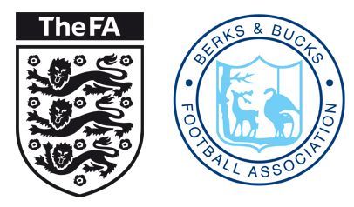
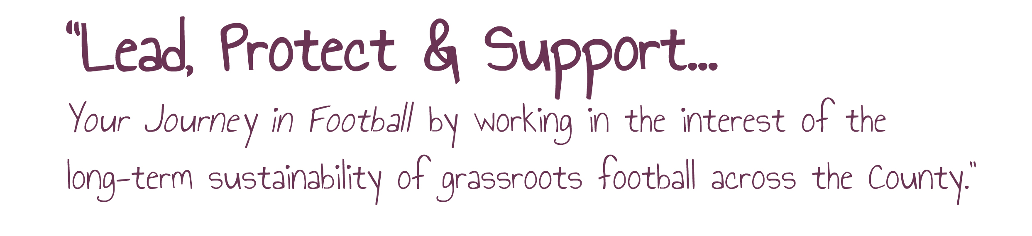

Tournament Sanction Pack – 2018-19

Benefits of Sanctioning Your Tournament

Your event will be covered by Public Liability Insurance provided all teams participating are affiliated to a County FA.

You will be able to appoint BBFA Registered Referees and Match Officials, which means that any disciplinary action taken on the day will be dealt with by us.

We can give you advice for clear, unambiguous rules, entrance form guides which you can use for your event and issue to all participants, risk assessments and safeguarding policies. Just ask if you would like some help with this, and we can send you some guidelines.

We will advertise your event for free on our website and social media platforms.*

*Make your application to us at least a couple of months in advance of your event so we have to time to advertise for you.

Things to consider
Teams Format, i.e. Mini Soccer, 9v9, Small Sided or 11v11.

Tournament Structure, Round Robin, Group Stage etc.

How small/ large do you want your event to be? Plan ahead.

Who will be administering/managing the event? You will need to let us know who is responsible for the overall organization, your ‘Tournament Secretary’, and list any other relevant Personnel, please see Management statement attached

Next Steps
Please fill in the Application Form and send to us at the address below, or scan and email to chris.cole@berks-bucksfa.com with copies of the following:
- Tournament Rules
- Management Statement

Payment
A Tournament Sanctions cost £25. Once the rules and management statement has been submitted and approved, the sanction will be created on the FA’s Whole Game System and an invoice will be sent to the club/competition secretary. This can be sent to an individual if the tournament is not being administered by a club (i.e. charity events, walking football events, etc.) please inform us if you would like this to be sent to a different person.

TOURNAMENT SANCTION APPLICATION – 2018-19

CLUB NAME:
PROPOSED DATE(S):

COMPETITION NAME:

Competition Secretary Details: | Name:  FAN:  Address:  Tel Home: Mobile:
Event Venue Details: | Address:
Competitions Secretary Signature:

Date:

Checklist, please make sure you complete all of the following items

Tournaments Rules | Management Statement | Safeguarding Commitment  (Events with youth teams only)

Office use only, please do not write below this line:________________________________________________________________
Date Rec’d | Rules Approved | Sanction Issue Date | Sanction Ref | Website Updated

MANAGEMENT STATEMENT

The Management Committee shall consist of the following personnel:

Role: Competition Secretary
Name: FAN:

Role: Welfare Officer (competitions with youth teams must have a qualified welfare officer)
Name: FAN:

Please List any other Committee Members who will be helping on the day and their roles below:

Name | Role | FAN

Your Obligations as hosts
- You will only allow entrance to Clubs/Teams which are Affiliated to a County FA.
- You will provide each participating team with a set of rules at invitation/on sign up, copies of which must also be clearly posted/accessible for the duration of the event.
- You will ensure that FA Rulings around age specific participation are strictly adhered to in relation to: age of players, size of teams, duration of matches, non-competitive play, awards of trophies/ mementos, prohibition of academy players.
- You will hold a full briefing with all teams before commencement of play including informing them of who the Welfare Officer is (events with youth teams only) code of conducts and complaints procedure.
The competition shall be governed in accordance with the Rules and Regulations of The Football Association. Matches shall be played in accordance with the Laws of Small Sided Football/Laws of the Game/Mini Soccer as laid down by The Football Association.
The above named committee will have the power to act upon and enforce the Rules of the Competition and will have jurisdiction over all matters affecting the Competition including any not provided for by these Rules. The committee shall also adjudicate in all cases of dispute, protest and complaint.

FA Safeguarding Commitment

Safeguarding in football is everybody’s responsibility. Please read and sign the below to confirm your event/tournament is committed to safeguarding and to play your part in safeguarding children in football.

(Failure to confirm this may result in your tournament sanction being denied)

Please acknowledge the statements below by ticking the boxes and signing below:

On behalf of ________________________________________________________ we confirm that the records provided on the enclosed management statement truly reflect who will be organising our event.

We commit to ensuring that all officials and those working on the day of the event with children have an in-date FA CRC

We commit to ensuring a qualified Welfare Officer is named and has full knowledge of the event/tournament

A list of all participating teams will be submitted to Berks and Bucks FA on or before the date specified on your Sanction Letter

Signed by the Tournament Secretary on behalf of the above named committee

Sign:......................................................................... Date: ..................................

By Signing you are agreeing to abide by the above Terms and Obligations

