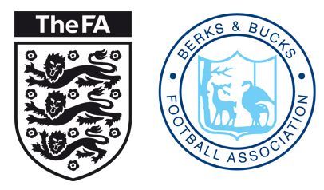
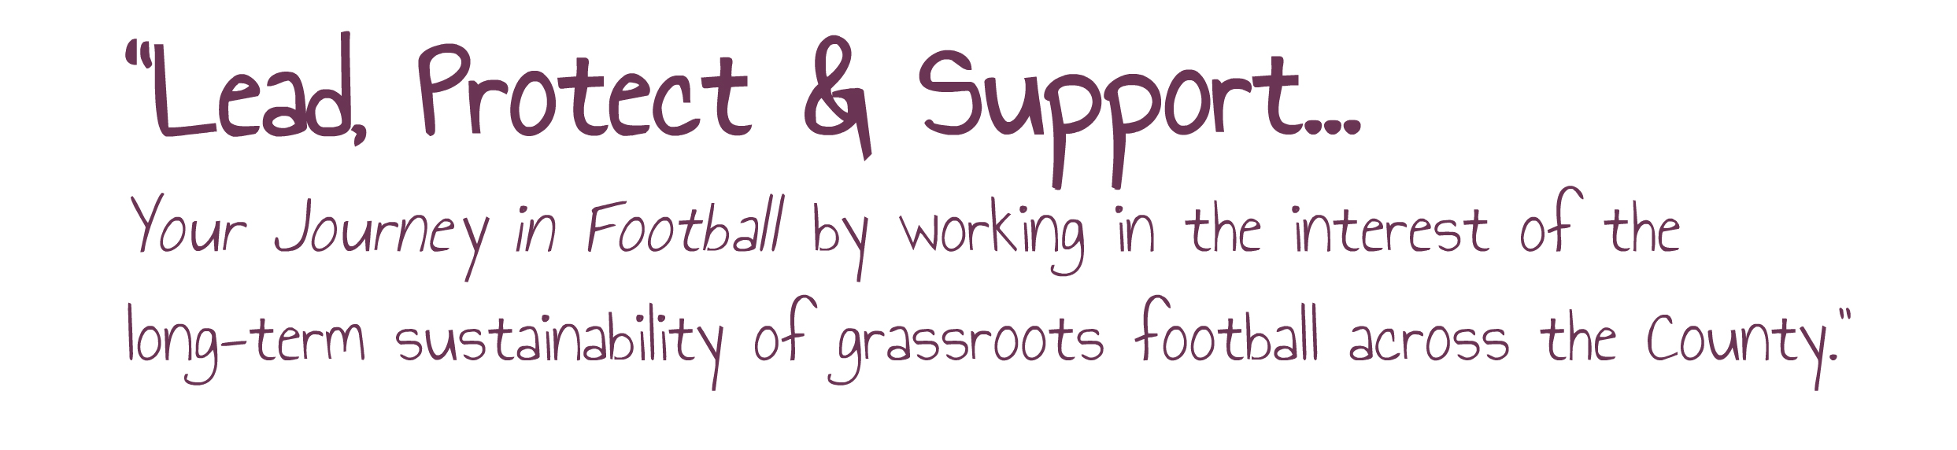
BERKS & BUCKS FA COUNTY CUP FINALS 2017-18

ADULT CUPS

Senior Cup – Date TBC - Slough Town FC

Womens Senior Cup – Maidenhead United Ladies v MK Dons Ladies – Sun 22 April 3pm – Stadium MK

Senior Trophy - Saxton Rovers v Marlow Utd – Sat 7th April 2018 3pm – Bracknell Town FC

Saturday Intermediate Cup -Tattenhoe Res v FC Tradesman - Sat 14th April 2pm Burnham FC

Saturday Junior Cup – Penn & Tylers Green Res v Delaford Colts - Sat 5th May 2pm – Abingdon United FC

Sunday Intermediate Cup – FC Bentons v Aylesbury Flooring - Sun 8th April 3pm - Bracknell Town FC

Womens Junior Cup – Buckingham Athletic Ladies v Abingdon Utd Women - Sun 15th April 2pm – Slough Town FC

Sunday Junior Cup – TBC

Sunday Junior Trophy – Twyford Comets v The Sportsman - Sun 15th April 11am - Slough Town FC

YOUTH CUPS

U18 Youth Cup – Bracknell Town v Didcot Town – Wed 25th April 7.30pm – Marlow FC

U18 Girls Cup – Westwood Wanderers v Milton United - Sat 21st April 1pm – Bracknell Town FC

U16 Minor Cup – Tattenhoe Youth Panthers v Eldon Celtic Junior Lions - Sun 22nd April 11am – Risborough Rangers

U16 Girls Cup – Berks County Girls v Tilehurst Panthers Stripes Sat 28th April – Venue TBC

U15 Minor Cup – Newport Pagnell Town Lions v Wendover Junior - Sun 29th April 2pm – Buckingham Athletic FC

U14 Minor Cup – Winslow Utd Junior Lions v Risborough Rangers Juniors - Sun 29th April 11am - Buckingham Athletic FC

U14 Girls Cup – Sat 28th April – Venue TBC

U13 Saturday Cup – GPS UK v Hazeley Cobras - Sat 5th May 11am – Abingdon Utd FC

U13 Sunday Cup – Haddenham Youth v Eldon Celtic Junior Lions - Sun 13th May 3.30pm - Flackwell Heath FC

U12 Saturday Cup – GPS v MK Wanderers Hawks - Sun 13th May – 12.30am - Flackwell Heath FC

U12 Sunday Cup – Reading Utd v George Green Juniors - Sun 13th May – 10am – Flackwell Heath FC

