NAME | DOB | TEAM | POSITION | PHONE | EMAIL | DUNSTABLE  11 JULY | WOOTTON 25 JULY | FLITWICK  01 AUGUST
Full Name | 01/01/80 | AFC Team U17 | CM | 07000 000000 | Full.Name@BedfordshireFA.com | Yes |  | Yes
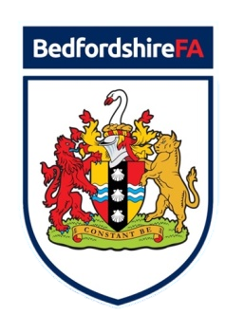
Please complete and return this form as a Team Coach or Individual Player.
You may select more than 1 Trial event to attend.
Return to: Marc.DiCarlo@BedfordshireFA.com | 07984 266441 | Josh.Spavins@BedfordshireFA.com | 07432 700589
U18 REP TEAM TRIALS 18/19

11 JULY – 19:00 to 20:00 | 25 JULY – 19:00 to 20:00 | 01 AUGUST – 19:00 to 20:00
Creasey Park 3G, Creasey Park Drive, Dunstable, LU6 1BB | Wootton Blue Cross, Bedford Road, Wootton, MK43 9JT | Flitwick Football Centre, Ampthill Road, Flitwick, MK45 1BA

