UK NORTH FINALS DAY

The Army Football Association (North) held its annual minor and major unit finals on 30th May 18, for the second year running at Northallerton Town FC, sponsored by Forces Mutual.
Minor Unit Final
5 Medical Regiment versus 3 Medical Regiment.
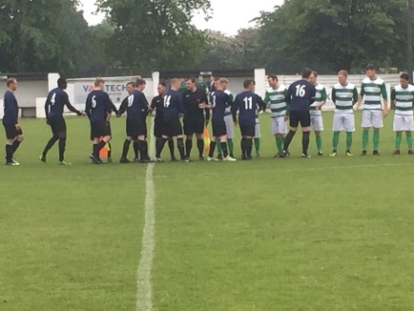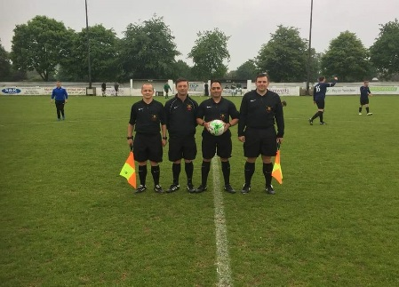

The team of officials was led by: SSgt Ficetola, ARs Cpl Corrigan, LCpl Lawlor and 4th official Cpl Brooks.
This was always going to be a very well contested game between two rival units. From the first whistle to the very last every ball was fiercely contested. A credit to both teams who displayed some great football however there was only going to be one winner, 3 medical Regiment came out with a victorious 3.0 win and lifted the trophy.
Major Unit Final
21 Engineer Regiment versus 32 Engineer Regiment
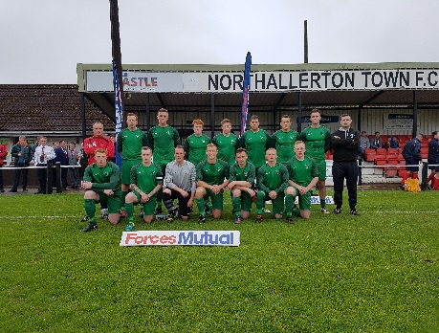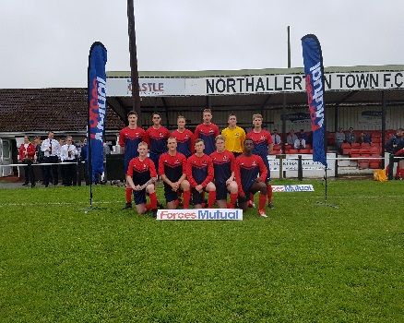
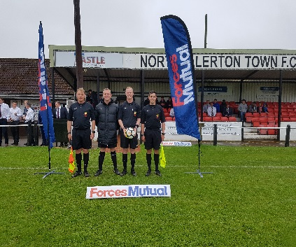
The team of officials was led by: Sgt Thorburn, ARs Capt Cuthbertson, Sgt Steadman and 4th official Cpl McNee
The one that everyone had been waiting for was the major final between two of the Region’s biggest rivals. From the first whistle 21 Engineers hit the ground running and got a quick goal. They continued to dominate the game, with lots of great football being played by both teams on what was a great playing surface. At the final whistle it was 21 Engineers who came out with a 3.0 win and lifted the trophy.

