Amateur Football Alliance
Adding Suspension Matches
September 2019

How to update suspensions
- Click on the Club Secretary Tab for your club

- Click on the Matches Tab on the left hand side of the screen
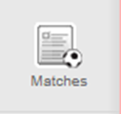
- Click on the New Match button the right-hand side of the screen

- Click on the box which reads Match Date
- When the calendar appears, click the date of the relevant match
- Select whether you were home or away
- Directly below the home and away options, you will see there is a box which says ‘All Teams’
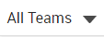
- Select the relevant team (in this case U13 Red)
- You will then be required to choose from one of the following options:
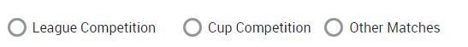
- You have not detailed in your email whether this is a league of cup fixture, so in this instance, I will assume is it a league fixture. Please notify me if different.
- Once you have selected the competition, you will then see the All Teams box appear again. This time, you need to click on the drop down to find the team you were playing.
- Once all the details have been entered you will then be able to create the match

- Once you have clicked on ‘create’ the system will take you back to the ‘Matches’ tab where you will now be able to see the match details:

- If you then click on the suspension tab for that match (see above image), this will then flag up which individuals’ suspensions this match will qualify for.

