JULY
KEEPING UP THE MOISTURE
With the consistently warmer months on the way and a heatwave due to hit at some point, it is best to be prepared for drought conditions which can lead to plant stresses.
Plant Stress can be relieved using Wetting Agents such as Abzorb in a spray application which can be tank mixed with an organic biostimulant such as Kelpak. This will assist the rapid penetration of water in dry areas for medium to long term re-wetting.
Wetting agents contain soil penetrating surfactants which are effective against turf diseases such as Dry Patch and Fairy Ring. Abzorb is suitable for use on grass areas such as lawns and amenity and sports turf. They are most effective when used monthly from spring onwards as this will mean the maximum amount of wetting agent will be present during the dry months of summer.
The 2.5kg Abzorb tank tablet can be pushed through an irrigation system. You can also spot water using a 250g Abzorb tablet in a spray gun or handheld sprayer.
A fast-acting wetting agent attaches itself to the waxes and lipids left by fungal spores on soil and sand particles, which in turn attracts water molecules allowing hydrophobic areas to be re-wet. They are a blend of soil penetrating surfactants, that help to re-wet dry areas of turf affected by turf diseases.
It is very important to irrigate after application of a wetting agent, so that it penetrates the soil. Applying 10-15mm of water straight after application will help, or when it is raining or due to. It can also scorch the leaf if left on it during hot weather.
Other benefits of wetting agents include:
• Keeps the surface of the soil open and more receptive to water so any irrigation gets into the soil and does not just run off.
• Reduces the amount of irrigation water needed so saves time and money.
• Reducing the amount of overhead irrigation will keep the surface drier and this can help with the reduction of Poa annua and disease.
• The surfactants reduce the surface tension in the water and so excess water will fall from the soil profile to drains far easier in times of higher rain fall.
• Can be used to help the penetration of pesticides into the thatch layer or soil. Particularly important when looking at actives such as azoxystrobin that are only translocated upwards in a plant and so to protect the whole plant.
• Can be applied just after seeding to increase germination rates and reduce watering requirements.

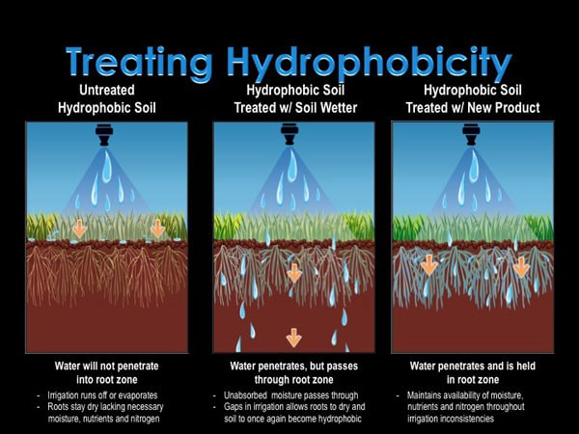
For more information, or to help you identify turf diseases that you may have, please get in touch for further advice.
Products mentioned in this blog:
https://www.agrigem.co.uk/abzorb-triple-action-wetting-agent-10l
https://www.agrigem.co.uk/abzorb-wetting-agent-tablet-250g
https://www.agrigem.co.uk/kelpak-seaweed-5l

About Adam:
Adam is Agrigem’s Technical Consultant for Sports Turf.
Adam has over 15 years of experience at Reading FC, where he eventually became Grounds Manager, overseeing both the Madejski Stadium and both Bearwood and Hogwood Training Grounds.
Adam currently advises Premier League clubs on their stadium and training grounds, as well as grassroots clubs through the company’s “Putting the Grass into Grassroots” programme.

